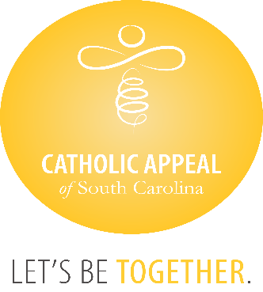

Catholic Appeal of South Carolina
July 2025 Update

At the close of July, the CASC received $4,455,316 in cash donations, with an additional $474,701 in pledges still to be paid, bringing us to $4,930,017 raised, which is 89% of the overall goal in cash received. A follow-up mailing to prior year donors twho have not made a 2025 donation is being mailed after Labor Day. Please encourage all your parishioners to participate at some level. The CASC funds are critical to so many important programs and ministries that share the gospel and Christ’s’ love for us all.

We wish congratulations to the following 31 parishes/missions that have surpassed their goals for the 2025 Catholic Appeal of South Carolina already:

- Holy Family, Hilton Head  - Holy Spirit, Johns Island  - Holy Spirit Mission, Laurens  - Our Lady of Good Counsel, Folly Beach  - Our Lady of Peace, N. Augusta  - Our Lady of Peace Mission, Bonneau  - Our lady of Perpetual Help, Camden  - Our Lady of the Lake, Chapin  - Precious Blood of Christ, Pawleys Island  - Sacred Heart, Abbeville  - St. Ann, Florence  - St. Ann, Kingstree  - St. Andrew, Clemson  - St. Anthony, Florence  - St. Anthony Mission, Hardeeville  - St. Boniface, Joanna | - St. Denis Mission, Bennettsville  - St. Francis Caracciolo Mission, Cane Bay  - St. Gregory the Great, Bluffton  - St. John the Beloved, Summerville  - St. Joseph Mission, Darlington  - St. Luke Mission, Easley  - St. Mary Mission, Allendale  - St. Mary Mission, Hampton  - St. Mary of Annunciation, Charleston  - St. Mary Help of Christians, Aiken  - St. Patrick Mission, Johnsonville  - St. Theresa Mission, Springfield  - St. Theresa, Winnsboro  - Transfiguration, Blythewood

