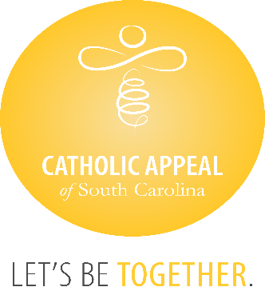

Catholic Appeal of South Carolina

October 2024 Update

At the close of September, the CASC has received $5,071,640 in cash donations, with an additional $230,642 in pledges still to be paid, bringing us to $5,302,283 raised. We are thrilled to be over the 5-million-dollar mark, but our participation is only at 15%. The CASC funds so many important programs and ministries that share the gospel and Christ’s love for us all, please encourage all faithful to participate at some level.

We wish congratulations to the following 40 parishes that have surpassed their parish goals for the 2024 Catholic Appeal of South Carolina already:

|  |  |
| --- | --- |
| * **Church of the Infant Jesus, Marion** * **Church of the Resurrection, Loris** * **Divine Redeemer, Hanahan** * **Good Shepherd, McCormick** * **Holy Cross, Pickens** * **Holy Spirit, Johns Island** * **Nativity Church, Charleston** * **Our Lady of Good Counsel, Folly Beach** * **Our Lady of Peace, North Augusta** * **Our Lady of Peace Mission, Bonneau** * **Our Lady of Perpetual Help, Camden** * **Our Lady of the Lake, Chapin** * **Our Lady of the Valley, Gloverville** * **Precious Blood of Christ, Pawleys Island** * **Sacred Heart, Abbeville** * **Saint Clare of Assisi, Daniel Island** * **St. Ann, Florence** * **St. Ann, Kingstree** * **St. Ann, Santee** * **St. Andrew, Clemson** | * **St. Andrew, Myrtle Beach** * **St. Anthony, Florence** * **St. Anthony Mission, Hardeeville** * **St. Boniface, Joanna** * **St. Denis Mission, Bennettsville** * **St. Francis Caracciolo Mission, Cane Bay** * **St. Gregory the Great, Bluffton** * **St. John the Beloved, Summerville** * **St. Joseph, Columbia** * **St. Joseph, Chester** * **St. Joseph Mission, Darlington** * **St. Luke, Easley** * **St. Mary, Yonges Island** * **St. Mary Help of Christians, Aiken** * **St. Mary Magdalene, Simpsonville** * **St. Patrick Mission, Johnsonville** * **St. Theresa, Winnsboro** * **St. Theresa Mission, Springfield** * **St. Theresa the Little Flower, Summerville** * **Transfiguration, Blythewood** |