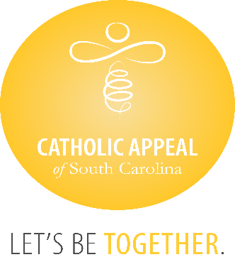

Catholic Appeal of South Carolina

August 2024 Update

At the close of August, the CASC has received $4,669,424 in cash donations, with an additional $381,349 in pledges still to be paid, bringing us to $5,050,773 raised, which is 93% of the overall goal. We are thrilled to be over the 5-million-dollar mark, but our participation is only at 15%. The CASC funds so many important programs and ministries that share the gospel and Christ’s love for us all, please encourage all faithful to participate at some level.

We wish congratulations to the following 31 parishes that have surpassed their parish goals for the 2024 Catholic Appeal of South Carolina already:

|  |  |
| --- | --- |
| * **Church of the Infant Jesus, Marion** * **Good Shepherd, McCormick** * **Holy Cross, Pickens** * **Holy Spirit, Johns Island** * **Our Lady of Good Counsel, Folly Beach** * **Our Lady of Peace Mission, Bonneau** * **Our Lady of Perpetual Help, Camden** * **Our Lady of the Lake, Chapin** * **Our Lady of the Valley, Gloverville** * **Sacred Heart, Abbeville** * **Saint Clare of Assisi, Daniel Island** * **St. Ann, Florence** * **St. Ann, Kingstree** * **St. Ann, Santee** * **St. Andrew, Clemson** | * **St. Anthony, Florence** * **St. Anthony Mission, Hardeeville** * **St. Denis Mission, Bennettsville** * **St. Francis Caracciolo Mission, Cane Bay** * **St. Gregory the Great, Bluffton** * **St. John the Beloved, Summerville** * **St. Joseph, Columbia** * **St. Joseph, Chester** * **St. Joseph Mission, Darlington** * **St. Luke, Easley** * **St. Mary Help of Christians, Aiken** * **St. Patrick Mission, Johnsonville** * **St. Theresa, Winnsboro** * **St. Theresa Mission, Springfield** * **St. Theresa the Little Flower, Summerville** * **Transfiguration, Blythewood** |