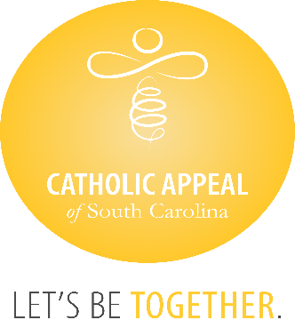

Catholic Appeal of South Carolina

July 2024 Update

At the close of July, the CASC has received $4,124,681 in cash donations, with an additional $430,845 in pledges still to be paid, bringing us to $4,555,526 raised, which is 82% of the overall goal. Overall, our number of donations and donors keep growing, but we must continue to remind all the catholic faithful we need everyone’s participation. The CASC funds so many important programs and ministries that share the gospel and Christ’s love for us all.

We wish congratulations to the following 28 parishes that have surpassed their parish goals for the 2024 Catholic Appeal of South Carolina already:

|  |  |
| --- | --- |
| * **Church of the Infant Jesus, Marion** * **Good Shepherd, McCormick** * **Holy Cross, Pickens** * **Holy Spirit, Johns Island** * **Our Lady of Good Counsel, Folly Beach** * **Our Lady of Peace Mission, Bonneau** * **Our Lady of Perpetual Help, Camden** * **Our Lady of the Lake, Chapin** * **Our lady of the Valley, Gloverville** * **Sacred Heart, Abbeville** * **Saint Clare of Assisi, Daniel Island** * **St. Ann, Florence** * **St. Ann, Kingstree** * **St. Andrew, Clemson** | * **St. Anthony, Florence** * **St. Anthony Mission, Hardeeville** * **St. Denis Mission, Bennettsville** * **St. Francis Caracciolo Mission, Cane Bay** * **St. Gregory the Great, Bluffton** * **St. John the Beloved, Summerville** * **St. Joseph, Columbia** * **St. Joseph, Chester** * **St. Joseph Mission, Darlington** * **St. Luke, Easley** * **St. Mary Help of Christians, Aiken** * **St. Theresa, Winnsboro** * **St. Theresa Mission, Springfield** * **St. Theresa the Little Flower, Summerville** |