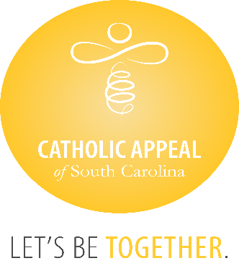

Catholic Appeal of South Carolina

June 2024 Update

At the close of June, the CASC has received $3,817,454 in cash donations, with an additional $570,067 in pledges still to be paid, bringing us to $4,387,521 raised, which is 76% of the overall goal. Overall, our number of donations and donors keep growing, but we must continue to remind all the catholic faithful we need everyone’s participation. The CASC funds so many important programs and ministries that share the gospel and Christ’s love for us all.

We wish congratulations to the following 25 parishes that have surpassed their parish goals for the 2024 Catholic Appeal of South Carolina already:

|  |  |
| --- | --- |
| * **Church of the Infant Jesus, Marion** * **Good Shepherd, McCormick** * **Holy Cross, Pickens** * **Holy Spirit, Johns Island** * **Our Lady of Good Counsel, Folly Beach** * **Our Lady of Peace Mission, Bonneau** * **Our Lady of Perpetual Help, Camden** * **Our Lady of the Lake, Chapin** * **Sacred Heart, Abbeville** * **Saint Clare of Assisi, Daniel Island** * **St. Ann, Florence** * **St. Ann, Kingstree** * **St. Andrew, Clemson** | * **St. Anthony, Florence** * **St. Anthony Mission, Hardeeville** * **St. Denis Mission, Bennettsville** * **St. Francis Caracciolo Mission, Cane Bay** * **St. Gregory the Great, Bluffton** * **St. John the Beloved, Summerville** * **St. Joseph, Chester** * **St. Joseph Mission, Darlington** * **St. Luke, Easley** * **St. Mary Help of Christians, Aiken** * **St. Theresa, Winnsboro** * **St. Theresa Mission, Springfield** |