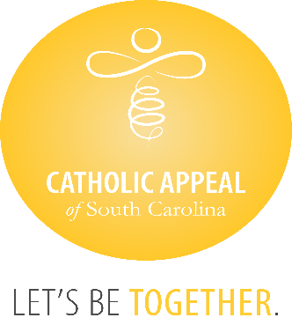

Catholic Appeal of South Carolina

May 2024 Update

At the close of May, the CASC has received $3,375.852 in cash donations, with an additional $639,600 in pledges still to be paid, bringing us to $4,015,452 raised, which is 68% of the overall goal. Overall, our number of donations and donors keep growing, but we must continue to remind all the catholic faithful we need everyone’s participation. The CASC funds so many important programs and ministries that share the gospel and Christ’s’ love for us all.

Please note that a second mailing has been sent to all households who have yet to contribute to the CASC. Encourage all parishioners to participate, gifts of any size can make a significant difference.

We wish congratulations to the following 17 parishes that have surpassed their parish goals for the 2024 Catholic Appeal of South Carolina already:

|  |  |
| --- | --- |
| * **Good Shepherd, McCormick** * **Holy Cross, Pickens** * **Holy Spirit, Johns Island** * **Our Lady of Peace Mission, Bonneau** * **Our Lady of Perpetual Help, Camden** * **Our Lady of the Lake, Chapin** * **Sacred Heart, Abbeville** * **Saint Clare of Assisi, Daniel Island** * **St. Ann, Kingstree** | * **St. Anthony Mission, Hardeeville** * **St. Denis Mission, Bennettsville** * **St. Gregory the Great, Bluffton** * **St. Francis Caracciolo Mission, Cane Bay** * **St. Joseph, Chester** * **St. Joseph Mission, Darlington** * **St. Theresa, Winnsboro** * **St. Theresa Mission, Springfield** |