Diocese of Charleston, Office of Family Life
Sponsors
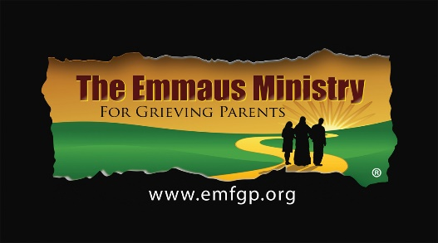
Saturday, November 18, 2023

A Spiritual One-Day Retreat for Parents Who Have Experienced the Death of
a Child of Any Age, By Any Cause, No Matter How Long Ago

Losing a child under any circumstances is horrendous. Focusing on the spirituality of the grieving process can help tremendously. Just as He comforted His grieving disciples on the road to Emmaus, Jesus comforts us and we comfort each other in this very special ministry.

Join other Emmaus Parent Companions and our Office of Family Life Retreat Team in a warm and loving place—
to think, to talk, to feel, and to pray. Find compassion, rest, and peace… at least for a time.
___________________________________________________________________

Emmaus Ministry for Grieving Parents
At The Oratory in Rock Hill, SC

ONE-DAY SPIRITUAL RETREAT
November 18, 2023 from 8:30am-6:30pm

All Are Welcome!

Donation: $20 Individuals; $35 Couples
Scholarships are available. Pre-registration is required.

For more information, contact Christy Brown at cbrown@charlestondiocese.org
803 554 6088

To register, complete the Registration Form at www.emfgp.org

The Emmaus Ministry for Grieving Parents at
The Oratory
St. John XXIII Center
434 Charlotte Ave
Rock Hill, SC

