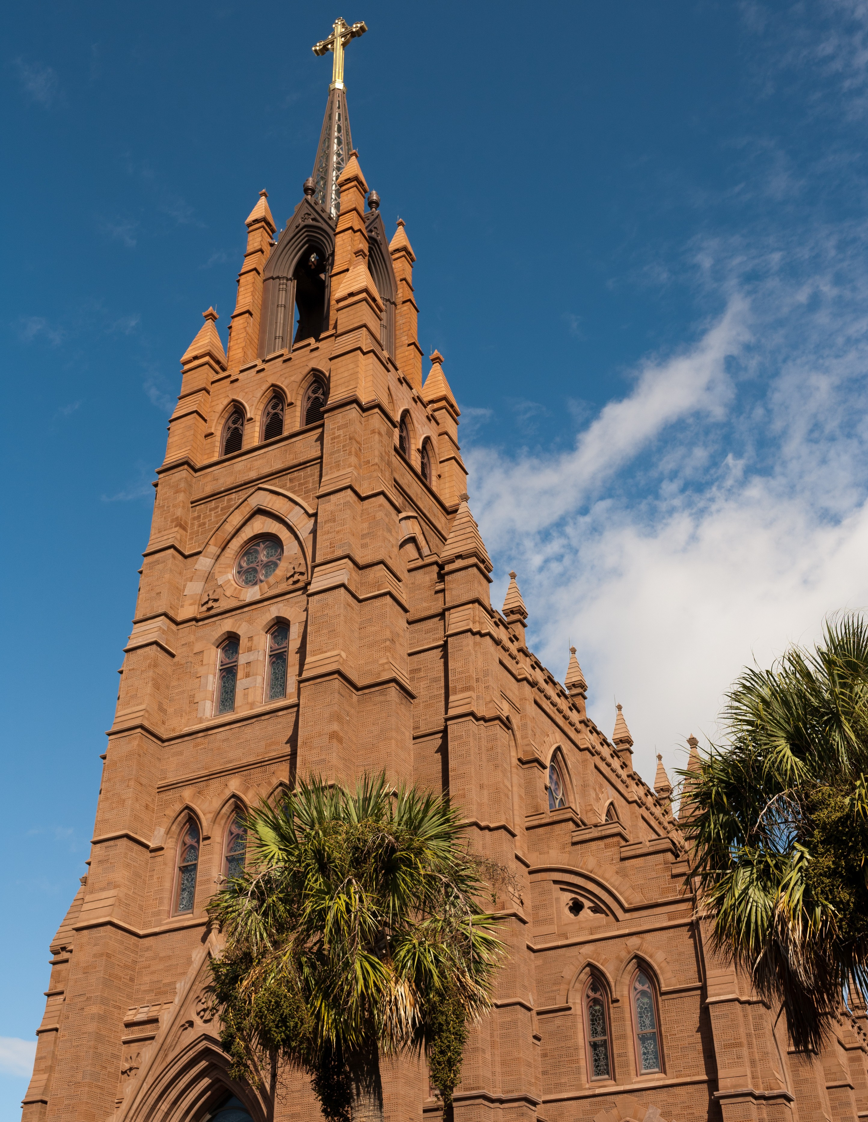

OVERVIEW
OVERVIEW
PAGE | 02

In an effort to better serve the parishes and ministries of South Carolina, the Diocese of Charleston is releasing a media toolkit each month with social media assets to promote a monthly theme across the state. This coming month, June, is the Month of Truth.

As we reflect on religious liberty, all parishes are encouraged to share and amplify the message #BeTruthful across their own social platforms with the help of the toolkit below.

OBJECTIVES

The objectives for this month’s campaign are to: Highlight special saint feast days
Highlight Religious Freedom Week (June 22-29)
Inform and inspire the faithful with guides for NFP awareness week (July 23-29)

STEPS

- DOWNLOAD the photo by right clicking an image below to save it onto your desktop. You can also simply drag it onto your desktop.
- LOG ON to your favorite social media site, such as Facebook, Twitter or Instagram.
- COPY & PASTE one of the sample captions below into your status update — or create your own message that includes the #BeTruthful hashtag.
- UPLOAD the #BeTruthful image saved to your desktop to accompany your status update.
- POST your status update and encourage others to join the initiative through liking, sharing, reposting, and tagging others!

PAGE | 03
SOCIAL MEDIA POSTS

SOCIAL MEDIA POSTS

POPE'S INTENTION - JUNE

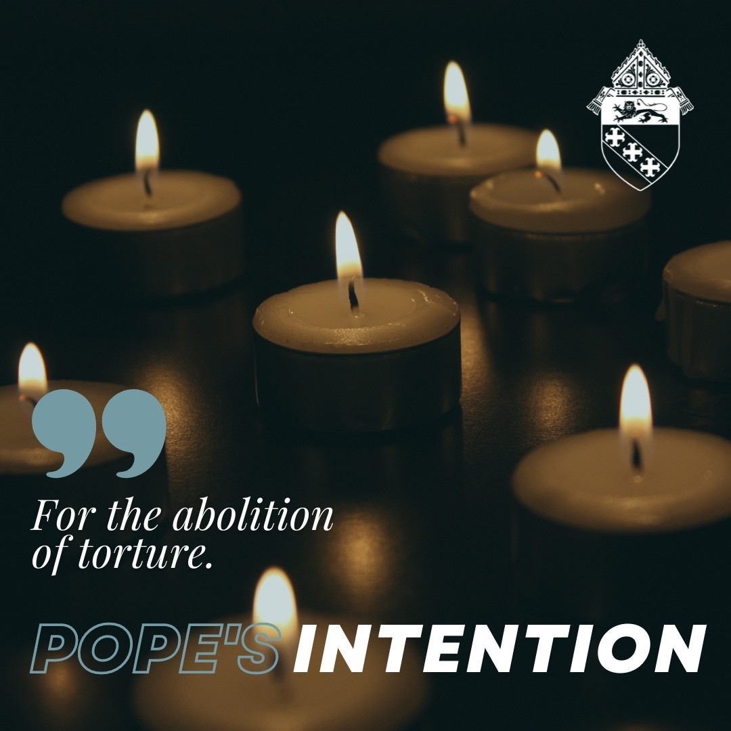
This month, please join Pope Francis in praying that the international community may commit in a concrete way to ensuring the abolition of torture and guarantee support to victims and their families.

#popesintention #betruthful

Graphic: For the abolition of torture. Pope’s Intention

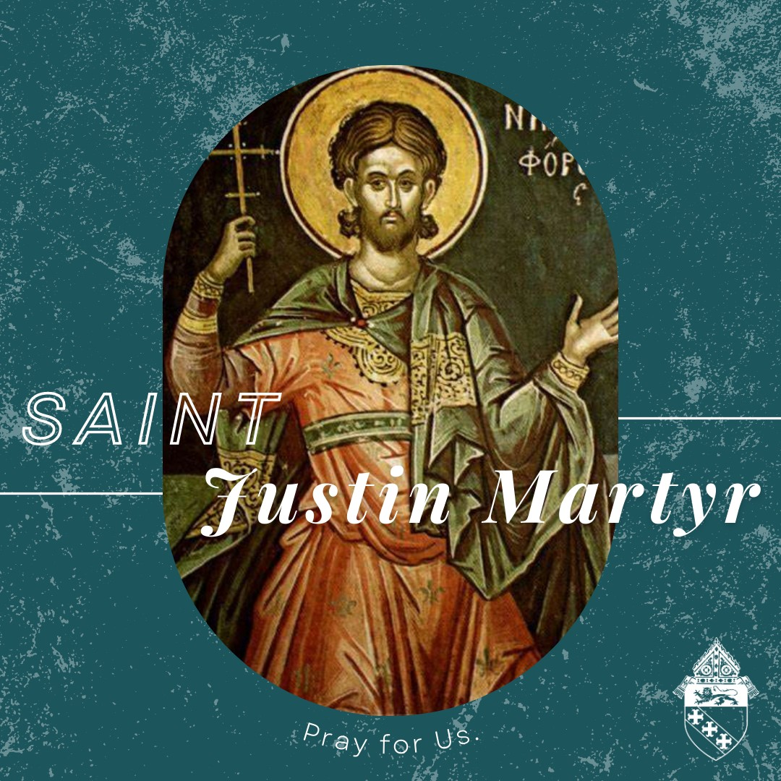
ST. JUSTIN MARTYR - JUNE 1

St. Justin (100-165 AD) was a Greek philosopher and apologist who spent much of his life defending the faith against pagan accusations, atheists, disloyalty and immorality. He was martyred during the reign of emperor Marcus Aurelius.

May we follow St. Justin's example of courage and faith by sharing the Gospel through our lives. St. Justin, pray for us.

#betruthful
Graphic: Saint Justin Martyr. Pray for us.

PAGE | 04
SOCIAL MEDIA POST

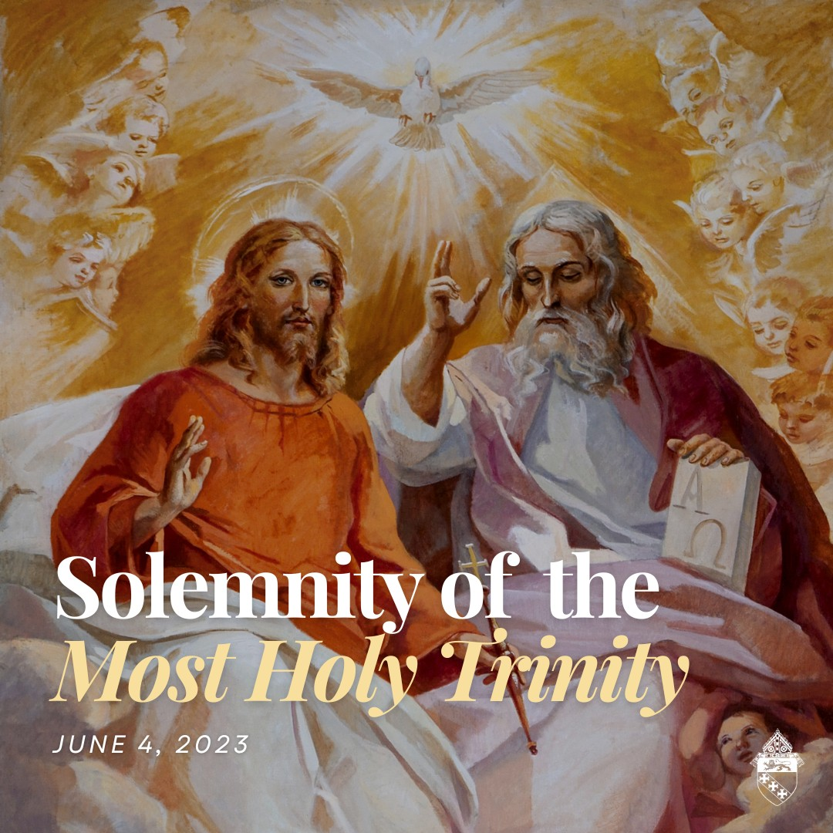
SOLEMNITY OF THE MOST HOLY TRINITY - JUNE 4

A blessed Solemnity of the Most Holy Trinity! This solemnity is celebrated a week after Pentecost to honor one of the most fundamental of Christian beliefs — the Holy Trinity.

"The whole divine economy is the common work of the three divine persons. For as the Trinity has only one and the same natures so too does it have only one and the same operation: 'The Father, the Son and the Holy Spirit are not three principles of creation but one principle." (Catechism #258)

#solemnity #holytrinity
Graphic: Solemnity of the Most Holy Trinity. June 4, 2023

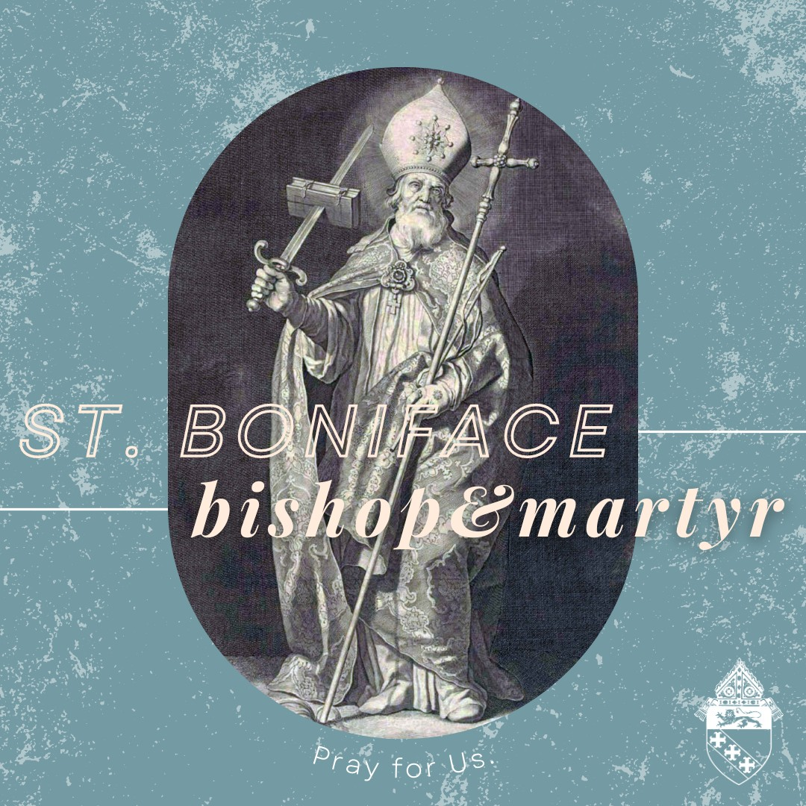
ST. BONIFACE - JUNE 5

"The Church is like a great ship being pounded by the waves of life's different stresses. Our duty is not to abandon ship, but to keep her on her course." // St.
Boniface, pray for us! #feastday #betruthful
Graphic: St. Boniface bishop & martyr. Pray for us.

PAGE | 05
SOCIAL MEDIA POST

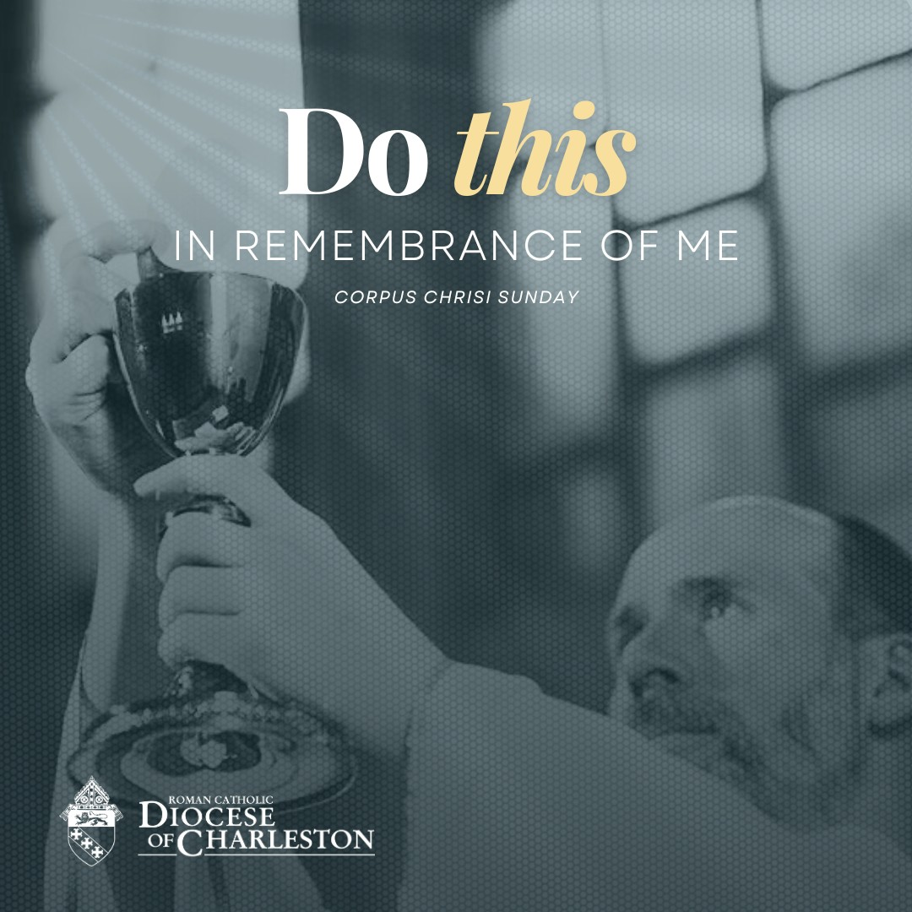
SOLEMNITY OF THE BODY & BLOOD OF CHRIST - JUNE 11

A blessed Solemnity of the Body and Blood of Christ (Corpus Christi). Today, we honor the true presence of Jesus in the holy Eucharist.

As Catholics, we believe that when we receive the Eucharist, we are receiving the body, blood, soul and divinity of the living God, Christ Jesus. Let us rejoice and give thanks for this wonderful sacrament that unites us to our savior!

#corpuschristisunday #betruthful
Graphic: Do this in remembrance of me. Corpus Christi Sunday

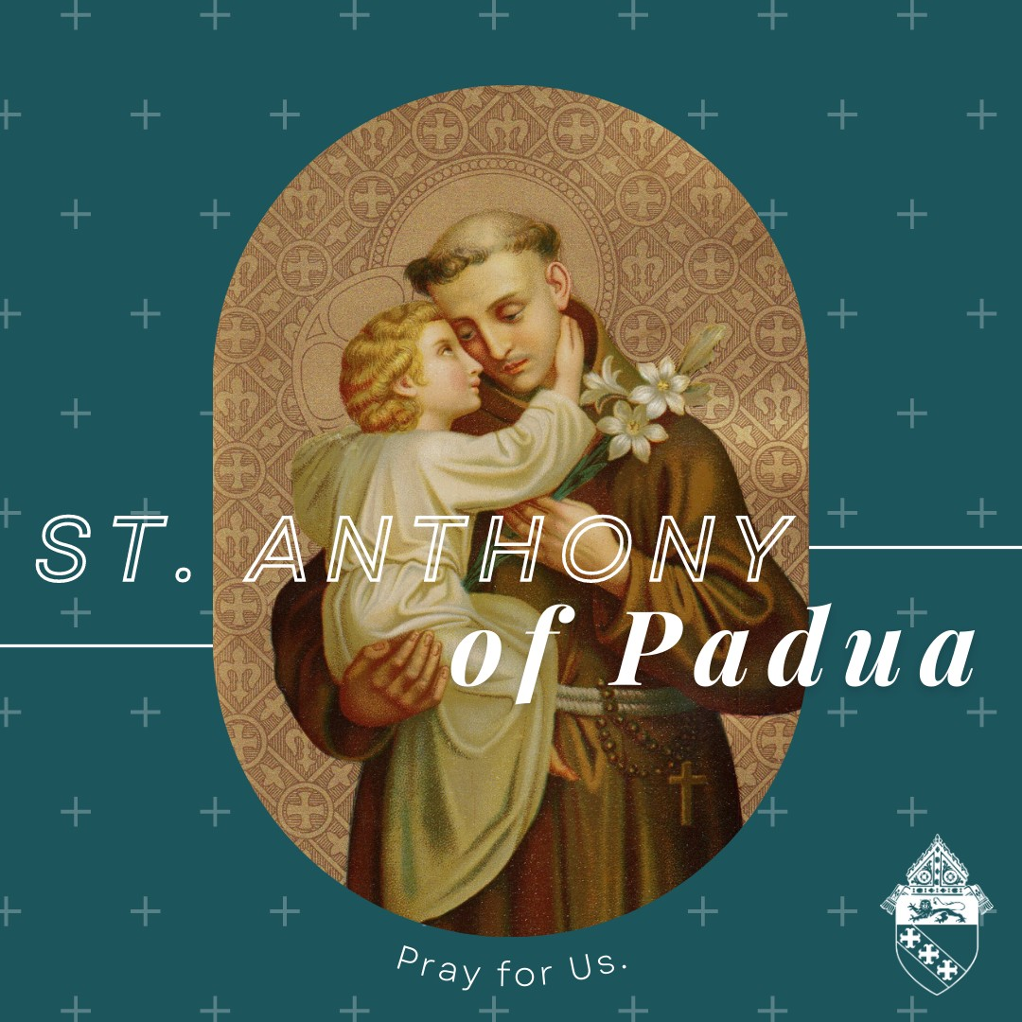
ST. ANTHONY - JUNE 13

"Charity is the soul of faith; it gives it life; without love, faith dies."

A blessed memorial of St. Anthony of Padua, the patron saint of lost or stolen things and the poor. St. Anthony, pray for us!

#feastday #betruthful
Graphic: St. Anthony of Padua. Pray for us.

PAGE | 06
SOCIAL MEDIA POST

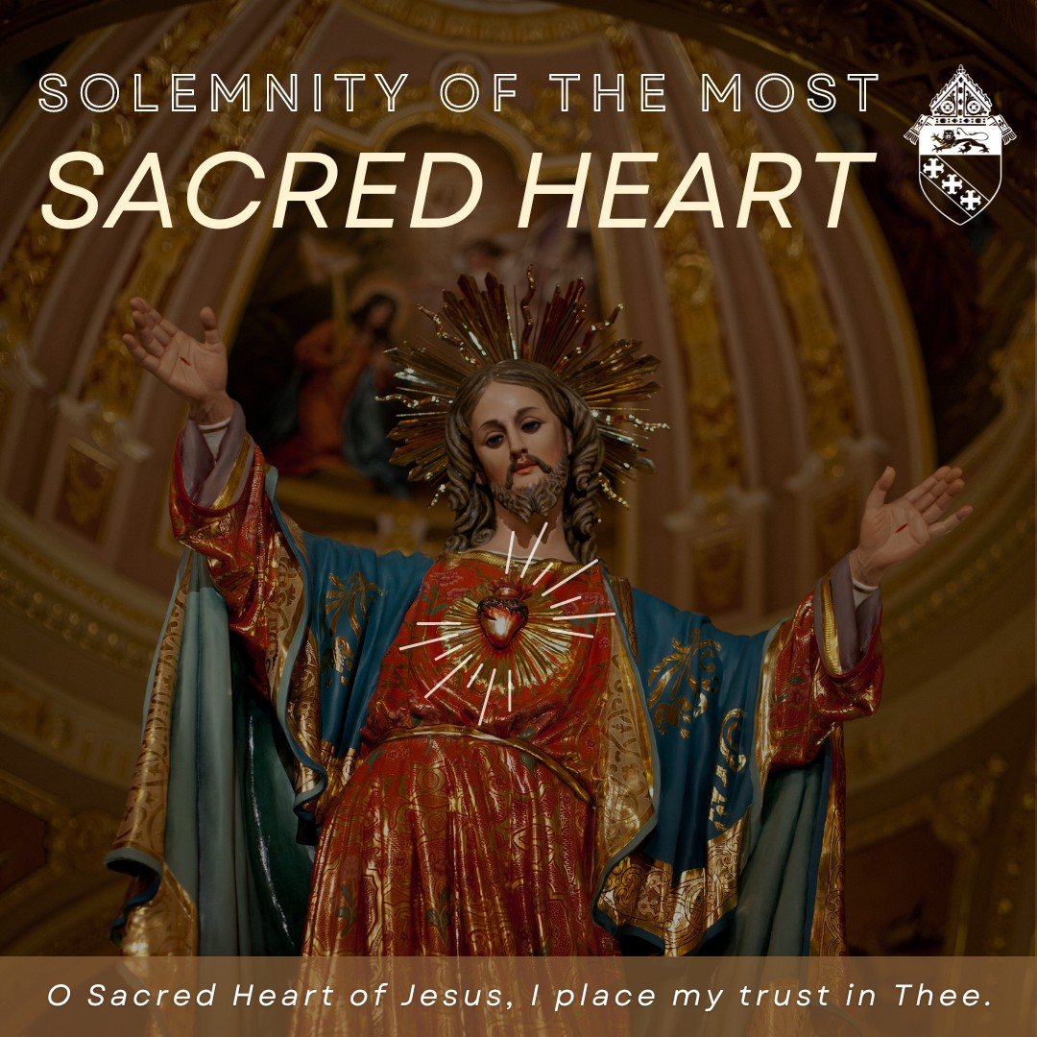
SOLEMNITY OF THE MOST SACRED HEART
- JUNE 16

Devotions to the Sacred Heart of Jesus were popularized when Sister Margaret Mary Alacoque (1647-1690), received visions from Jesus. He told her, “My Divine Heart is so passionately in love with humanity that it can no longer contain within itself the flames of its ardent love. It must pour them out. I have chosen you for this great plan.”

From these visions, Jesus asked her to receive the Eucharist on the first Friday of the month for nine consecutive months and to make reparation through prayer to his most Sacred Heart. Pope Pius IX made it an obligatory feast throughout the universal Church in 1856. "First Friday" devotions are a beautiful way to grow closer to Christ's heart.
To read more about the 12 promises of the Sacred Heart of Jesus, visit this link: bit.ly/3pwzvb2.
Graphic: Solemnity of the Most Sacred Heart. O Sacred Heart of Jesus, I place my trust in Thee.

JUNETEENTH - JUNE 19

Today we celebrate Juneteenth, the federal holiday that honors the freeing of the last enslaved people in America. Juneteenth is an opportunity to honor the dignity of every human life and the unique contributions that the children of God, in their abundant diversity, bring to his kingdom.

Many of our parishes will hold celebratory events, especially in our historically Black Catholic churches. Check with your local parish to see events in your area.

#juneteenth #betruthful
Graphic: June 19, Juneteenth, Celebrate Freedom

PAGE | 07
SOCIAL MEDIA POST

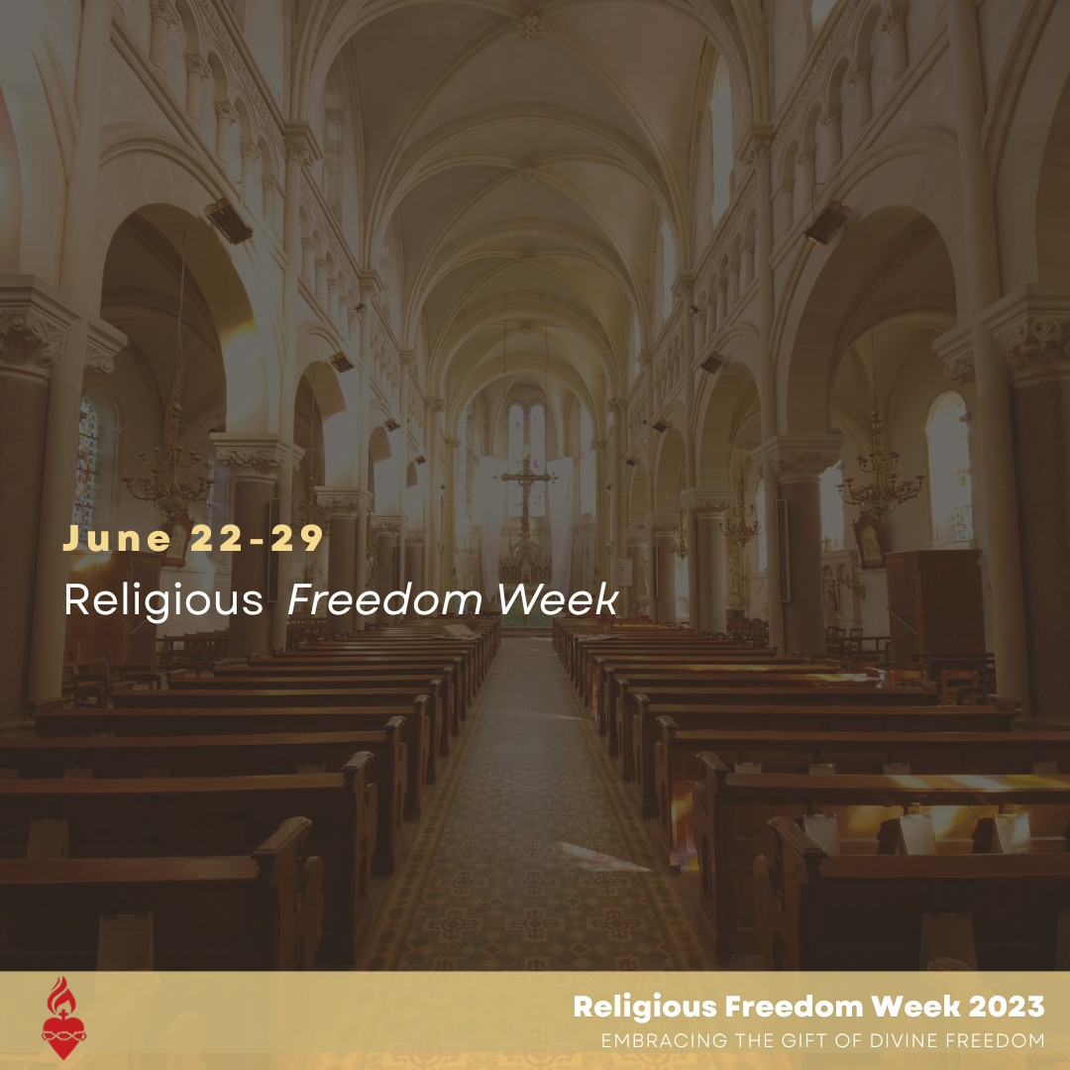
RELIGIOUS FREEDOM WEEK - JUNE 22-29

This is Religious Freedom Week, which corresponds to the shared feast day of Sts. Thomas More and John Fisher, both of whom were martyred for their faith.

Religious freedom allows the Church and all religious communities to live out their faith in public to serve the good of all.

Let us pray, reflect and act to promote religious freedom. Sts. Thomas More and John Fisher, pray for us!

#religiousfreedom #betruthful
Graphic: June 22-29 Religious Freedom Week
Religious Freedom Week 2023
Embracing the Gift of Divine Freedom

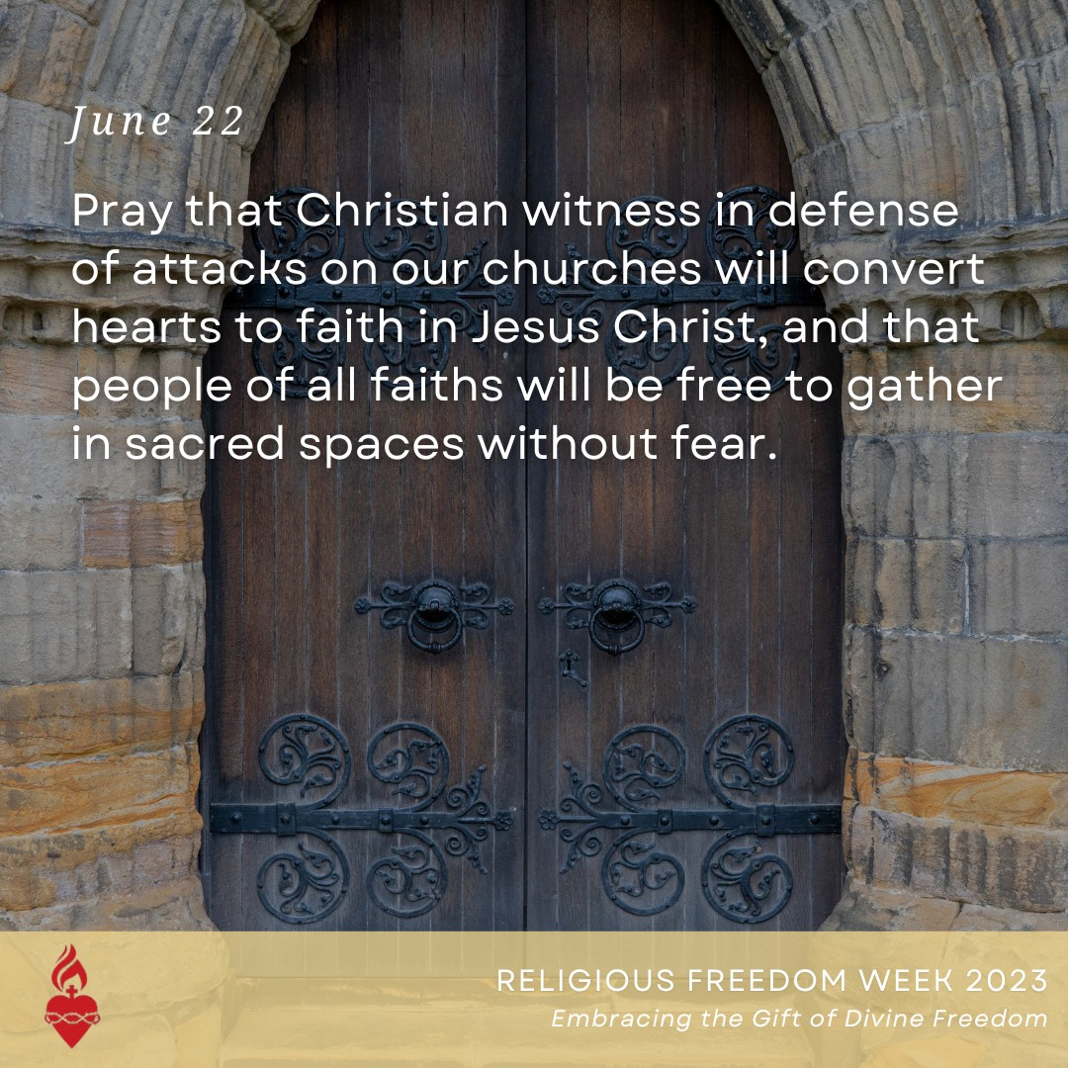
RELIGIOUS FREEDOM WEEK - JUNE 22

The very nature of a sacred space is that it is set apart as a place of divine worship and should be treated with respect.

In recent years, a wave of vandalism and arson has hit Catholic churches. There have been over 250 attacks so far, and that number continues to grow. Attacks on sacred spaces, whether from political ideology or commerce, are harmful to religious freedom.

Please join us in praying for respect of sacred spaces for all faith communities.
#religiousfreedom #betruthful
Graphic: June 22 Pray that Christian witness in defense of attacks on our churches will convert hearts to faith in Jesus Christ, and that people of all faiths will be free to gather in sacred spaces without fear. Religious Freedom Week 2023 Embracing the Gift of Divine Freedom.

PAGE | 08
SOCIAL MEDIA POST

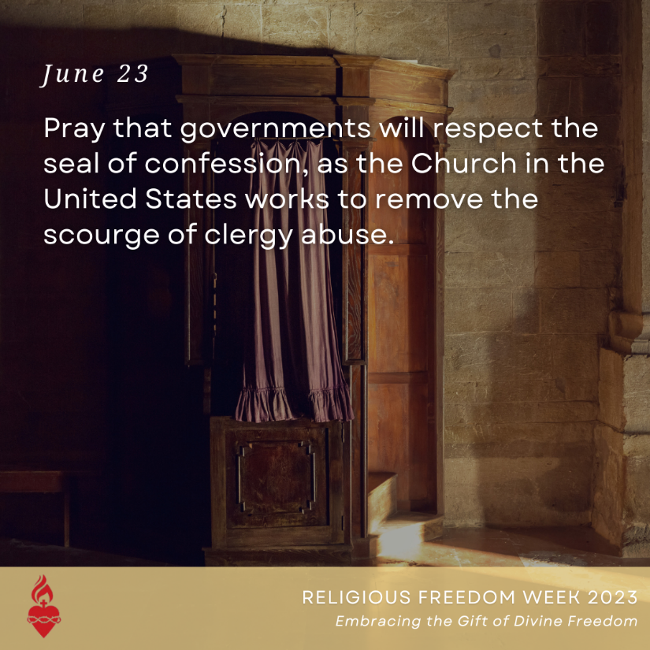

RELIGIOUS FREEDOM WEEK - JUNE 23

The sacrament of confession is a sacred encounter between the penitent and the Lord Jesus, who offers forgiveness and healing through the ministry of the priest. The Code of Canon Law forbids priests from divulging information received in confession.

Some governments seek to revoke this privilege in the hope of exposing crimes against children and vulnerable adults. It is essential that, to the extent it can, the Church works with civil authorities to ensure that criminals are brought to justice and communities are kept safe. At the same time, the government has no right to encroach upon this sacred communication.

Let us make an act of reparation to the Sacred Heart of Jesus for the crimes committed by members of the Church and for renewal of the Church.
#religiousfreedom
Graphic: June 23 Pray that governments will respect the seal of confession, as the Church in the United States works to remove the scourge of clergy abuse.

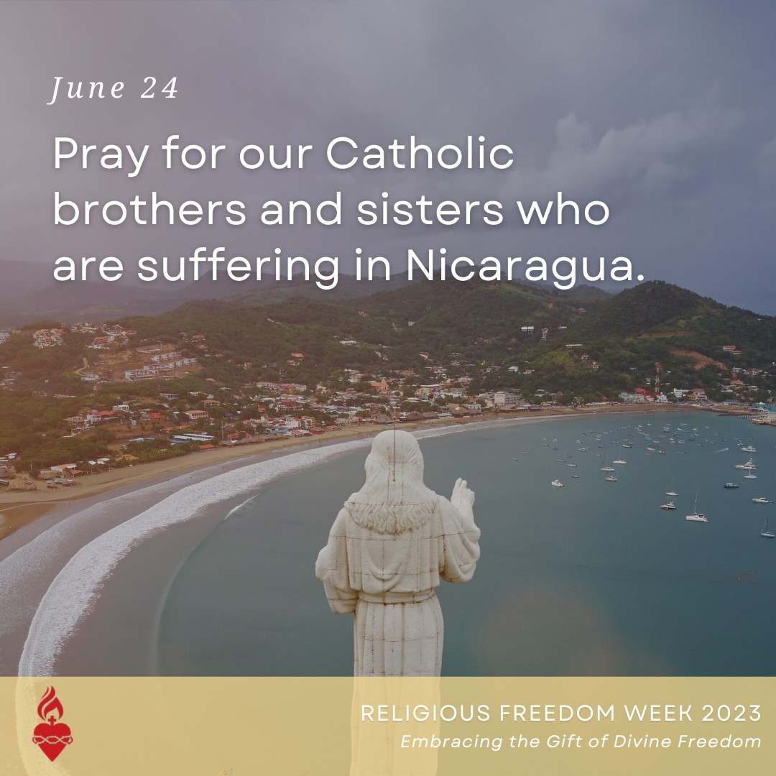
RELIGIOUS FREEDOM WEEK - JUNE 24

Since 2018, the Church in Nicaragua has faced a systematic and persistent campaign of aggression from the government and pro- government operatives. Churches have been attacked with deadly force, priests and religious imprisoned or exiled and the Apostolic Nuncio was expelled. In February 2023, Bishop
Rolando Alvarez of Matagalpa, Nicaragua, was unjustly sentenced to 26 years in prison.
The viciousness of the persecution is highlighted in the numerous acts of desecration against the Blessed Sacrament by pro- government forces. These spiritual attacks are intended to send a message to bishops, priests and faithful that the regime will go to any length to silence the moral voice of the Catholic Church.
Let us pray for Nicaragua! #religiousfreedom
Graphic: June 24 Pray for our Catholic brothers and sisters who are suffering in Nicaragua. Religious Freedom Week 2023 Embracing the Gift of Divine Freedom

PAGE | 09
SOCIAL MEDIA POST

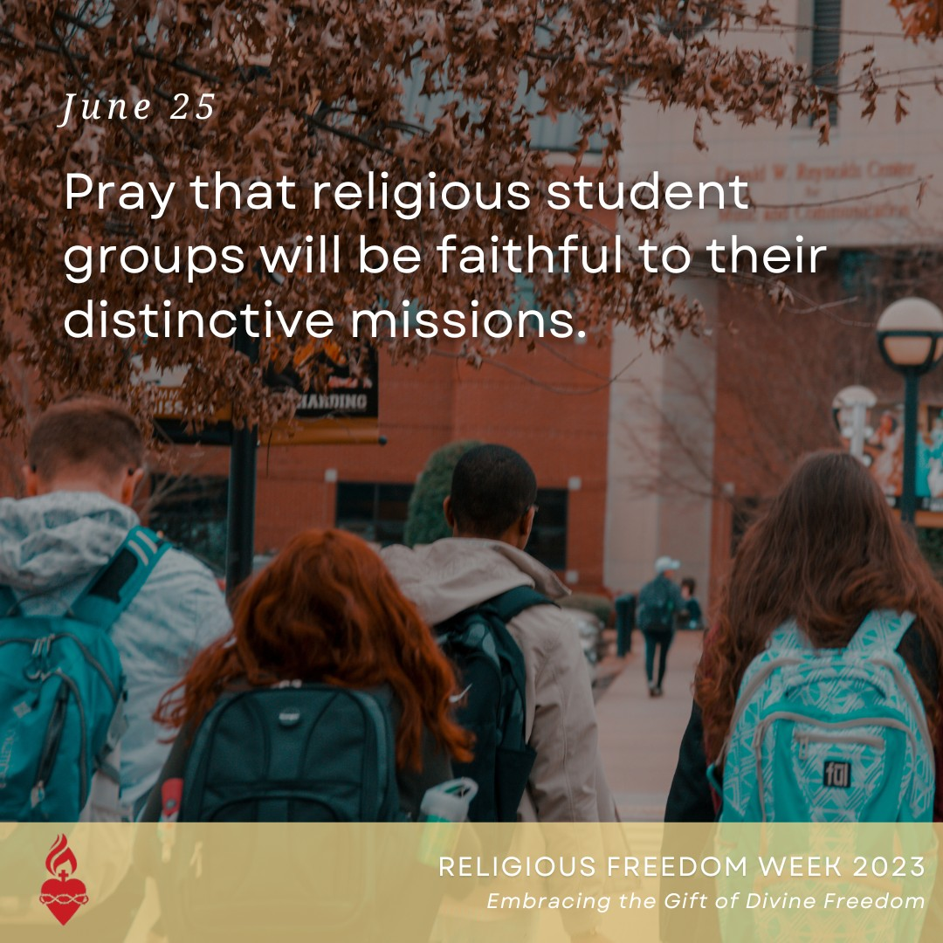
RELIGIOUS FREEDOM WEEK - JUNE 25

Recently, university policies meant to promote inclusivity — such as a rule that any student has the right to be a leader of a campus student group — have been used to prohibit religious student groups from ensuring that leaders and members share their beliefs.

The sentiment of such policies seems appealing, but in practice, it means that an atheist could lead a Bible study, a climate change denier could lead the environmental club, or a Democrat could lead the college Republicans and vice versa. This false idea of inclusivity prevents groups from having any distinctive mission or identity.
College campuses must embrace the gift of freedom by allowing student groups to operate in accordance with their distinctive missions and faith traditions. Urge congress to support the Equal Campus Access Act!
#religiousfreedom #betruthful
Graphic: June 25 Pray that religious student groups will be faithful to their distinctive missions. Religious Freedom Week 2023 Embracing the Gift of Divine Freedom

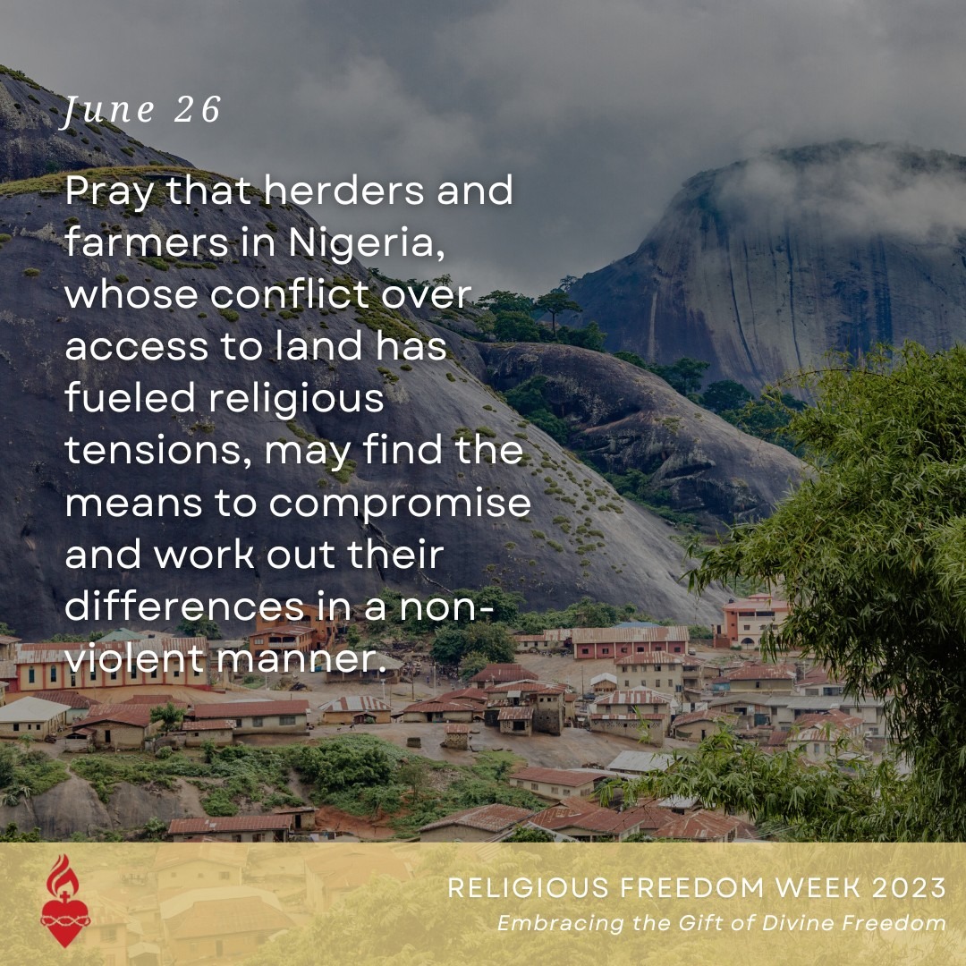
RELIGIOUS FREEDOM WEEK - JUNE 26

In Nigeria, police forces and the courts have failed to establish the rule of law. It has led to a lack of security while simultaneously, shrinking land for grazing contributes to rising conflict between herders and farmers.
Herders are generally Muslims from the Fulani tribe and farmers are generally Christians of various ethnicities, which has heightened ethnic and religious tensions. Amid continuing violence and polarization, the Catholic Bishops' Conference of Nigeria continues to call and work for peace. How can you help? Support Aid to the Church in Need, Catholic Relief Services, the U.S. Bishop's Solidarity Fund for Aid to the Church in Africa, and other organizations that assist internally displaced people and offer peacebuilding between those of different faiths. Graphic: Pray that herders and farmers in Nigeria, whose conflict over access to land has fueled religious tensions, may find the means to compromise and work out their differences in a non-violent manner.

PAGE | 10
SOCIAL MEDIA POST

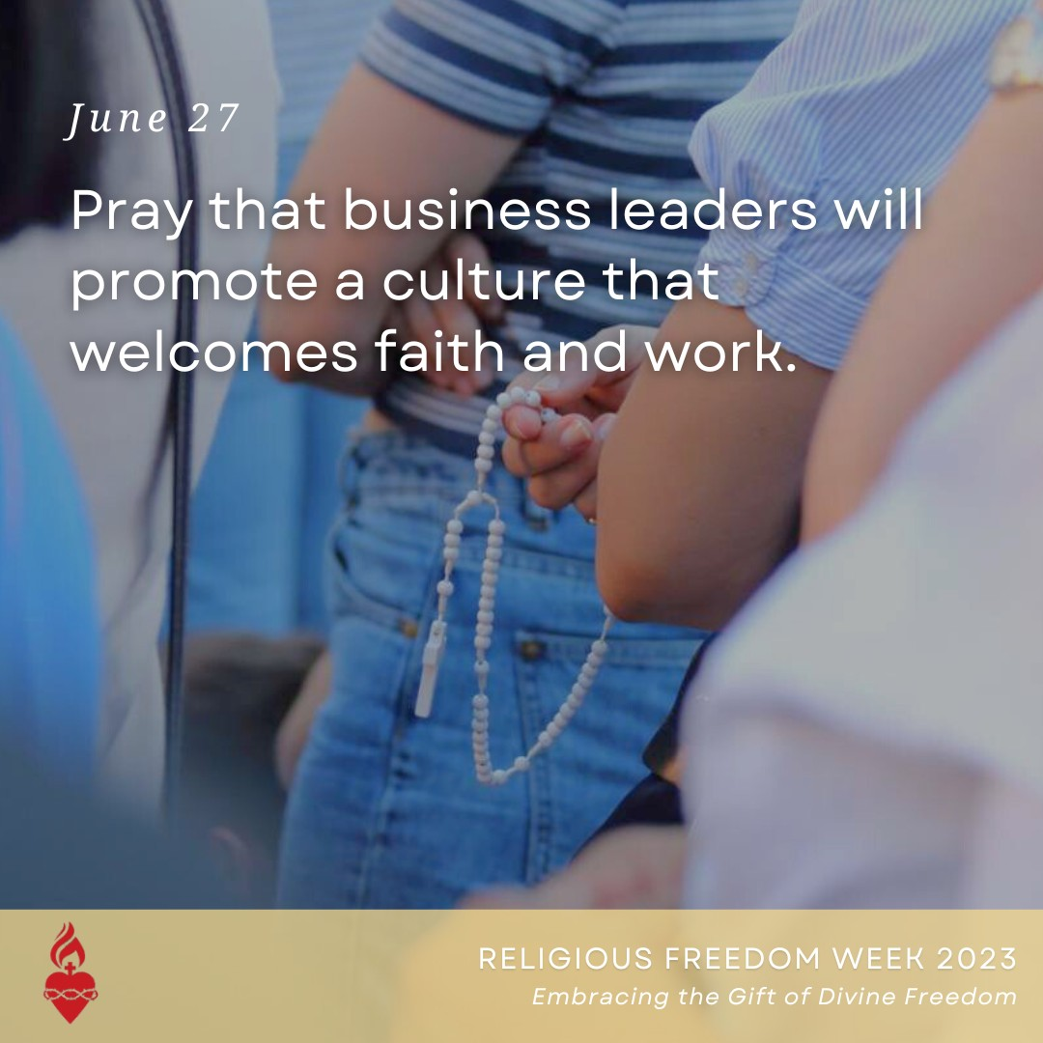
RELIGIOUS FREEDOM WEEK - JUNE 27

The Catholic Church calls on us to witness to our faith in all spheres of life. All people should be free to allow faith to guide them in daily affairs, even in work and business.

Let us pray for a culture that embraces the divine gift of freedom and that makes as much space as possible for persons to participate in work life in accordance with their religious convictions.

#religiousfreedom #betruthful
Graphic: June 27 Pray that business leaders will promote a culture that welcomes faith and work. Religious Freedom Week 2023 Embracing the Gift of Divine Freedom

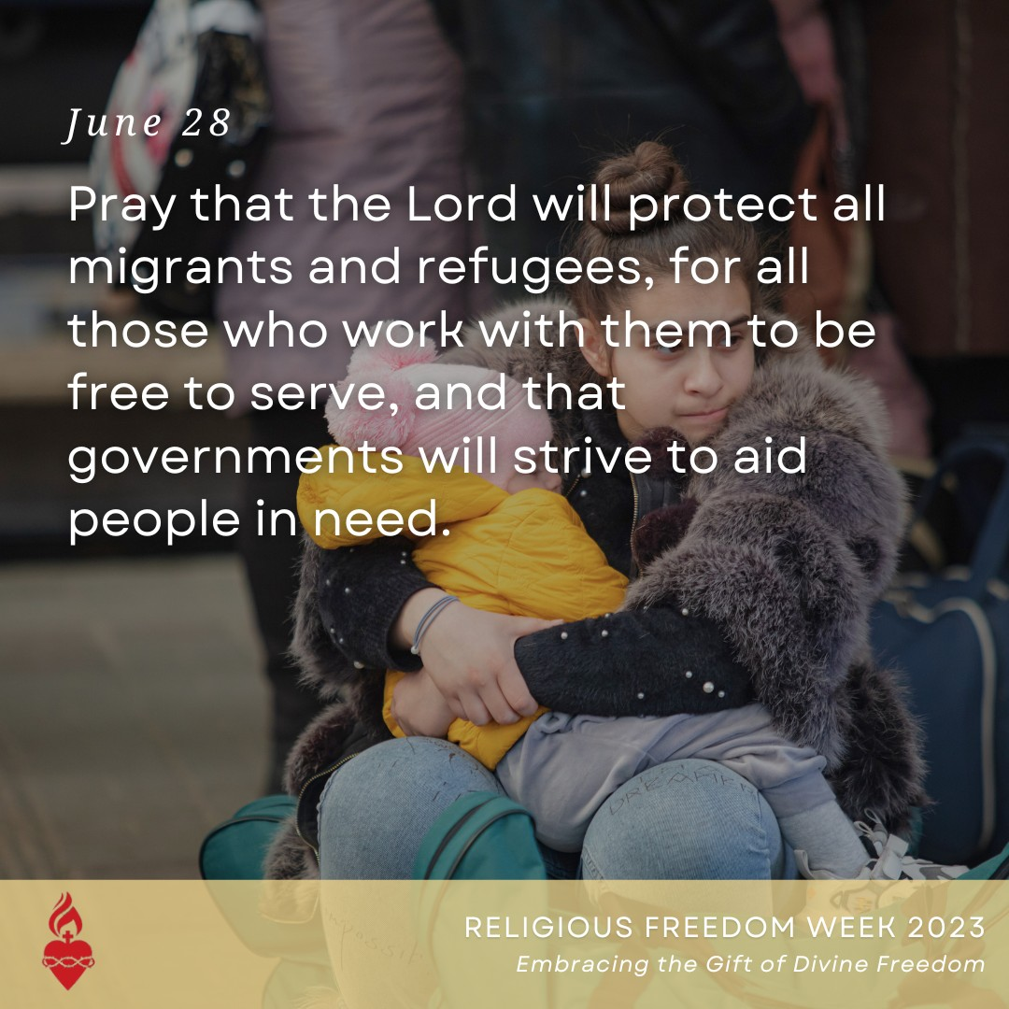
RELIGIOUS FREEDOM WEEK - JUNE 28

Civil authorities are responsible for ensuring public order, including maintaining national borders, as part of their duty to uphold the common good. Governments must respect the rights and dignity of all people, and the Gospel mandates that the Church serve vulnerable populations, including migrants and refugees.
The Church has long sought to assist the
needs of "people on the move." However, many Christian services have faced legal setbacks.
State governments have passed or proposed laws that forbid harboring or transporting undocumented immigrants — even when the “harboring” is providing a safe place to sleep, or the "transporting" is a ride to Mass. These types of laws could essentially criminalize much of the Church’s ministry to migrants.
May we pray for all those whom the Church serves. #religiousfreedom #betruthful

Graphic: June 28 Pray that the Lord will protect all migrants and refugees, for all those who work with them to be free to serve, and that governments will strive to aid people in need. Religious Freedom Week 2023 Embracing the Gift of Divine Freedom

PAGE | 11
SOCIAL MEDIA POST

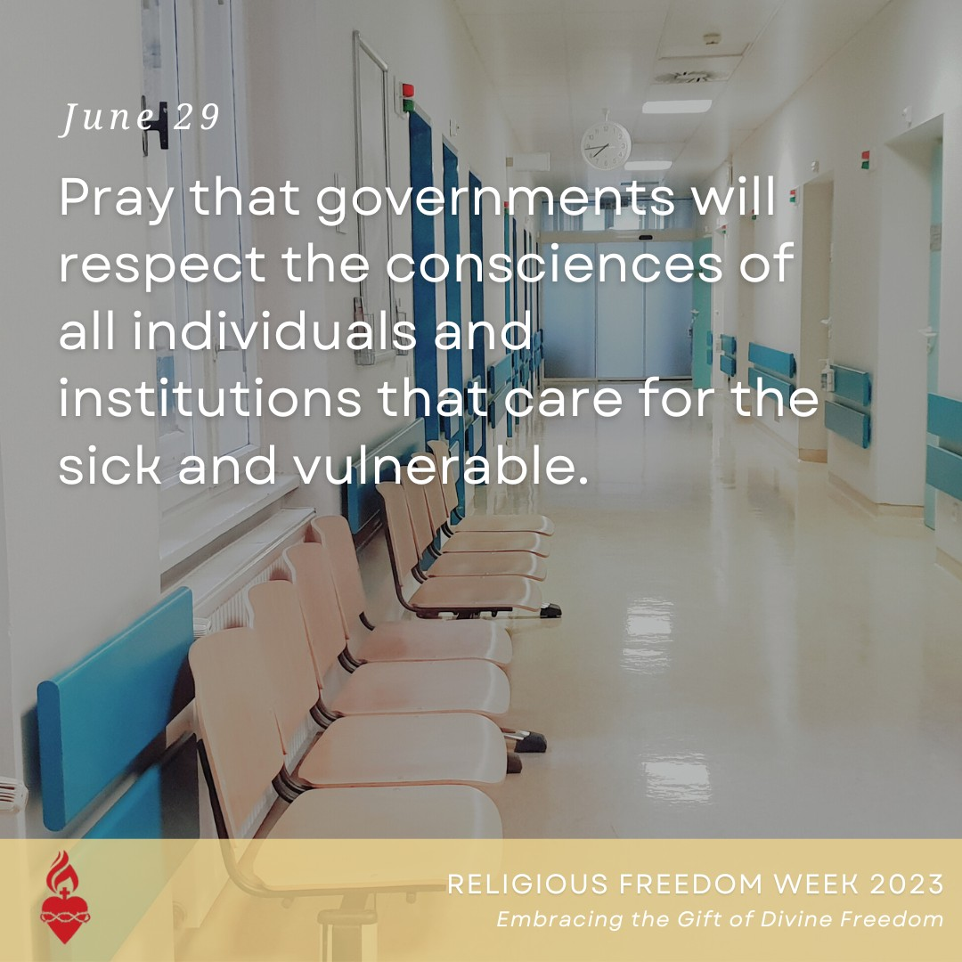
RELIGIOUS FREEDOM WEEK - JUNE 29

Recently, activists have sought to undermine the Church’s mission by forcing Catholic hospitals to perform procedures that destroy human life and undermine human dignity, such as sterilization, gender reassignment surgery and even abortion. People of faith who work in secular institutions may find themselves coerced into performing these procedures, or face unemployment.

Over the past year, the government proposed a cascade of changes to federal regulations, many of which removed conscience protections from healthcare institutions and individuals. We pray for a culture that respects the rights of hospitals and professionals who seek to carry out the healing ministry of Christ.
#religiousfreedom #betruthful
Graphic: June 29 Pray that governments will respect the consciences of all individuals and institutions that care for the sick and vulnerable. Religious Freedom Week 2023 Embracing the Gift of Divine Freedom

NFP AWARENESS WEEK - JULY 23-29

The privilege of husband and wife to bring new life into the world is a gift from God — a sacred responsibility through which they participate in God's creative power. Natural Family Planning (NFP) helps couples understand the beauty of their union by defining the scientific, natural and moral aspects of family planning that allow couples either to achieve or postpone pregnancy.

Stay tuned this week for more information about various methods of Natural Family Planning, and resources to accompany you on your journey.
#NFPweek #marriage
Graphic: Natural Family Planning Week July 23-29, 2023 Called to the Joy of Love #NFPweek

PAGE | 12
SOCIAL MEDIA POST

NFP AWARENESS WEEK

Have you ever heard of Creighton Model FertilityCare Method or the Billings Ovulation Method? Both types of NFP fall under the category of cervical mucus methods. Swipe to learn more about these types of Natural Family Planning.

#NFPweek #marriage
Graphic: What are the Cervical Mucus Methods? Called to the Joy of Love #NFPweek

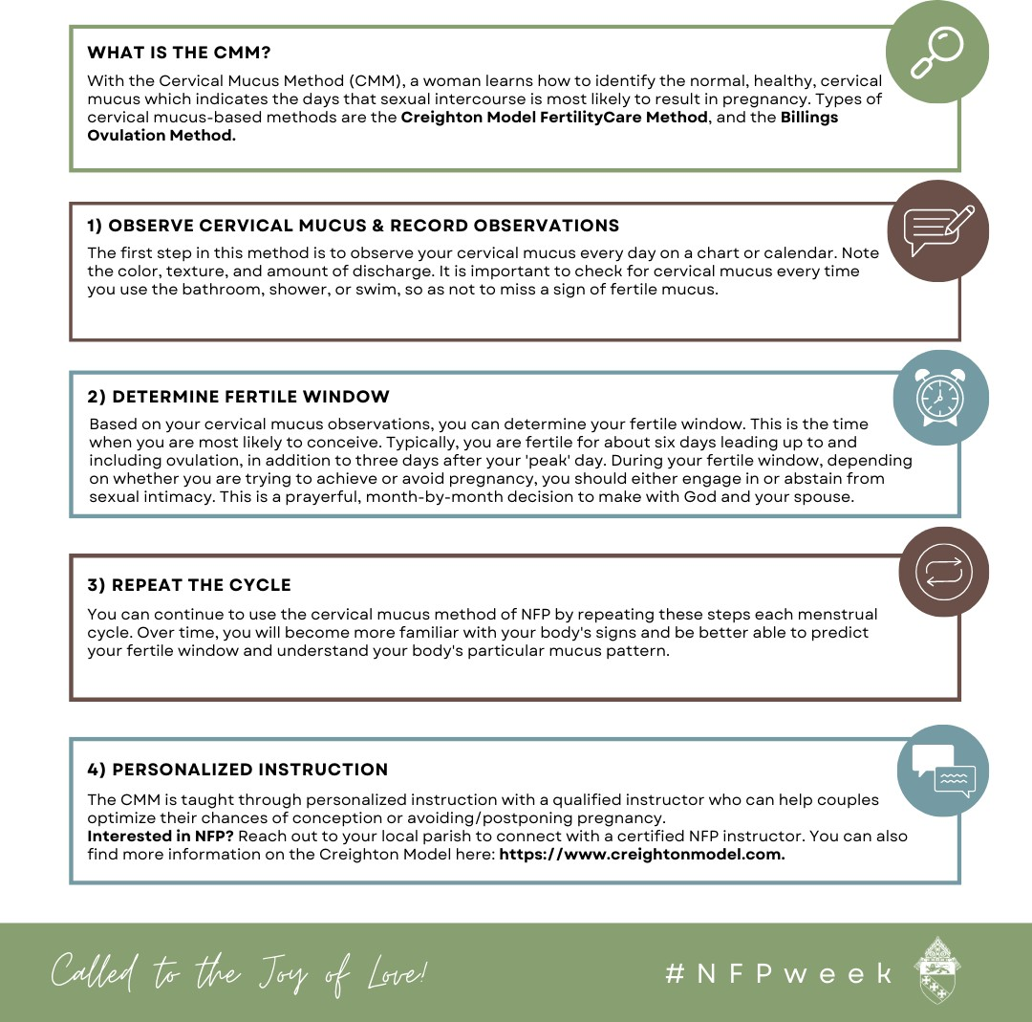

PAGE | 12
SOCIAL MEDIA POST

NFP AWARENESS WEEK

Have you heard of the Couple to Couple League or Northwest Family Services Method? Both of these methods of NFP fall under the category of sympto-thermal methods. Swipe to learn more about these types of Natural Family Planning.

#NFPweek #marriage
Graphic: What are the Sympto-Thermal Methods? Called to the Joy of Love #NFPweek

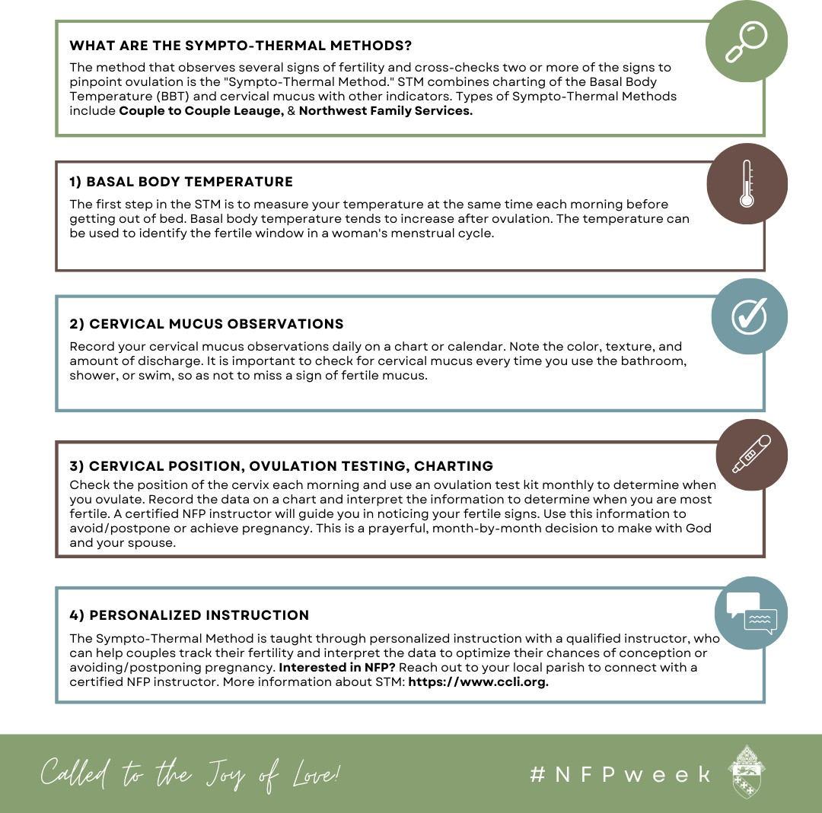

PAGE | 13
SOCIAL MEDIA POST

NFP AWARENESS WEEK

Have you ever heard of the Marquette Model of NFP? This type of Natural Family Planning falls into the symto-hormonal category. Swipe to learn more about this type of NFP.

#NFPweek #marriage
Graphic: What are the Sympto-Hormonal Methods? Called to the Joy of Love! #NFPweek

