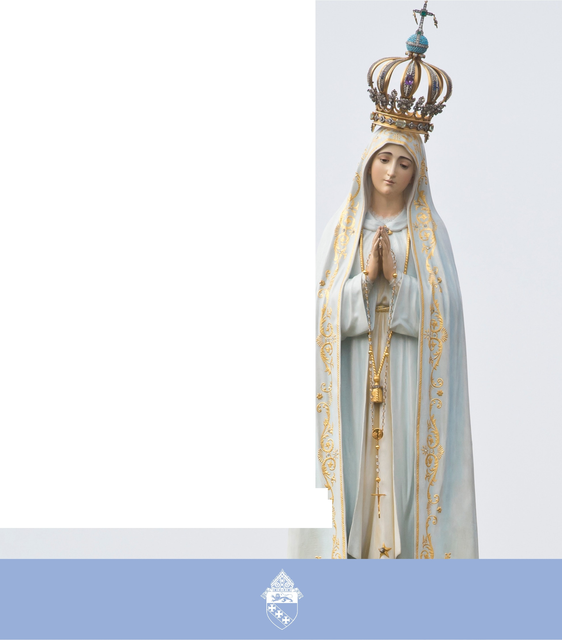

SOCIAL MEDIA TOOLKIT

MAY
MONTH OF MARY ?�
p.

PREPARED BY THE OFFICE OF COMMUNICATIONS

OVERVIEW
OVERVIEW
PAGE | 02

In an effort to better serve the parishes and ministries of South Carolina, the Diocese of Charleston is releasing a media toolkit each month with social media assets to promote a monthly theme across the state. This coming month, May, is the Month of Compassion.

As we reflect on the compassionate heart of Mary, all parishes are encouraged to share and amplify the message #BeCompassionate across their own social platforms with the help of the toolkit below.

OBJECTIVES

The objectives for this month’s campaign are to: Highlight special saint feast days
Highlight Marian feasts
Inform and inspire the faithful with guides for a fruitful Easter season

STEPS

- DOWNLOAD the photo by right clicking an image below to save it onto your desktop. You can also simply drag it onto your desktop.
- LOG ON to your favorite social media site, such as Facebook, Twitter or Instagram.
- COPY & PASTE one of the sample captions below into your status update — or create your own message that includes the #BeCompassionate hashtag.
- UPLOAD the #BeCompassionte image saved to your desktop to accompany your status update.
- POST your status update and encourage others to join the initiative through liking, sharing, reposting and tagging others!

PAGE | 03
SOCIAL MEDIA POSTS

SOCIAL MEDIA POSTS

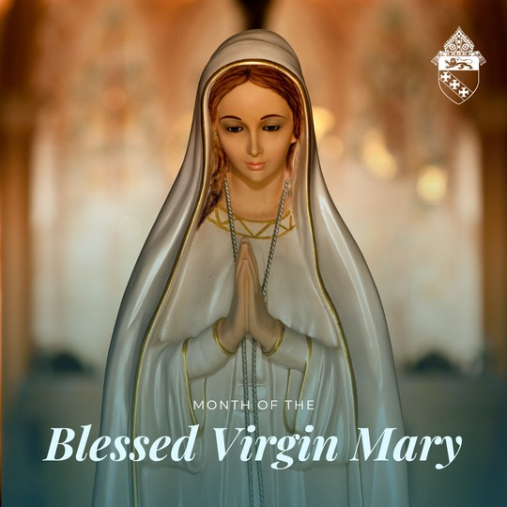
MONTH OF THE BLESSED VIRGIN MARY

During May, the Month of Mary, the Church invites us to pray the rosary, attend Masses dedicated to our Mother and participate in other devotions to honor her. Some parishes also hold May Crowning ceremonies in which a statue of Mary is crowned with flowers as a symbol of her queenship.

May is a time to reflect on the life and virtues of Mary, her model to us of humility, obedience and trust in God. It is also a time to ask for her intercession in our lives and to deepen our relationship with her as our spiritual mother.

The Month of Mary is a beautiful opportunity for Catholics to draw closer to the Queen of Heaven and to honor her as the Mother of God.

#becompassionate #maycrowning
Graphic: Month of the Blessed Virgin Mary

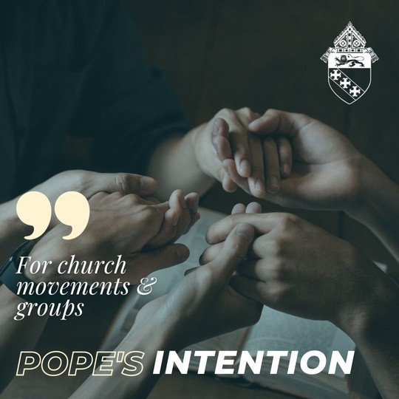
POPE'S INTENTION - MAY

This month, in unity with Pope Francis, we pray that Church movements and groups may rediscover their mission of evangelization each day, placing their own charisms at the service of needs in the world.

#popesintention #becompassionate
Graphic: For church movements & groups
Pope’s Intention

PAGE | 04
SOCIAL MEDIA POST

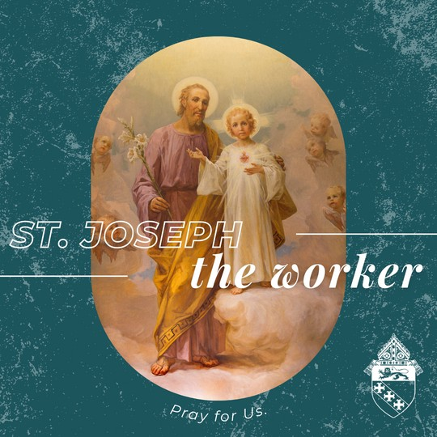
FEAST OF ST. JOSEPH THE WORKER - MAY 1

Today we honor the life and work of St. Joseph, the earthly father of Jesus. Joseph is the patron of workers, carpenters and fathers.

The celebration of this feast reminds us of the dignity of work and the importance of treating workers with respect and fairness. We ask for St. Joseph's intercession and blessings on all those who work to earn a living for themselves and their families.

St. Joseph, pray for us!
Graphic:
St. Joseph the worker
Pray for us.

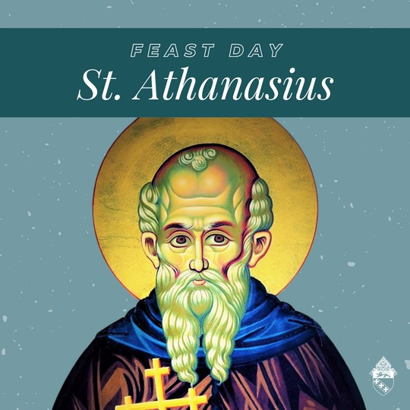
FEAST OF ST. ATHANASIUS - MAY 2

A blessed feast of St. Athanasius, a bishop and theologian who lived in Egypt during the fourth century AD. He played a significant role in the early Christian Church by defending the doctrine of the Trinity and combating the Arian heresy.
St. Athanasius was exiled several times for his beliefs but remained steadfast in his conviction.

He is a Doctor of the Church and his writings on theology, such as the "Incarnation of the Word," are still studied by scholars today. St. Athanasius, pray for us, that we may be bold in defending the faith.
Graphic: Feast Day St. Athanasius

PAGE | 05
SOCIAL MEDIA POST

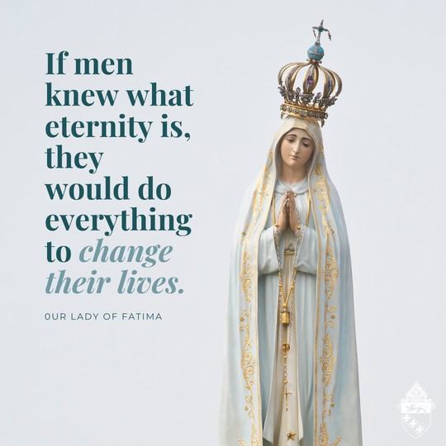
OUR LADY OF FATIMA - MAY 13

Today we celebrate the feast of our Lady of Fatima, who appeared to three shepherd children in Portugal in 1917. Her message of prayer, penance and reparation still guides us today. May we center our lives around Christ and seek Our Lady of Fatima's intercession in our daily lives.

#OurLadyofFatima #Prayer #Penance #Reparation
Graphic: If men knew what eternity is, they would do everything to change their lives. Our Lady of Fatima

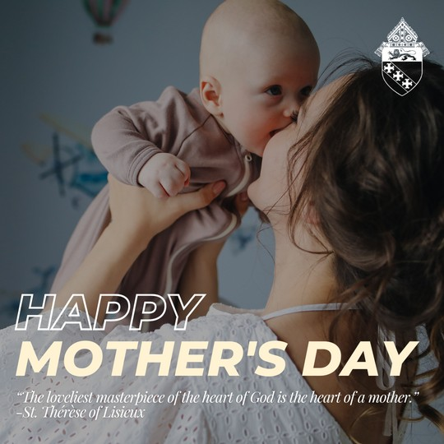
MOTHER'S DAY - MAY 14

Happy Mother's Day! Today, we honor all mothers, both biological and spiritual, who carry out their vocation as a beautiful reflection of the nurturing and compassionate love of God.

Thank you to all mothers for your sacrifice, strength and grace. Blessed Virgin Mary, our heavenly mother, pray for us!

#mothersday #becompassionate
Graphic: Happy Mother’s Day
“The loveliest masterpiece of the heart of God is the heart of a mother.” – St. Therese of Lisieux

PAGE | 06
SOCIAL MEDIA POST

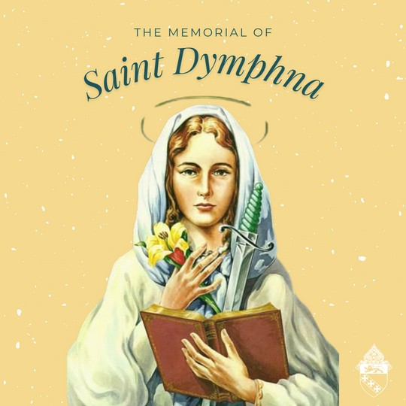
ST. DYMPHNA - MAY 15

St. Dymphna, patron of those who suffer from mental illness or emotional distress, pray for us!

#feastday #becompassionate
Graphic: The memorial of Saint Dymphna

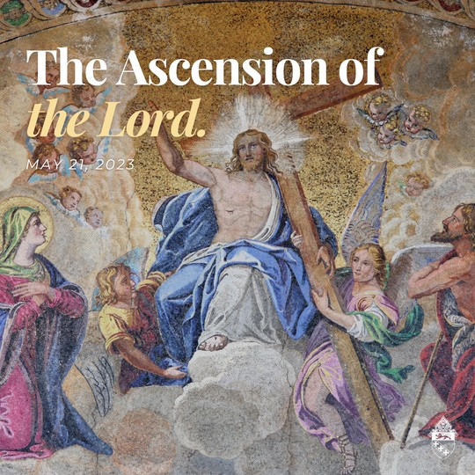
THE ASCENSION OF THE LORD - MAY 21

Today we celebrate the Solemnity of the Ascension of the Lord, which marks the physical, bodily raising of Jesus into heaven. The ascension powerfully signifies Christ's victory over death and his reign over all creation. Today also marks the beginning of the waiting period for the coming of the Holy Spirit at Pentecost.

#ascension #easterseason
Graphic: The Ascension of the Lord
May 21, 2023

PAGE | 07
SOCIAL MEDIA POST

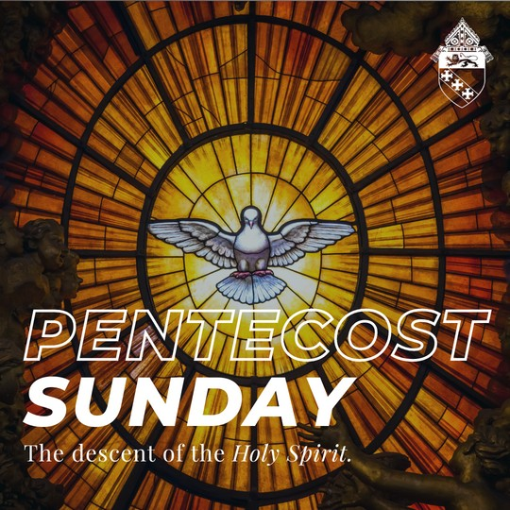
PENTECOST SUNDAY - MAY 28

The word Pentecost comes from the Greek word pentekostos, which means "fiftieth," referring to the 50 days after Easter. Today we celebrate the descent of the Holy Spirit upon the 12 Apostles, the Blessed Mother and other followers of Jesus. Pentecost is the birth of the Church, which was empowered and guided by the Holy Spirit. The apostles, who were previously fearful and uncertain, were transformed into bold and charismatic leaders who spread the teachings of Jesus throughout the world.

Holy Spirit, come into our Church and our hearts, just as you did on the first Pentecost and enliven us to live out the Gospel without fear.
Graphic: Pentecost Sunday
The descent of the Holy Spirit.

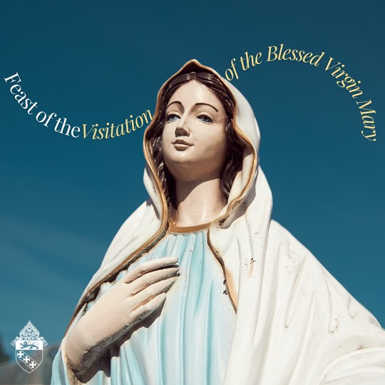
THE VISITATION OF THE BLESSED VIRGIN MARY - MAY 31

Today we celebrate the feast of the visitation of the Blessed Virgin Mary, when Mary visited her cousin Elizabeth. From the beautiful account of this meeting in the Gospel of Luke (1:46-55), we receive the Magnificat, or the Canticle of Mary, where she gives glory to God for the miracle she carries within her womb. Let us follow Mary's example of complete acceptance of God's will and joyfully share the love of Christ with those around us.

#FeastOfTheVisitation #BlessedVirginMary
Graphic: Feast of the Visitation of the Blessed Virgin Mary

