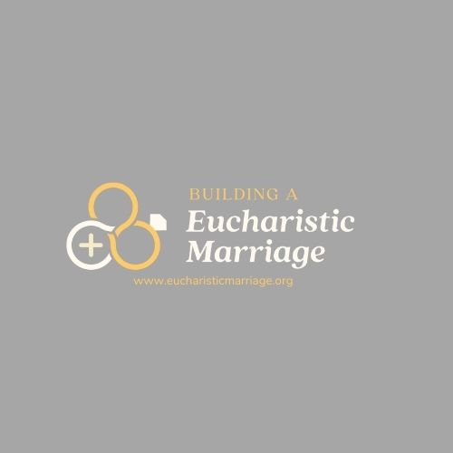
Building a Eucharistic Marriage – Building a Eucharistic Marriage is a 7-part online video series that connects 7 areas for therapeutically strengthening your marriage with 7 areas of deepening your relationship with Christ through the Eucharist. There are options for couples who want to purchase an individual copy for home use or for parishes who would like to purchase a license for running the video series at their parish. The Parish License comes with a leaders’ guide, unlimited participant guides, as well as advertising options and participant discounts on their own copy of the program.

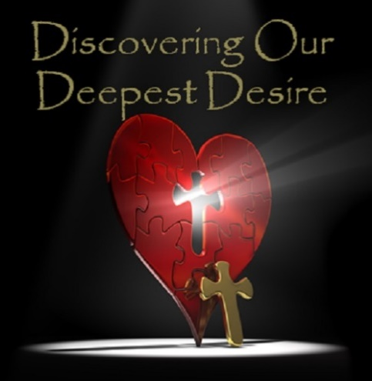
Discovering Our Deepest Desire – Discovering our Deepest Desire is a curriculum designed for all couples, from those with strong marriages to those who are struggling. Designed by marriage therapist, Greg Schutte, LISW-S, it is built off of a therapeutic model for change. Infused with Scripture, Catechism, marriage enrichment skills, as well as concepts from the Theology of the Body, the classes are designed to be interactive, informative, and fun. Written in 2013, the marriage curriculum has been implemented in numerous churches. The program works to build marriage teams in parishes while presenting the enrichment curriculum to couples. The DODD curriculum can be presented over 12 sessions, 7 sessions, or an extended weekend.

