PREPARED BY THE OFFICE OF COMMUNICATIONS

OVERVIEW
OVERVIEW
PAGE | 02

In an effort to better serve the parishes and ministries of South Carolina, the Diocese of Charleston is releasing a media toolkit each month with social media assets to promote a monthly theme across the state. This coming month, April, is the Month of Sustenance.

As we reflect on what it means to be sustained by Christ, all parishes are encouraged to share and amplify the message #BeSustained across their own social platforms with the help of the toolkit below.

OBJECTIVES

The objectives for this month’s campaign are to: Highlight special feast days
Provide Lenten & Easter Resources
Inform and inspire the faithful with guides for a fruitful Holy Week & Easter

STEPS

- DOWNLOAD the photo by right clicking an image below to save it onto your desktop. You can also simply drag it onto your desktop.
- LOG ON to your favorite social media site, such as Facebook, Twitter or Instagram.
- COPY & PASTE one of the sample captions below into your status update — or create your own message that includes the #BeSustained hashtag.
- UPLOAD the #BeSustainedimage saved to your desktop to accompany your status update.
- POST your status update and encourage others to join the initiative through liking, sharing, reposting, and tagging others!

PAGE | 03
SOCIAL MEDIA POSTS

SOCIAL MEDIA POSTS

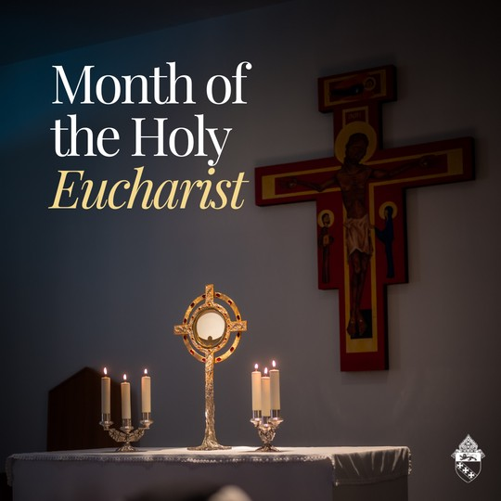
MONTH OF THE HOLY EUCHARIST

April is the month of the Holy Eucharist, a month dedicated to spreading the truth that Jesus Christ is fully present and available in the bread of life we see inside a monstrance.

Make a holy hour this month, invite a friend to adoration, or attempt daily Mass to center your life more around Christ.

#besustained

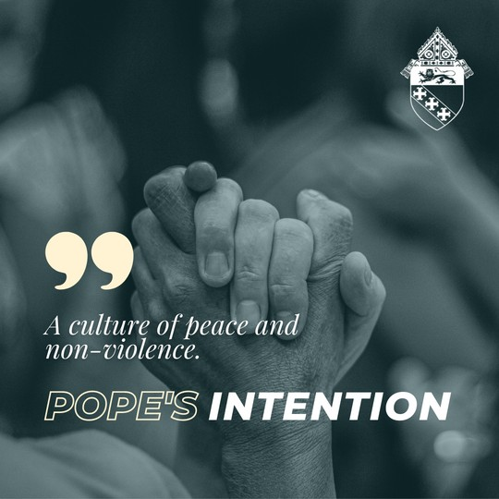
POPE'S INTENTION - APRIL

This month, in unity with Pope Francis, we pray for the spread of peace and non-violence.

#popesintention #besustained

PAGE | 04
SOCIAL MEDIA POST

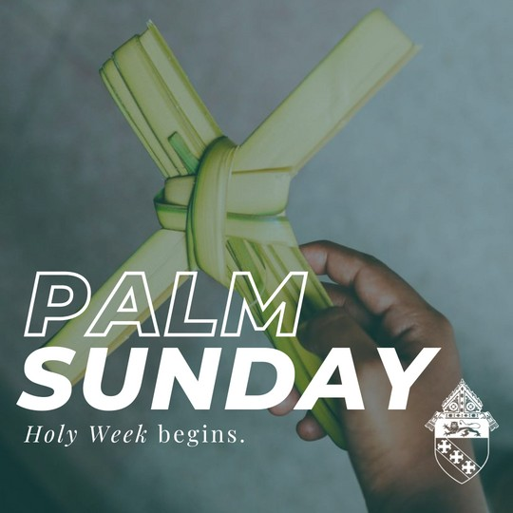
PALM SUNDAY - APRIL 2

"Rather, he emptied himself, taking the form of a slave, coming in human likeness; and found human in appearance, he humbled himself, becoming obedient to the point of death, even death on a cross." // Philippians 2:7-8

How can you 'empty yourself' out for love of God as you enter into Holy Week?

#besustained

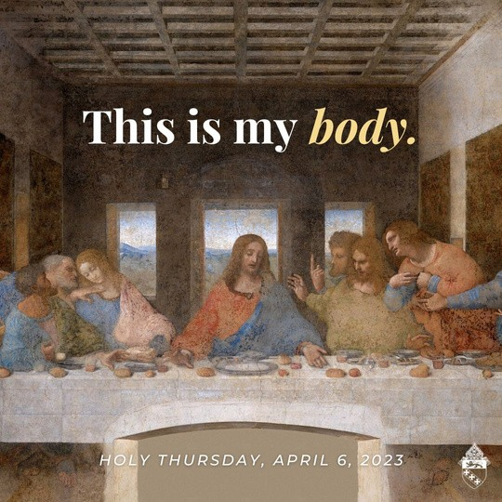
HOLY THURSDAY - APRIL 6
On Holy Thursday, we celebrate the institution of the Eucharist as the true body and blood of Jesus Christ and the institution of the priesthood.

During the Last Supper, Christ offered Himself as the sacrificial Lamb and showed each ordained priest how to offer the same sacrifice.

May today be a reminder of Jesus' abiding presence with us through his real presence in the Eucharist.

#holythursday #truepresence

PAGE | 05
SOCIAL MEDIA POST

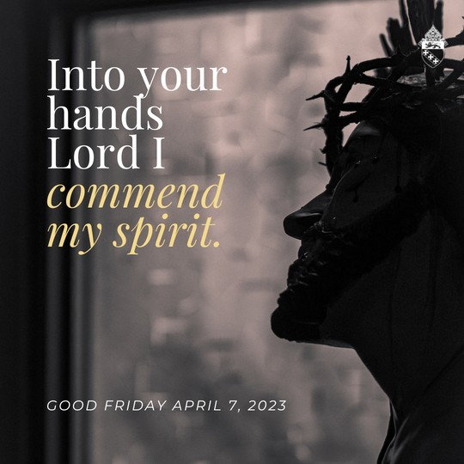
GOOD FRIDAY - APRIL 7

"When Jesus had taken the wine, he said, “It is finished.” And bowing his head, he handed over the spirit." // John 19:30

Today, reflect on His sacrificial death - all for love of you.

#goodfriday #besustained

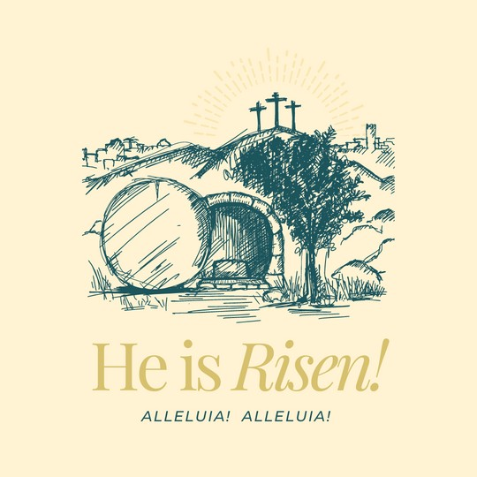
EASTER SUNDAY - APRIL 9

Happy Resurrection Sunday from the Diocese of Charleston! May the glory of Christ's resurrection reign in your lives this Easter season.

"We are the Easter people and Alleluia is our song!" // Pope John Paul II

#besustained

PAGE | 06
SOCIAL MEDIA POST

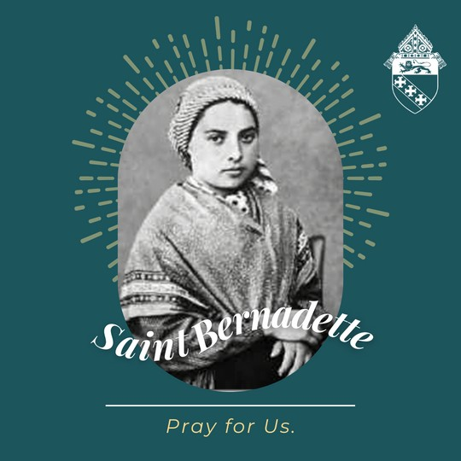
ST. BERNADETTE - APRIL 16

Part of a poor, but happy family, St. Bernadette's life changed forever when she encountered a woman “so lovely that, when you have seen her once, you would willingly die to see her again!" The Blessed Virgin appeared in a series of apparitions where she conveyed several messages about her desires for humanity to return to her Son.

Lourdes is now the site of over 7,000 healings, 69 that the Church officially recognizes as miracles. St. Bernadette's incorrupt body can be seen today, at the chapel of St. Gildard in Nevers, France.

St. Bernadette, pray for us! #besustained

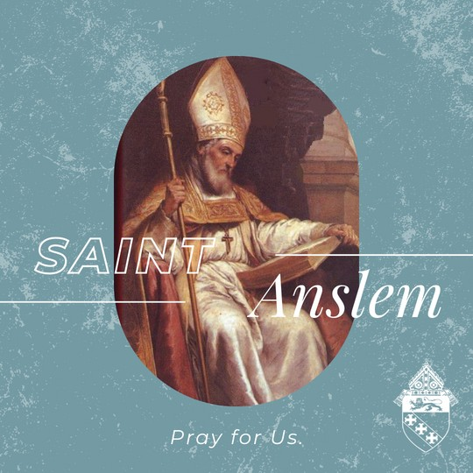
ST. ANSLEM - APRIL 21

St. Anlsem (1033 - 1109) was a Benedictine monk, Christian philosopher, and scholar who is recognized for many intellectual accomplishments, including his definition of theology as "faith seeking understanding." St. Anslem, pray for us!

PAGE | 07
SOCIAL MEDIA POST

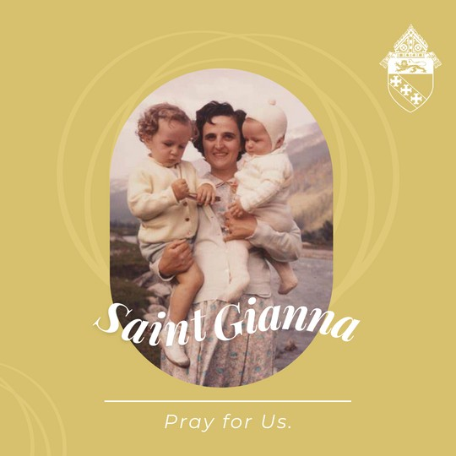
ST. GIANNA - APRIL 28

A blessed feast of St. Gianna! Gianna Beretta Molla was a pediatric physician, wife and mother. She graduated from the University of Pavia, Italy, in 1952 and earned degrees in medicine and surgery. Gianna married Pietro Molla, and they had three children in four years. Two pregnancies followed which ended in miscarriage. Early in her final pregnancy, doctors discovered a tumor in her uterus.
Gianna allowed the surgeons to remove it, but not complete the entire procedure because it would have killed her baby. She gave birth to Gianna Emanuela Molla in April of 1962.
Postoperative complications caused an infection that led to the saint’s death. Gianna Molla was beatified in 1994 and canonized 10 years later. She is the patron of mothers, physicians and unborn children.

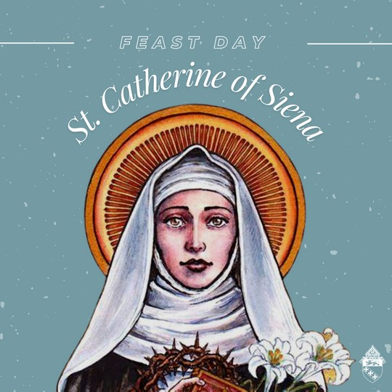
ST. CATHERINE OF SIENA - APRIL 29

A blessed Feast of St. Catherine of Siena, a mystic, spiritual writer and doctor of the Church. St. Catherine, pray for us!

#feastday #besustained

