MONTH OF TRANSFORMATION

PREPARED BY THE OFFICE OF COMMUNICATIONS

OVERVIEW

In an effort to better serve the parishes and ministries of South Carolina, the Diocese of Charleston is releasing a media toolkit each month with social media assets to promote a monthly theme across the state. This coming month, March, is the Month of Transformation.

As we reflect on what it means to love, all parishes are encouraged to share and amplify the message #BeTransformed across their own social platforms with the help of the toolkit below.

OBJECTIVES

The objectives for this month’s campaign are to: Highlight special feast days
Provide Lenten Resources
Inform and inspire the faithful with guides for a fruitful Lent

STEPS

- DOWNLOAD the photo by right clicking an image below to save it onto your desktop. You can also simply drag it onto your desktop.
- LOG ON to your favorite social media site, such as Facebook, Twitter or Instagram.
- COPY & PASTE one of the sample captions below into your status update — or create your own message that includes the #BeTransformed hashtag.
- UPLOAD the #BeTransformed image saved to your desktop to accompany your status update.
- POST your status update and encourage others to join the initiative through liking, sharing, reposting, and tagging others!

SOCIAL MEDIA POSTS

LENT - PRAYER
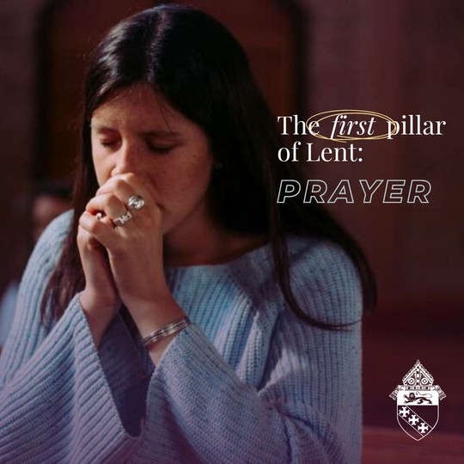
During Lent, we are called to deny ourselves and foster virtue, to grow closer to Christ, to create habits that improve our spiritual lives and increase our love for God and neighbor through prayer, fasting and giving.

In prayer, we are united with our Creator. It is necessary for us to pray, so that we learn to trust God’s will in our lives. This Lent, think about how you can add to your prayer life. Consider saying a quick Hail Mary between daily activities or pray the rosary during your commute. Give up unnecessary internet use to make time to enter into silent prayer each day. Of course, make it a priority to frequent the sacraments. The list is endless of things we can detach ourselves from to make time for prayer.

This Lent, let us pray for the grace to spend time in prayer growing closer to the Lord. #lentenjourney #betransformed

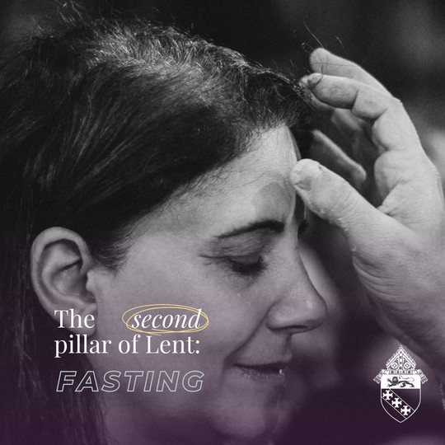
LENT - FASTING
When we fast, we deny ourselves things that we want, but do not need. For example, we can fast from unnecessary internet use or complaining.

The benefits of fasting, when done for love of God, are two-fold: spiritual and physical. When we fast, we intentionally take on discomfort for the sake of our souls, and the souls for whom we offer our sacrifices.

Fasting helps us recognize our reliance on God and our limited nature. Catholics are called to abstain from meat each Friday during Lent, and fast and abstain on Ash Wednesday and Good Friday.

What are you fasting from this Lent to grow closer to the Lord? Let us know in the comments!

#lentenjourney #betransformed

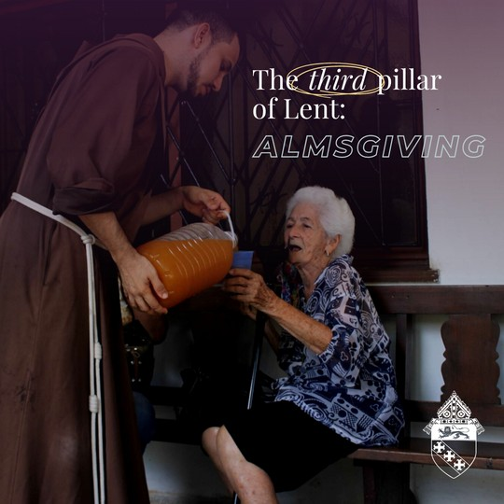
LENT - ALMSGIVING

When we give alms, we remember the parable of the poor widow from the Gospel of Mark (12:40-44). Jesus describes the woman giving away her only coins to the Temple’s treasury.

Like her, we are called to give not only of our money, but also our time and resources to benefit those who are most in need.

“A life without generosity, without giving of ourselves for another, is a dead life.”
// Bishop Jacques Fabre-Jeune, CS

#lentenjourney #betransformed

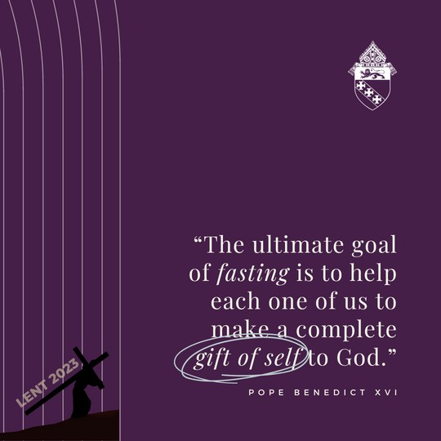
LENT

"The ultimate goal of fasting is to help each one of us to make a complete gift of self to God." // Pope Benedict XVI

#lentenjourney #betransformed

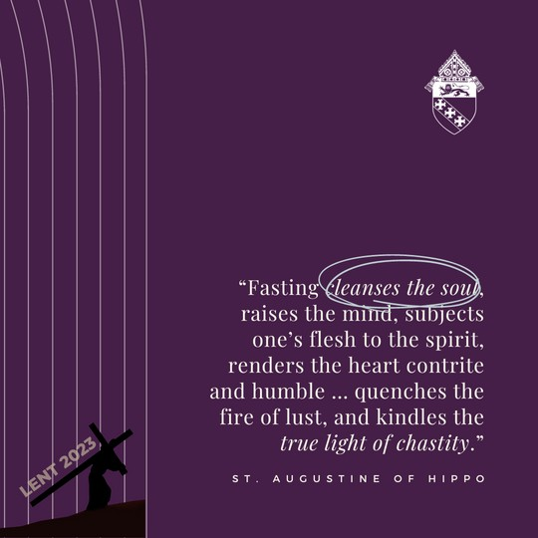
LENT

Fasting, when offered for love of God, is a sure way to grow closer to his heart.

#lentenjourney #betransformed

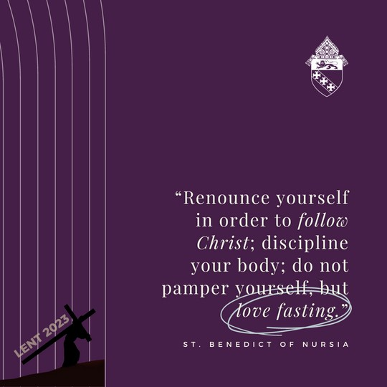
LENT

St. Benedict of Nursia pray for us, that we too may take up our cross to follow Christ!

#lentenjourney #betransformed

ST. KATHARINE DREXEL - MAR 3
"All is vanity except knowing, loving and serving God." // St. Katharine Drexel

Katharine was born in 1858 and grew up in a family of deep faith. At a young age, she felt called to the contemplative life. Her spiritual director recommended that she start a religious order to serve marginalized peoples, so she formed the Sisters of the Blessed Sacrament, which served Indigenous and Black people in the United States.

Her order spread rapidly, spanning 17 states, despite the trials of the Great Depression and World War II. She died March 3, 1955, at age 96. St. Katharine Drexel, pray for us!

#lentenjourney #betransformed

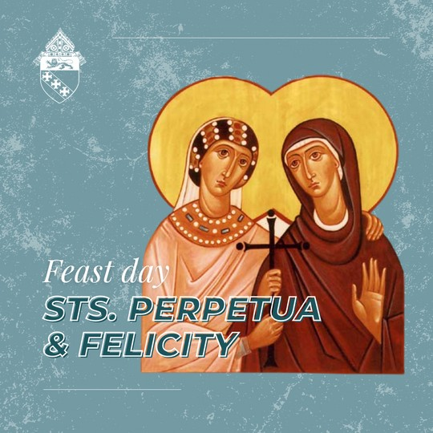
STS. PERPETUA & FELICITY - MAR 7

Sts. Perpetua and Felicity, martyrs for the faith, pray for us!

#feastday #betransformed #lentenjourney

POPE'S INTENTION - MARCH

This month, Pope Francis asks that we pray for victims of abuse. We pray that those who have suffered harm from members of the Church may find within the Church a concrete response to their pain and suffering.

#lentenjourney #betransformed

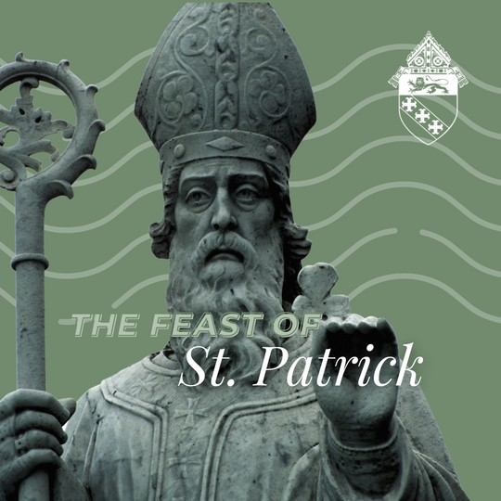
FEAST OF ST. PATRICK - MAR 17

A blessed feast of St. Patrick!

At age 14, Patrick was captured by pirates and taken to Ireland as a slave. He was finally able to escape captivity at age 20.

While back in Britain, he was ordained a priest and then bishop. He chose to return to Ireland, and in just 40 years converted the country to Catholicism.

St. Patrick, pray for us, that we may have your zeal for mission and for Christ!

#feastday #lentenjourney #betransformed

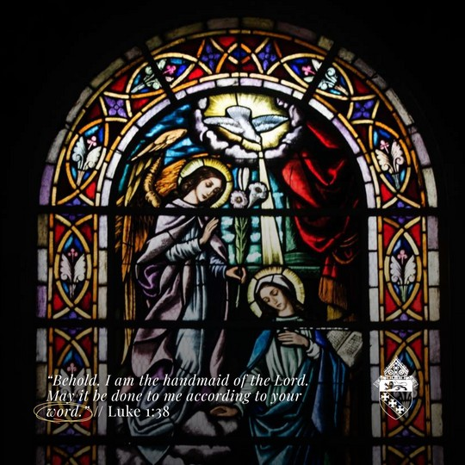
SOLEMNITY OF ANNUNCIATION OF LORD - MAR 25

A blessed Solemnity of the Annunciation of the Lord! Today, we celebrate Mary's perfect "yes" to being the God-bearer, or Theotokos.

May we strive to emulate the Blessed Mother's perfect humility and obedience to the will of God.

#feastday #betransformed #lentenjourney

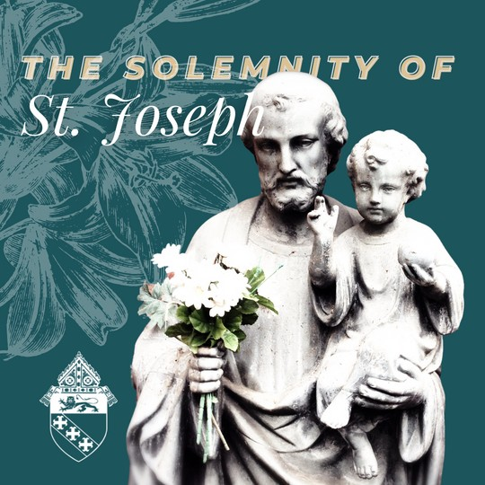
SOLEMNITY OF ST. JOSEPH - MAR 20

Today is the Solemnity of St. Joseph!

St. Joseph, spouse of the Blessed Virgin Mary and foster-father of Christ, was a working man who practiced as a carpenter to provide for the Holy Family.

He is the patron saint of a happy death, workmen, immigrants and the Universal Church. He will guard us as he guarded the Holy Family.

St. Joseph, pray for us!

#feastday #betransformed #lentenjourney

FIRST SUNDAY OF LENT - FEB 26

Lent is a time to purify ourselves of earthly attachments, repent and turn back to Christ.

Each Sunday of Lent, we will post a weekly challenge as inspiration to take up your cross and grow in holiness.

This week, plan to make a holy hour to talk with the Lord about what areas of your life you can surrender to him this Lent.

#lentenjourney #betransformed

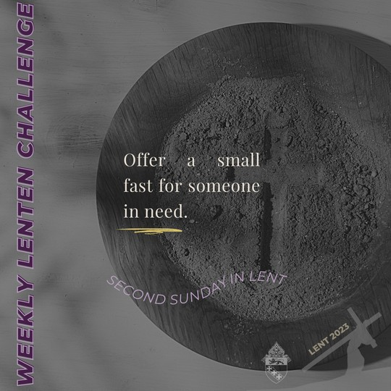
SECOND SUNDAY OF LENT - MAR 5

It's the Second Sunday of Lent. Offer a small fast for someone in need this week.

Specifically, try to offer a sacrifice for someone who has wronged you, or with whom you are in disagreement, that you both may be transformed.

#lentenjourney #betransformed

THIRD SUNDAY OF LENT - MAR 12

This week, aim to make no unnecessary purchases and donate the money you would have spent on nonessentials to charity.

#lentenjourney #betransformed

FOURTH SUNDAY OF LENT - MAR 19

This week during Lent, invite someone to attend Mass with you.

Christ calls us to boldly "make disciples." Be open to how the Holy Spirit desires to use you in building the Church today.

#lentenjourney #betransformed

FIFTH SUNDAY OF LENT - MAR 26

This week, watch a movie about the life of Christ. Some examples are The Chosen series, Jesus of Nazareth and The Passion of the Christ.

#lentenjourney #betransformed

