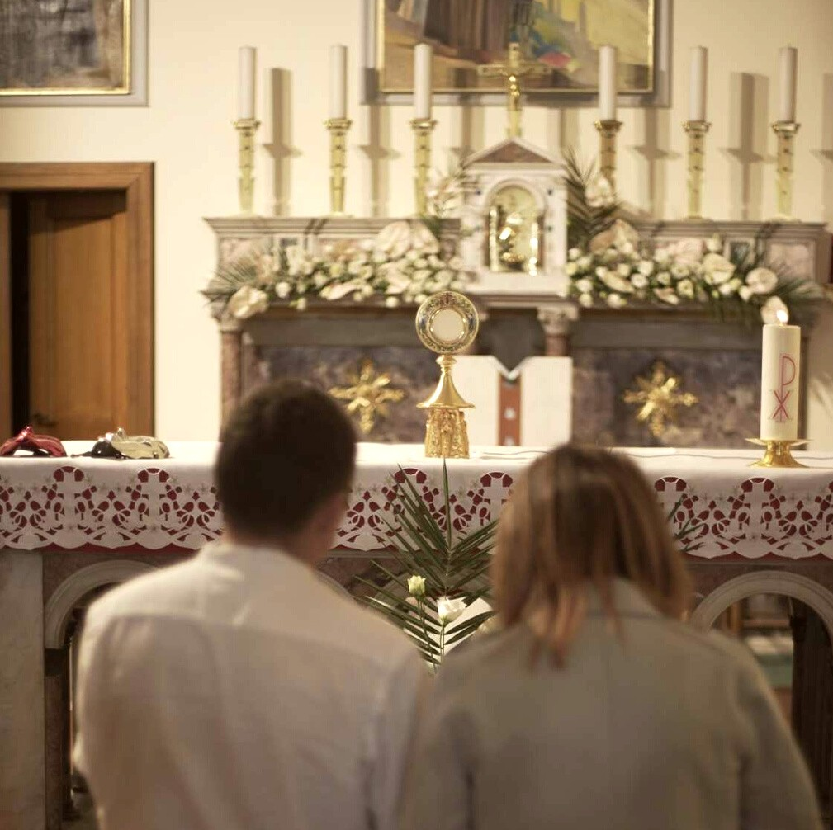

MONTH OF LOVE

PREPARED BY THE OFFICE OF COMMUNICATIONS

OVERVIEW

In an effort to better serve the parishes and ministries of South Carolina, the Diocese of Charleston is releasing a media toolkit each month with social media assets to promote a monthly theme across the state. This coming month, February, is the Month of Love & Lent.

As we reflect on what it means to love, all parishes are encouraged to share and amplify the message #BeLoved across their own social platforms with the help of the toolkit below.

OBJECTIVES

The objectives for this month’s campaign are to: Highlight special feast days
Prepare for Lent
Highlight Human Trafficking Awareness Month and Black History Month
Inform and inspire the faithful with Catholic inspiration to authentically love one another

STEPS

- DOWNLOAD the photo by right clicking an image below to save it onto your desktop. You can also simply drag it onto your desktop.
- LOG ON to your favorite social media site, such as Facebook, Twitter or Instagram.
- COPY & PASTE one of the sample captions below into your status update — or create your own message that includes the #BeLoved hashtag.
- UPLOAD the #BeLoved image saved to your desktop to accompany your status update.
- POST your status update and encourage others to join the initiative through liking, sharing, reposting, and tagging others!

SOCIAL MEDIA POSTS

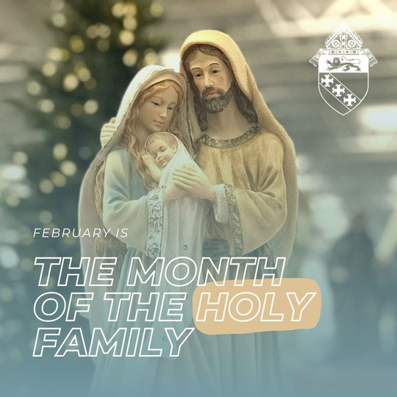
FEBRUARY

February is the Month of the Holy Family!

Family is the school of virtue for parents and their children. It is where we learn to love, pray and practice the gifts of charity and forgiveness. May we pray, through the intercession of the Holy Family, that God's grace will make us instruments of love and peace in our homes.

This month, try offering a family rosary for the intention of growing in holiness as a family.

#beloved

FEBRUARY

As we grow closer to God and grow in virtue, we realize what we were made for: to love God and love others.

We can only find ourselves, and find true happiness, once we make a complete gift of ourselves to God, and to those around us. #beloved

FEBRUARY

February is Black History Month, a time to honor our African American brothers and sisters in Christ, and their contributions and legacy across U.S. history and society. Please visit bit.ly/3GHKX9E for my information and events.

#blackhistorymonth #unitedinChrist

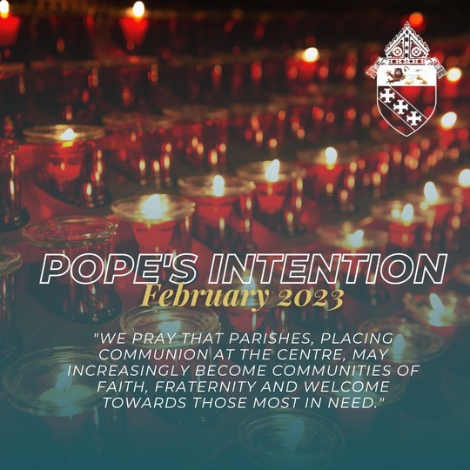
FEBRUARY

This month, Pope Francis invites us to pray for parishes, that they may place communion at the center, become communities of faith and fraternity, and that they would welcome those most in need.

#beloved

FEBRUARY

This February, as we celebrate love, may we look to the Lord's example of what love means. The world tells us that love only consists of feelings and emotions. God shows us that love requires action - willing the good of the other.

#beloved

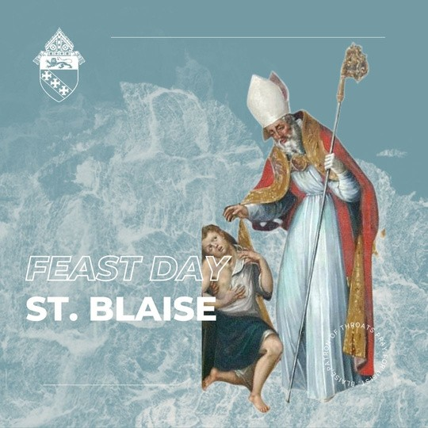
FEB 3

A blessed feast of St. Blaise! St. Blaise was a physician and Bishop of Sebaste who suffered martyrdom under Licinius in 316 AD.

St. Blaise is the patron saint of throat ailments, and on his feast day, many parishes have a blessing of the throats. The priest prays, "through the intercession of St. Blaise, bishop and martyr, may God deliver you
from every disease of the throat and from every other illness … "

St. Blaise, pray for us!

FEB 8

Feb. 8, the feast of St. Josephine Bakhita, is the International Day of Prayer & Awareness Against Human Trafficking. The Catholic Church has long spoken out against the evil that is human trafficking, stating that “slavery, prostitution, the selling of women and children, [and] disgraceful working conditions where [people] are treated as mere tools for profit, rather than as free and responsible persons.”

With more than 20 million victims globally, including in the United States, human trafficking is a grave attack on the dignity of every person. St. Josephine Bakhita, patron saint of human trafficking, pray for us.

#endtrafficking #freedomfirst

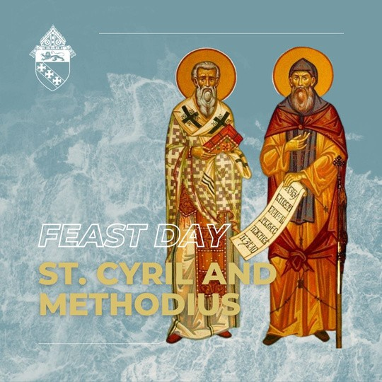
FEB 14

A blessed Feast of Sts. Cyril and Methodius! These brothers were known as the "Apostles of the Slavs" for their relentless work in spreading the Gospel throughout Eastern Europe in the ninth century. Sts. Cyril and Methodius, pray for us, that we too may have a zeal for spreading the Gospel!

#beloved #feastday

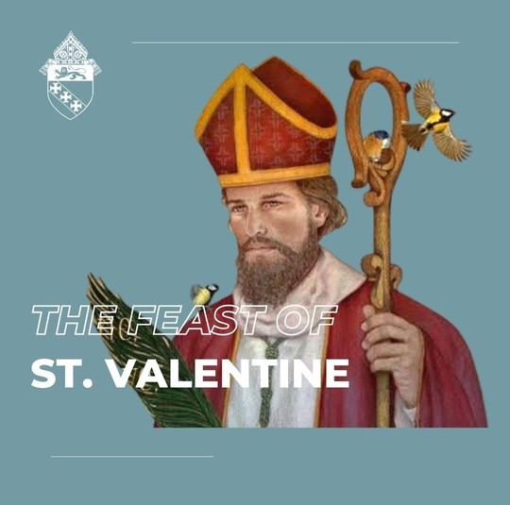
FEB 14

A blessed feast of St. Valentine, an early Church martyr who loved our Lord even to the point of death. While he is the patron saint of "courtly love," his martyrdom points to a greater love, that of the Sacred Heart — sacrificial, selfless and unconditional.

Let us live the words of Jesus, "This is my commandment: love one another as I have loved you. There is no greater love than this: to lay down one's life for one's friends" (Jn 15:12- 13).

St. Valentine fulfilled this command to love. May we do the same.

#beloved

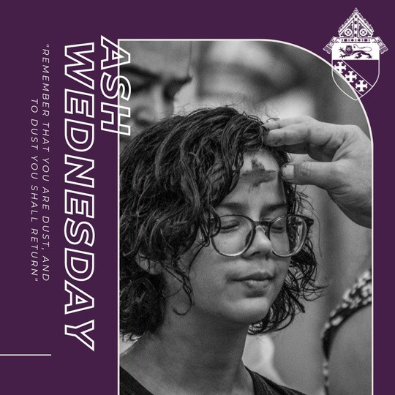
FEB 22

Ash Wednesday marks the start of the Lenten season: an opportunity for us to die to self, take up our crosses, and follow Jesus more closely.

We receive ashes to remember our sinfulness and mortality, and that death will come to each of us. However, death is nothing to fear when we place our faith in Christ, staying close to the sacraments and living according to God's will.

May we repent of sin, purify our desires and grow in holiness this Lent to celebrate Easter with abundant joy.

How are you drawing closer to Jesus this Lent? Let us know in the comments!

