JANUARY
MONTH OF RENEWAL

PREPARED BY THE OFFICE OF COMMUNICATIONS

OVERVIEW

In an effort to better serve the parishes and ministries of South Carolina, the Diocese of Charleston is releasing a media toolkit each month with social media assets to promote a monthly theme across the state. This coming month, January, is the Month of Renewal.

As we reflect on the New Year, all parishes are encouraged to share and amplify the message #BeRenewed across their own social platforms with the help of the toolkit below.

OBJECTIVES

The objectives for this month’s campaign are to:
Highlight Catholic School's Week and School Choice Week Highlight special feast days
Inform and inspire the faithful with Catholic inspiration for the New Year

STEPS

- DOWNLOAD the photo by right clicking an image below to save it onto your desktop. You can also simply drag it onto your desktop.
- LOG ON to your favorite social media site, such as Facebook, Twitter or Instagram.
- COPY & PASTE one of the sample captions below into your status update — or create your own message that includes the #BeRenewed hashtag.
- UPLOAD the #BeRenewed image saved to your desktop to accompany your status update.
- POST your status update and encourage others to join the initiative through liking, sharing, reposting, and tagging others!

SOCIAL MEDIA POSTS

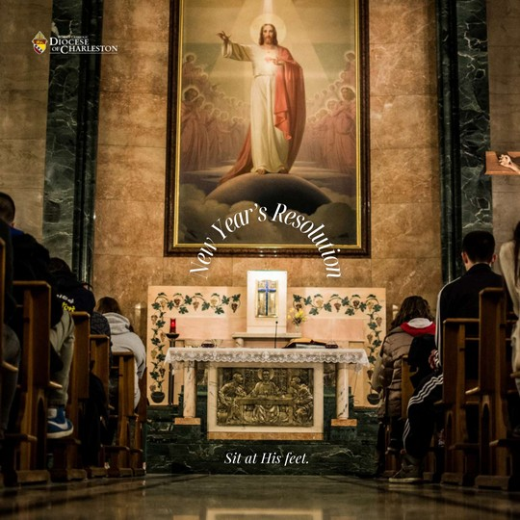
JAN 2023

The fulfillment you're seeking this New Year can only be found in the presence of Jesus.

Spend time with Him in adoration this year, and see how your life, and joy, transforms. #berenewed

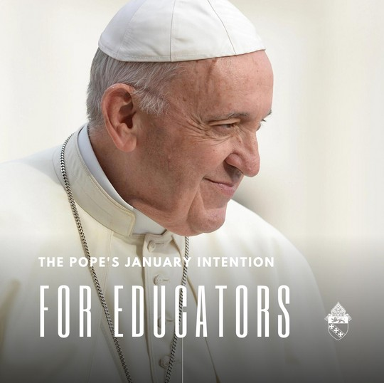
JAN 2023

This January, Pope Francis asks that we pray for all educators. We thank God for the irreplaceable role they hold in teaching the future of our Church. #berenewed

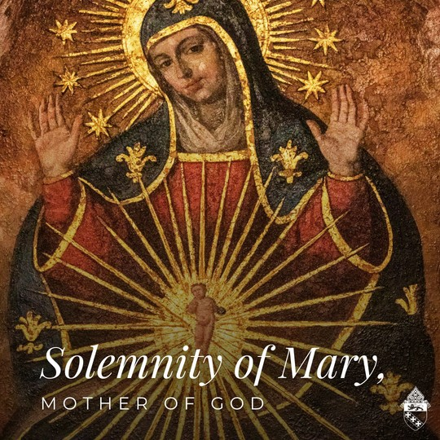
JAN. 1

Today, the octave of Christmas, is the Solemnity of Mary, the Mother of God, and a holy day of obligation.

This solemnity is a powerful reminder to the faithful of the role the Blessed Mother plays in our salvation. Christ's incarnation was made possible through Mary's initial yes, or "fiat." Mary, Mother of God, intercede for us, that we may be brought closer to your Son.

#berenewed

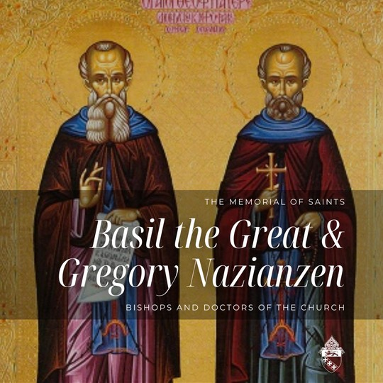
JAN. 2

St. Basil the Great and St. Gregory Nazianzen, both bishops and Doctors of the Church, were the backbone of Catholic Orthodoxy during a period of doctrinal struggle and confusion.
Gregory led the second ecumenical council, held in Constantinople, that produced the Nicene-Constantinople Creed that the Catholic Church recites each Sunday.

Sts. Gregory and Basil, pray for us!

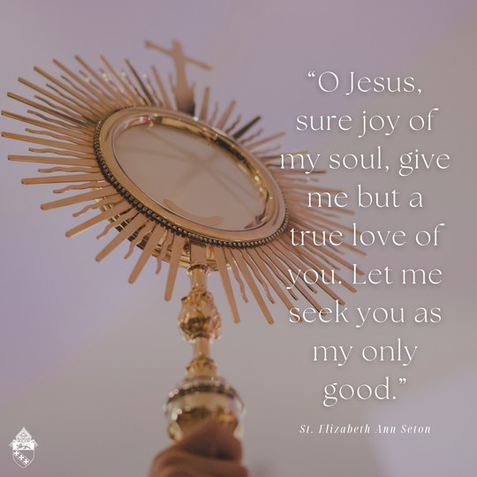
JAN. 4

"O Jesus, sure joy of my soul, give me but a true love of you. Let me seek you as my only good." St. Elizabeth Ann Seton, pray for us!

#berenewed

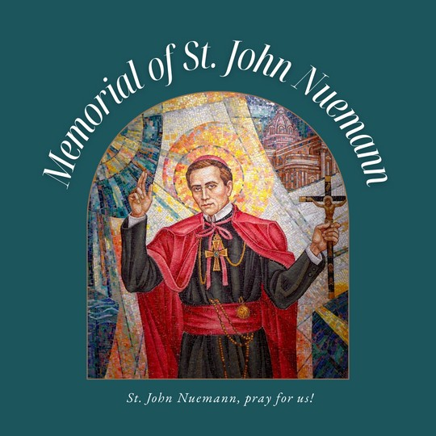
JAN. 5

"Fear not that thy life shall come to an end, but rather fear that it shall never have a beginning." -St. John Neumann

St. John Neumann, patron saint of Catholic education, pray for us!

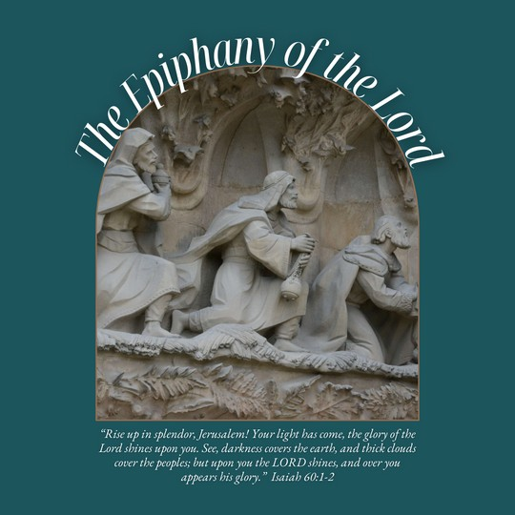
JAN. 8

A blessed Epiphany! The word "epiphany" comes from the Greek word epiphainen, which means "to shine upon," "to manifest," or "to make known." Thus, the Church celebrates the feast of the Epiphany to commemorate how Christ made himself known to us through the visit of the Magi, the Baptism of Jesus, and the miracle at Cana. It is customary to bless our homes and the people who dwell within them on the feast of the Epiphany. #berenewed

Follow the link to learn more about blessing your home: bit.ly/3OX22z5.

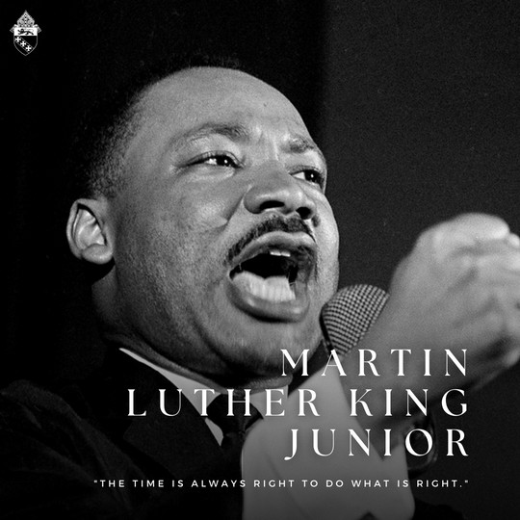
JAN. 16

Today, we honor the legacy of Martin Luther King, Jr., a Baptist minister who advocated for nonviolent means to end racial segregation.

Dr. King was the founder of the Southern Christian Leadership Conference and leader of the 1963 March on Washington. He was instrumental in passing the Civil Rights Act of 1964 and the Voting Rights Act of 1965.

King's legacy is a beacon of light and hope that every child of God will be treated with the dignity and value inherent to every human person.

#mlkday #equity #diversity

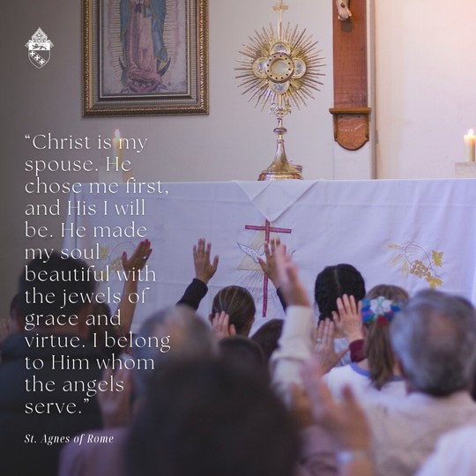
JAN. 21

A blessed feast of St. Agnes! She lived under the rule of Diocletian who, in 302, resolved to wipe out the Church in Rome. He burned sacred works, arrested clergy and demanded to be worshiped. St. Agnes was a beautiful young woman, and many suitors wished to marry her, but she committed herself to virginity and to being the spouse of Christ.

When a particular suitor was rejected, he reported her to the Roman authorities where she was tried and eventually beheaded. She could have spared her life by worshiping at a pagan alter, but she refused out of love for God.

St. Agnes, pray for us!

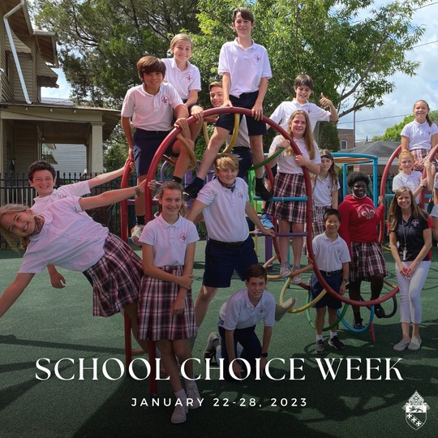
JAN. 22-28

School Choice Week: January 22-28, 2023

Every child deserves an education that meets their needs and challenges them to grow — this is why School Choice Week exists!

School choice is the process of allowing every family to choose the K-12 educational options that best fit their children. Because each student has his or her own unique set of talents, interests and challenges, having a variety of options in education is crucial. School choice ensures that each student can find a learning environment that inspires and creates success.

#schoolchioceweek2023 #catholiceducation

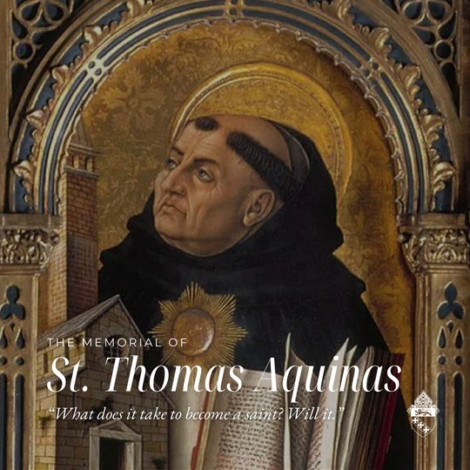
JAN. 28

A blessed Memorial of St. Thomas Aquinas! St. Thomas Aquinas showed that Catholicism exists between faith and reason and proved that there can be no contradiction between the two. He was canonized is 1323 and declared a doctor of the Church in 1567. St. Thomas Aquinas, pray for us.

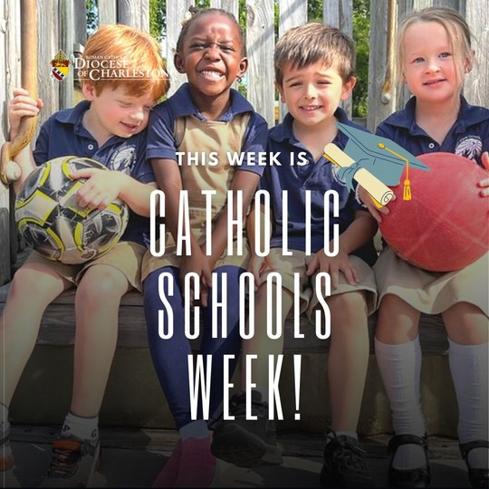
JAN 29. - FEB. 4

It's Catholic School's Week, a national celebration of Catholic education! Schools throughout the Diocese of Charleston will be celebrating with special Masses, assemblies, and other activities for students, families and parishioners.

We thank God for the wonderful gift of Catholic education here in South Carolina that is rooted in faith, excellence and service.

Find ways to celebrate at www.ncea.org. #CSW23

