SOCIAL MEDIA TOOLKIT

DECEMBER
MONTH OF JOY

PREPARED BY THE OFFICE OF COMMUNICATIONS

OVERVIEW

In an effort to better serve the parishes and ministries of South Carolina, the Diocese of Charleston has decided to release a social media toolkit each month for the coming year with social media assets to promote a monthly theme. This coming month, December, is the Month of Joy.

As we reflect on the Nativity of our Lord this month, all parishes are encouraged to share and amplify the message #Bejoyful across their own social platforms with the help of the toolkit below.

OBJECTIVES

The objectives for this month’s campaign are to:
Equip the faithful of South Carolina to have an attitude of Christian joy Highlight special feast days
Inform and inspire the faithful with Advent devotions

STEPS

- DOWNLOAD the photo by right clicking an image below to save it onto your desktop. You can also simply drag it onto your desktop.
- LOG ON to your favorite social media site, such as Facebook, Twitter or Instagram.
- COPY & PASTE one of the sample captions below into your status update — or create your own message that includes the #BeJoyful hashtag.
- UPLOAD the #BeJoyful image saved to your desktop to accompany your status update.
- POST your status update and encourage others to join the initiative through liking, sharing, reposting, and tagging others!

SOCIAL MEDIA POSTS

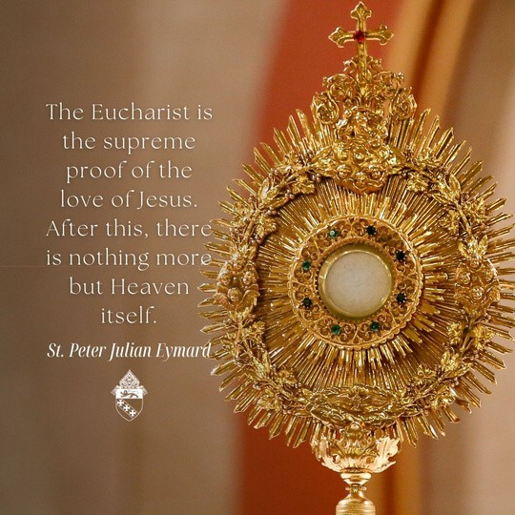
Jesus taught us that the greatest form of love consists in sacrificing for the good of another. He gave us the Holy Eucharist, his very body and blood, as the ultimate gift of love, the means of our redemption and font of grace. #bejoyful

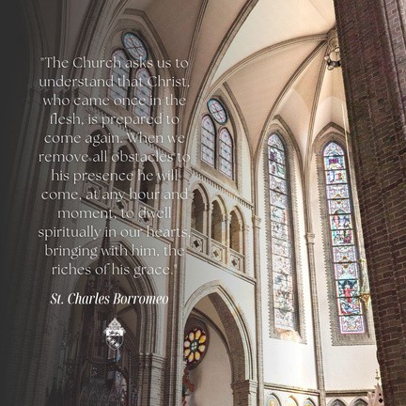
This Advent, let us prepare our hearts, minds and souls for Christ’s birth. By clinging to the sacraments, we invite God to dwell within us. In living out our vocations, we journey with the wise men to the Infant King. #bejoyful

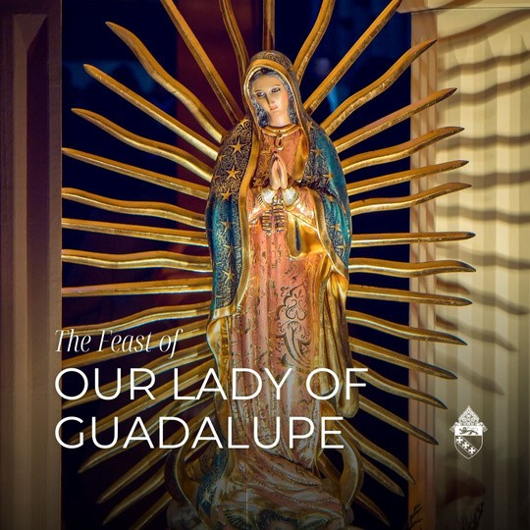
Happy feast of Our Lady of Guadalupe! She appeared to Juan Diego to ask that a chapel be built on Tepeyac Hill. She provided a miracle to the local bishop, imprinting her image on Juan Diego’s tilma, or cloak. The black sash that she wears denotes that she is with child, and thus, she is regarded as the patroness of the unborn.

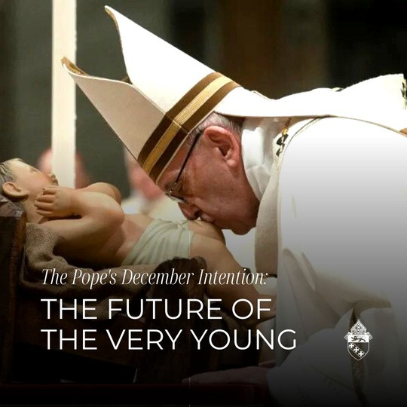
This month, Pope Francis asks that we join in prayer for the future of the very young. Let us do everything in our power to set up the future of our church by ministering to our youth.

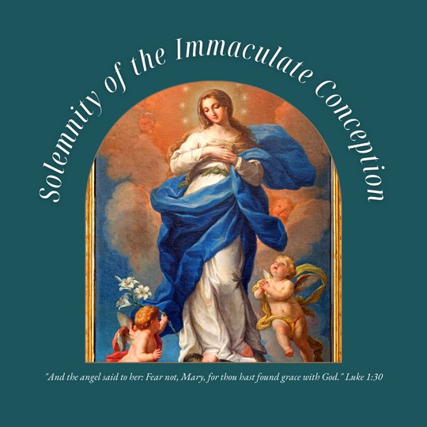
A blessed Solemnity of the Immaculate Conception! The Catholic Church teaches that Mary was conceived without the indelible mark of original sin on her soul. Let us ask for her intercession, that she might advocate for us at the throne of God.

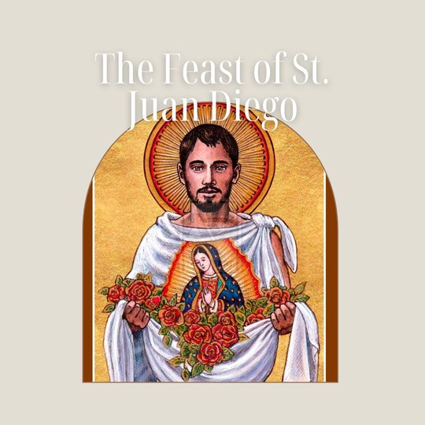
Early in the morning Dec. 9, 1531, an indigenous man named Juan Diego was walking to Mass along Tepeyac Hill on the outskirts of what is now Mexico City. He heard a voice say, "Juanito." He saw a mestizo woman who called herself "the perfect and perpetual Virgin Mary, Mother of Jesus, the true God." She asked for a church to be built on the site. Juan Diego told Bishop Juan de Zumárraga of the woman's request, but the bishop did not believe him.

Mary appeared once again to Juan Diego and told him to go to the top of the hill to pick flowers, which he collected in his tilma, or cloak, and went to tell the bishop. When he opened his tilma to present them, the bishop saw Castilian roses from Spain and also a beautiful image of Our Lady. By Christmas of that year, an adobe structure was built atop Tepeyac Hill in honor of our Blessed Mother, Our Lady of Guadalupe. St. Juan Diego, pray for us!

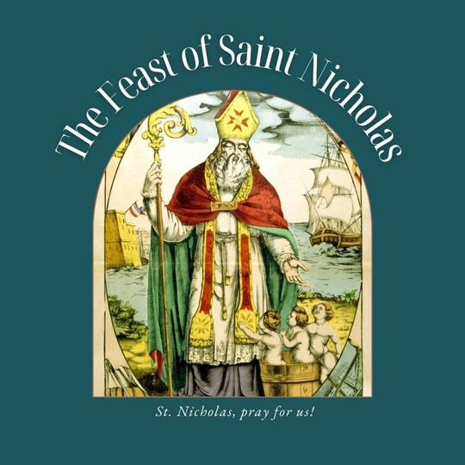
Happy Feast of St. Nicholas! Nicholas was the Bishop of Myra in the province of Lycia (modern- day Turkey) in the fourth century. He is believed to be the patron saint of children and gift-giving. Tradition states that St. Nicholas' parents died at a young age, leaving him a large sum of money. With this inheritance, he practiced Christian charity, helping the poor and less fortunate.

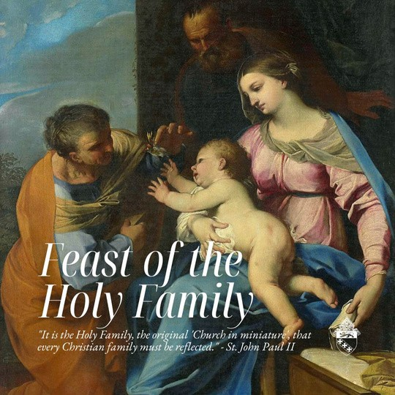
"The hidden life at Nazareth allows everyone to enter into fellowship with Jesus by the most ordinary events of daily life" (Catechism of the Catholic Church, 533).

A blessed feast of the Holy Family! May our own family units strive to imitate the Holy Family through loving one another in the joys and struggles of daily life. It is through our 'yes' to God in the ordinary moments that we become holy.

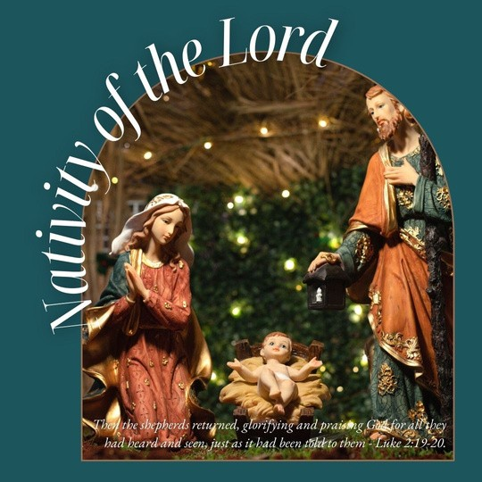
The Diocese of Charleston wishes you and yours a very Merry Christmas! May you revel in the joy of the Savior's birth this Christmas season.

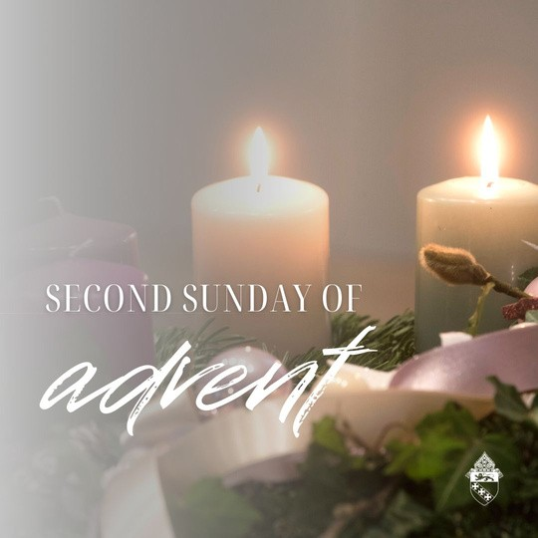
"John the Baptist appeared, preaching in the desert of Judea and saying, 'Repent, for the kingdom of heaven is at hand!' It was of him that the prophet Isaiah had spoken when he said: A voice of one crying out in the desert, Prepare the way of the Lord, make straight his paths … At that time Jerusalem, all Judea, and the whole region around the Jordan were going out to him and were being baptized by him in the Jordan River as they acknowledged their sins" (Mt 3:1- 12).

REFLECT:
Take a few moments to pray with this Scripture. What is Jesus saying to you through this excerpt from today's Gospel?

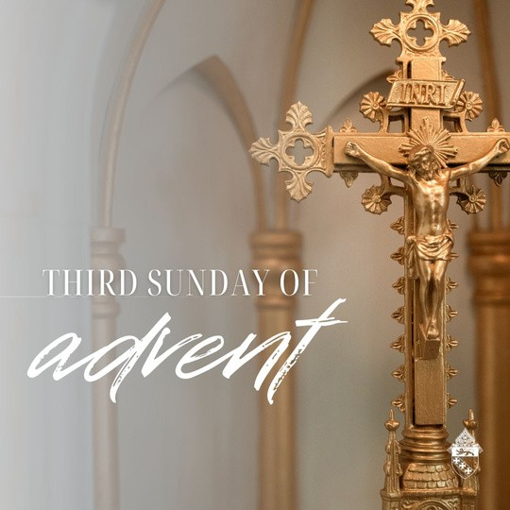
"When John the Baptist heard in prison of the works of the Christ, he sent his disciples to Jesus with this question, 'Are you the one who is to come, or should we look for another?' Jesus said to them in reply, 'Go and tell John what you hear and see: the blind regain their sight, the lame walk, lepers are cleansed, the deaf hear, the dead are raised, and the poor have the good news proclaimed to them. And blessed is the one who takes no offense at me'" (Mt 11:2- 11).

REFLECT:
Take a few moments to pray with this Scripture. What is Jesus saying to you through today's Gospel?

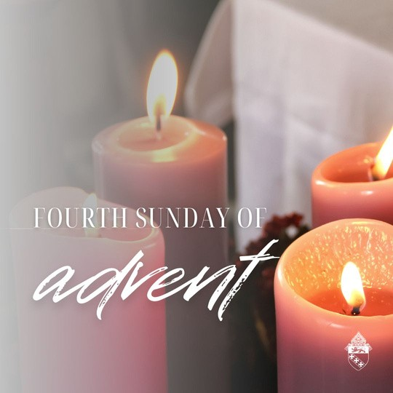
"Behold, the virgin shall conceive and bear a son, and they shall name him Emmanuel, which means 'God is with us'" (Mt 23).

Jesus is truly the light of the world. His light does not dull or fade.
He illuminates everything he touches.
His light is healing — it restores our souls. We were made to live in His light.

REFLECT:
Take a few moments to pray with this Scripture passage. What is Jesus saying to you? How can you honor Jesus as the light of your life?

