2023 High School Youth Conference
March 4-5, 2023
Columbia Convention Center

Come join Catholic youth and adults from around the Diocese as we gather on March 4-5, 2023, at the Columbia Convention Center for the 32nd Annual Diocesan High School Youth Conference! We invite you to be part of this exciting diocesan wide event. The theme for this year is “The Summit!” The scripture verse is John 6:35.

Then Jesus declared, “I am the bread of life. Whoever comes to me will never go hungry, and whoever believes in me will never be thirsty.”

The word summit means to reach the apex, the top, the highest point. And we are taught at a young age that we need to ascend to the top, but what is the top, the apex? We live in a world where it seems everyone is climbing over others to get somewhere… but where? So many times, we listen to what the world says only to finally arrive at where the world says we need to be, only to be disappointed and empty. Jesus tells us over and over in scripture that we will never find true fulfillment until we truly encounter Christ! This weekend come and see what the summit really looks like, come and see the summit of our faith and how it can change you for eternity!

This weekend promises to change your life! Our keynotes for the weekend are going to challenge, encourage, and give you hope! This year’s presenters for the conference are Father Louis Merosne, Meredith Gotta, and Doug Tooke. This weekend will also have challenging and thought-provoking workshops, awesome music, fun games, and skits. You will have the opportunity to experience grace in Adoration, Reconciliation, and the Eucharist! Bishop Fabre-Jeune will be joining us for the closing mass on Sunday.

Father Louis Merosne
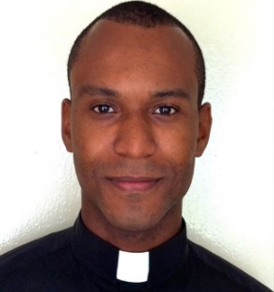
Father Louis Merosne is madly in love with the Trinity, the Blessed Mother, and the Catholic Church. Born in Haiti, he moved to Boston in 1993. He studied at the Franciscan University (undergraduate French, philosophy, and theology from 2002 to 2005 and graduate theology and Christian ministry from 2005 to 2007). Ordained in 2011, he now serves in Haiti in the Diocese of Anse-à-Veau and Miragoâne under Bishop Pierre-André Dumas. Preaching the Good News of Jesus Christ is both a duty and a passion for him. His perpetual prayer intention is to be a saintly priest.

Meredith Gotta (formerly Clemmens)
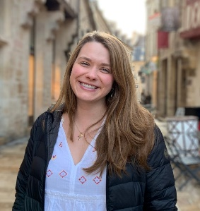
Meredith Gotta grew up in Aiken, SC and now lives in Charlotte with her husband Brendan. She is an IT manager for a DC-based tech company and enjoys volunteering in prison ministry for the Diocese. She grew up attending DYC, participated as a member of E-Team from 2010-2012, and looks forward to coming back ten years later to share her story!

Doug Tooke
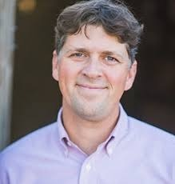
Doug Tooke is Vice President of Ministry at ODB films. With Bachelor of Arts degrees in both Philosophy and theology and a Masters in Pastoral Ministry, he has more than 20 years of professional ministry experience. Over the past 20 years, Doug has served more than 100 Dioceses - teaching, keynoting at conventions, and training youth ministers.

Youth Leaders Information
First, I want to thank you for bringing your youth to this event! It is an honor to have you bring your youth and adult chaperones to the 32nd annual high school youth conference! I know events like these are not easy to get your group altogether as you have so many things going on.

Registration
Registration cost for the conference is $100 per person before February 6, 2023. After a postmark of February 6, 2023, the cost will be $120 per person. We have created an online registration link for adults which will capture the adult release form as well as an online youth registration link which will capture the parent permission form. Youth ministers are still responsible for having a copy of these forms on hand but if your group registers online, a copy will no longer be required for our office. For those that do not register online, please submit all paperwork via e-mail. Registration links are listed below:

DYC Adult Registration

DYC Youth Registration

Hotel
We have a room block with the following hotels: Hyatt and Cambria. All hotels are located very close and within a block of the Columbia Convention Center. We ask that you please use our block hotels which we reserved for the youth groups of our diocese. It is your responsibility to get the necessary rooms that you need for your group. You are responsible for how many rooms you need and whether you want the hotel for Friday and/or Saturday night. The last day you can book a hotel room will be February 2, 2023. However, please note that these rooms are first come, first serve. The cost for the Hyatt hotel per night is $149 plus tax and the cost of the Cambria Hotel is $159 plus tax. Hotel links are listed below:

Cambria:

https://www.choicehotels.com/reservations/groups/EE19P0

Hyatt:

DYC 2023 Group Block Booking Link
Parking
Parking is an additional cost at these hotels. However, the Convention Center stated we are welcome to leave our cars in their lot at no cost with the understanding that it is an unsecured surface lot so you would do this at your own risk.

Meals
Included in your registration is lunch on Saturday. You will be responsible for the Saturday night dinner and Sunday breakfast. I will work with the Columbia Convention Office to identify restaurants nearby and see if we can get any discounts.

Parish time
Throughout the weekend we are going to work on building time in for parishes to gather and talk about what they have seen and/or have heard.

Basic Schedule
Below is a basic schedule which will give you an idea of when things begin and end:

Saturday, March 4, 2023

9:15 a.m. Registration Begins

10:00 a.m. Morning Session Begins

12:00 p.m. Lunch

1:00 p.m. Afternoon Sessions (Workshops/Keynote/Parish Time)

4:30 p.m. Break for Dinner

7:00 p.m. Evening Opening Session/Keynote/Adoration

10:00 p.m. Done

Sunday, March 5, 2023

9:00 a.m. Morning Session (Opening, Keynote, Mass with the Bishop)

11:30 a.m. Dismiss

Reconciliation
Reconciliation will be Saturday evening during Adoration. If you have a priest that would be available to offer the sacrament of reconciliation, please let us know. We will need to have them at the convention center from 8:00-10:00 p.m. but no later than 10:00 p.m.

Sunday Mass
If you have a priest that would like to concelebrate the closing mass on Sunday, please let us know. If you are a deacon and would like to participate in the closing mass, please let me know as we are limited in the number for the closing mass.

First Aid
We are looking for a few people who have medical backgrounds who would be willing to help with medical issues that come up during the weekend. We will waive their registration cost for the conference.

Scholarships
Please note that we do have scholarship money available for registrations for those who might need help with attending the conference. Please contact our office with your request.

