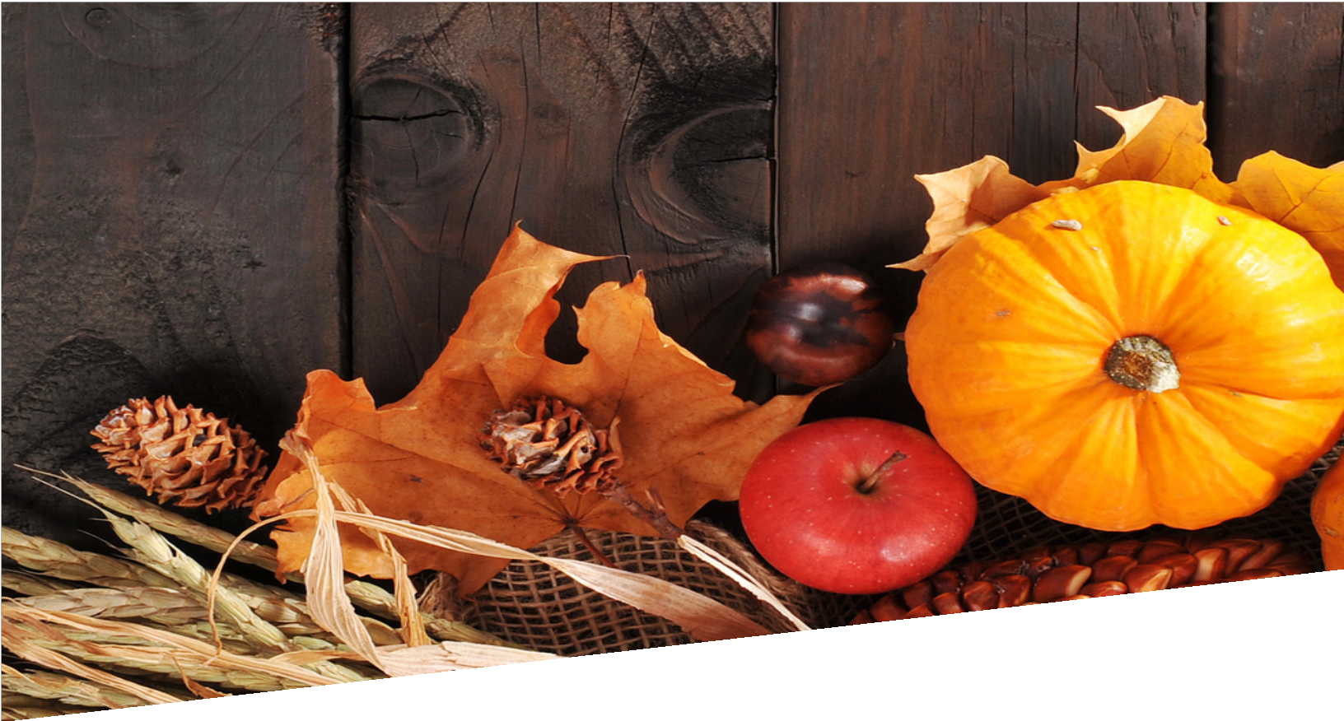

SOCIAL MEDIA TOOLKIT

NOVEMBER
MONTH OF THANKSGIVING

PREPARED BY THE OFFICE OF COMMUNICATIONS

OVERVIEW

To better serve the parishes and ministries of South Carolina, the Diocese of Charleston has decided to release a social media toolkit each month for the coming year with social media assets to promote a monthly theme. This coming month, November, is the Month of Thanksgiving.

All parishes are encouraged to share and amplify the message of #BeThankful across their own social platforms with the help of the toolkit below.

OBJECTIVES

The objectives for this month’s campaign are to:
Equip the faithful of South Carolina to have an attitude of gratitude for all of the blessings the Lord has bestowed upon them
Highlight the importance of Black Catholic History Month
Inform and inspire the faithful during Vocations Awareness Week (October 6-12)

STEPS

- DOWNLOAD the photo by right clicking an image below to save it onto your desktop. You can also simply drag it onto your desktop.
- LOG ON to your favorite social media site, such as Facebook, Twitter or Instagram.
- COPY & PASTE one of the sample captions below into your status update — or create your own message that includes the #BeThankful hashtag.
- UPLOAD the #BeThankful image saved to your desktop to accompany your status update.
- POST your status update and encourage others to join the initiative through liking,
sharing, reposting, and tagging others!

SOCIAL MEDIA POSTS

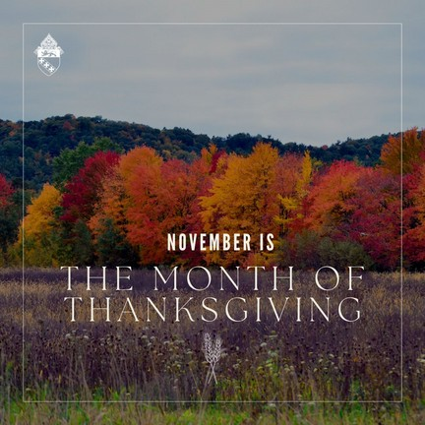
This holiday season, let us give thanks for each of the blessings God has given us. May we use our gifts and talents to build the Kingdom of God. #bethankful

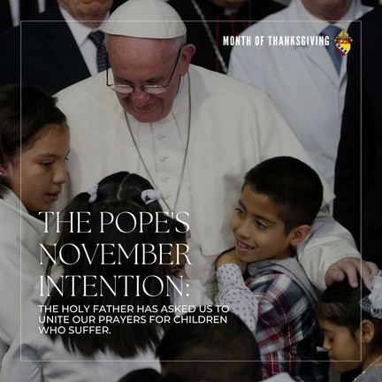
Pope Francis has asked that all men and women of faith unite in prayer for children who suffer. We particularly pray for homeless, orphans, and victims of war. May they be graced with loving homes, safety from all harm, and the resources and education to thrive. Our Lady, pray for us.

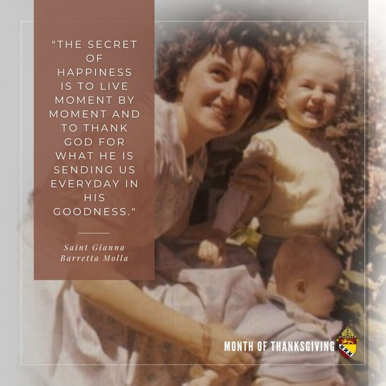
Every day, we are given an opportunity to be born anew in the fullness of grace. Let us thank God for each moment we have in our lives. #bethankful

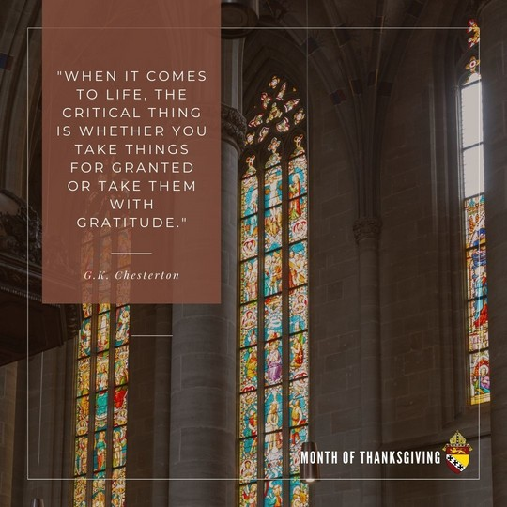
It is easy to take blessings for granted in our everyday lives. Everything we have, and everything we are, is not for us alone. May we never forget to cherish all the blessings, including the little things that make our lives whole. #bethankful

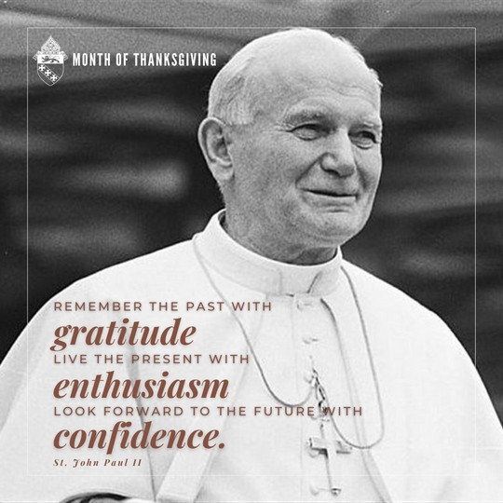
We are called to live our life with a spirit of gratitude. In calling to mind the gifts that we have been given, we are able to give of ourselves more for others. All the joys and sufferings that we experience on earth are opportunities to imitate our father in heaven. St. Pope John Paul II, pray for us. #bethankful

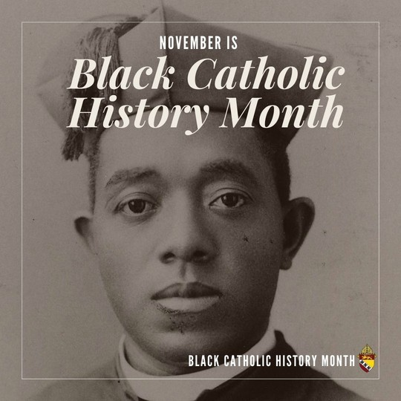
This month, we honor and recall the lives of all Black Catholic men and women who have gone before us as witnesses, defenders, and patrons of the faith. Let us ask for their special intercession this month and seek to imitate their witness in our own lives.

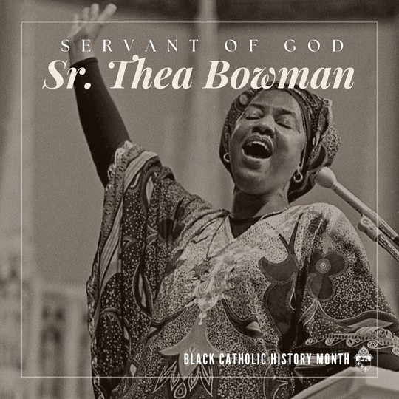
Today, we honor the legacy Sr. Thea Bowman, Servant of God. At the young age of 15, she joined the Franciscan sisters of Perpetual Adoration as the only African American in the convent. In 1989 she addressed the USCCB about the “true truths” of being black and Catholic in America. Until the day she died, she lived, loved, and fully served the Church and our Holy Father. Let us pray for the cause of her beatification.

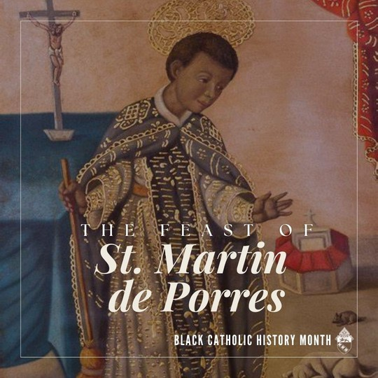
Happy feast of St. Martin de Porres. As a young man in Peru, Martin experienced ridicule for his mixed race. He became a talented barber and surgeon and used his medical talents to care for the sick as a Dominican lay brother. He was known to practice miracles in his lifetime, and in his death, his remains were found to be incorrupt. He is the patron saint of barbers, innkeepers, and people of mixed race. St. Martin de Porres, pray for us!

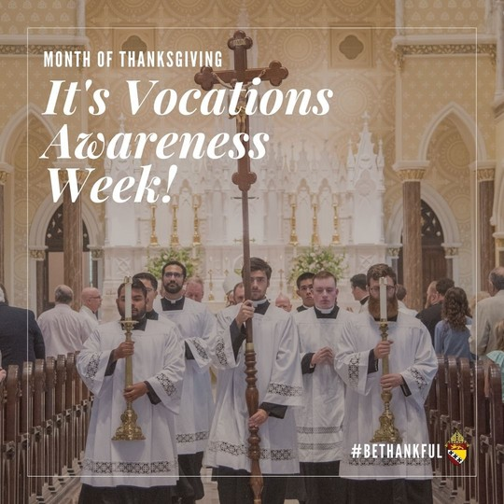
The Church dedicates this week as Vocations Awareness Week. We are invited to pray for the increase of holy priests, religious men and women, and Catholic families in our diocese. May we pray for all those discerning religious and lay life. St. Junipero Serra, patron saint of discernment, pray for us!

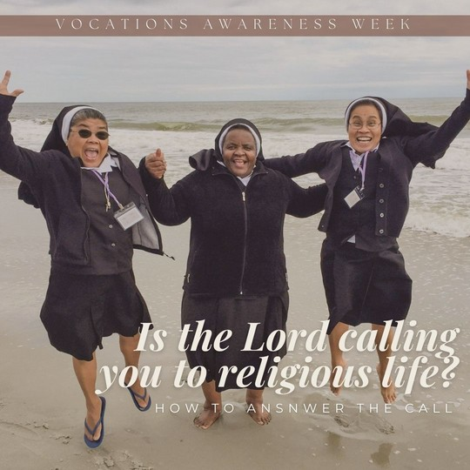
God calls many faithful men and women to serve Him and His Church by taking up vows of poverty chastity, and obedience. If you feel called to religious life, cling to prayer and the sacraments, in imitation of the saints, for clarity. Parents are called to foster and encourage their children to consider the consecrated life. #vocationawarenessweek

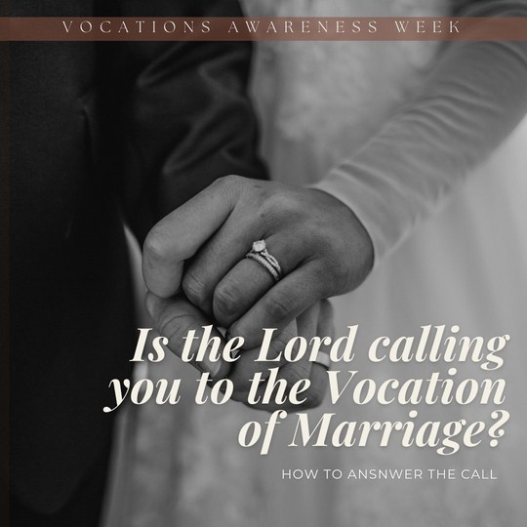
Do you feel like you are called to the vocation of marriage? If so, pray for the intercession of St. Joseph and the Holy Family to guide you in your present or future relationship. Marriage is a lifelong covenant between man, woman, and God. Let us pray for the sanctity of all married and engaged couples. #vocationawarenessweek

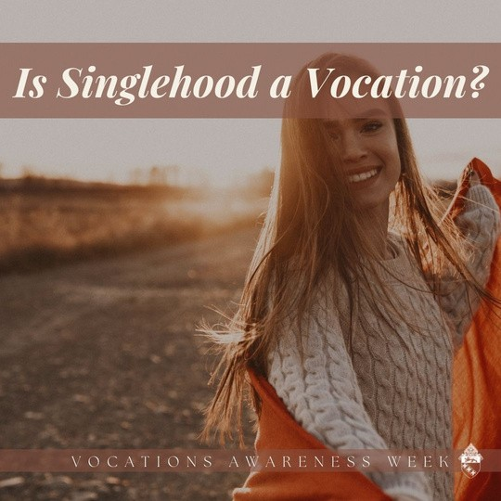
Is singlehood a vocation? While being single is not a vocation in and of itself, like those in holy orders, religious life, and married life, all people are called to the universal vocation of laying down our lives for the good of others. Let us give of ourselves in imitation of Christ.

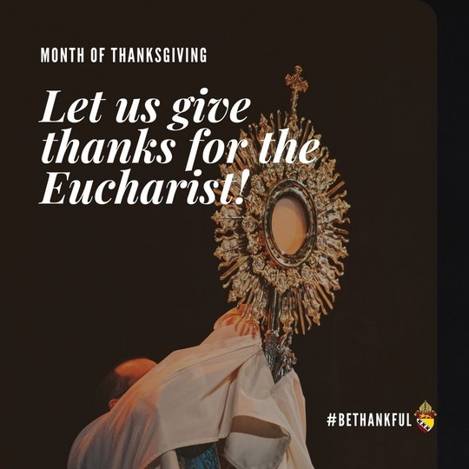
The word Eucharist means “to give thanks.” It is through giving that we receive. God’s ultimate gift was the sacrifice of his son to redeem the world. In giving of his body, blood, soul and divinity, Jesus opened the gates of paradise and set the world free. #bethankful

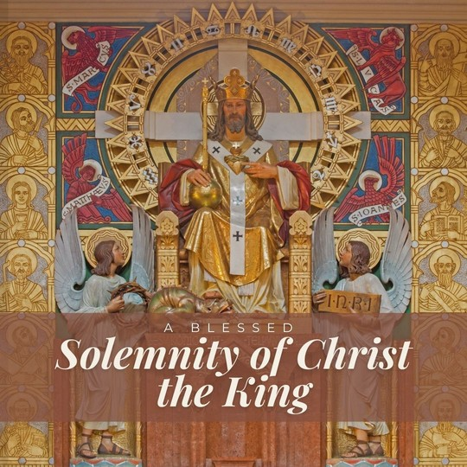
On the last Sunday of each liturgical year, the Church celebrates the Solemnity of Our Lord Jesus Christ, King of the Universe, or Christ the King. The feast originated in 1925 when Pope Pius XI instituted it to respond to growing secularism and atheism. He wanted to place a special emphasis on how governments come and go, but the Kingship of Christ is forever. Jesus Christ “is very truth, and it is from him that truth must be obediently received by all mankind.” When we celebrate the Solemnity of Christ the King, we declare to the world and remind ourselves that Jesus is the Lord of the Church and of the entire universe.

