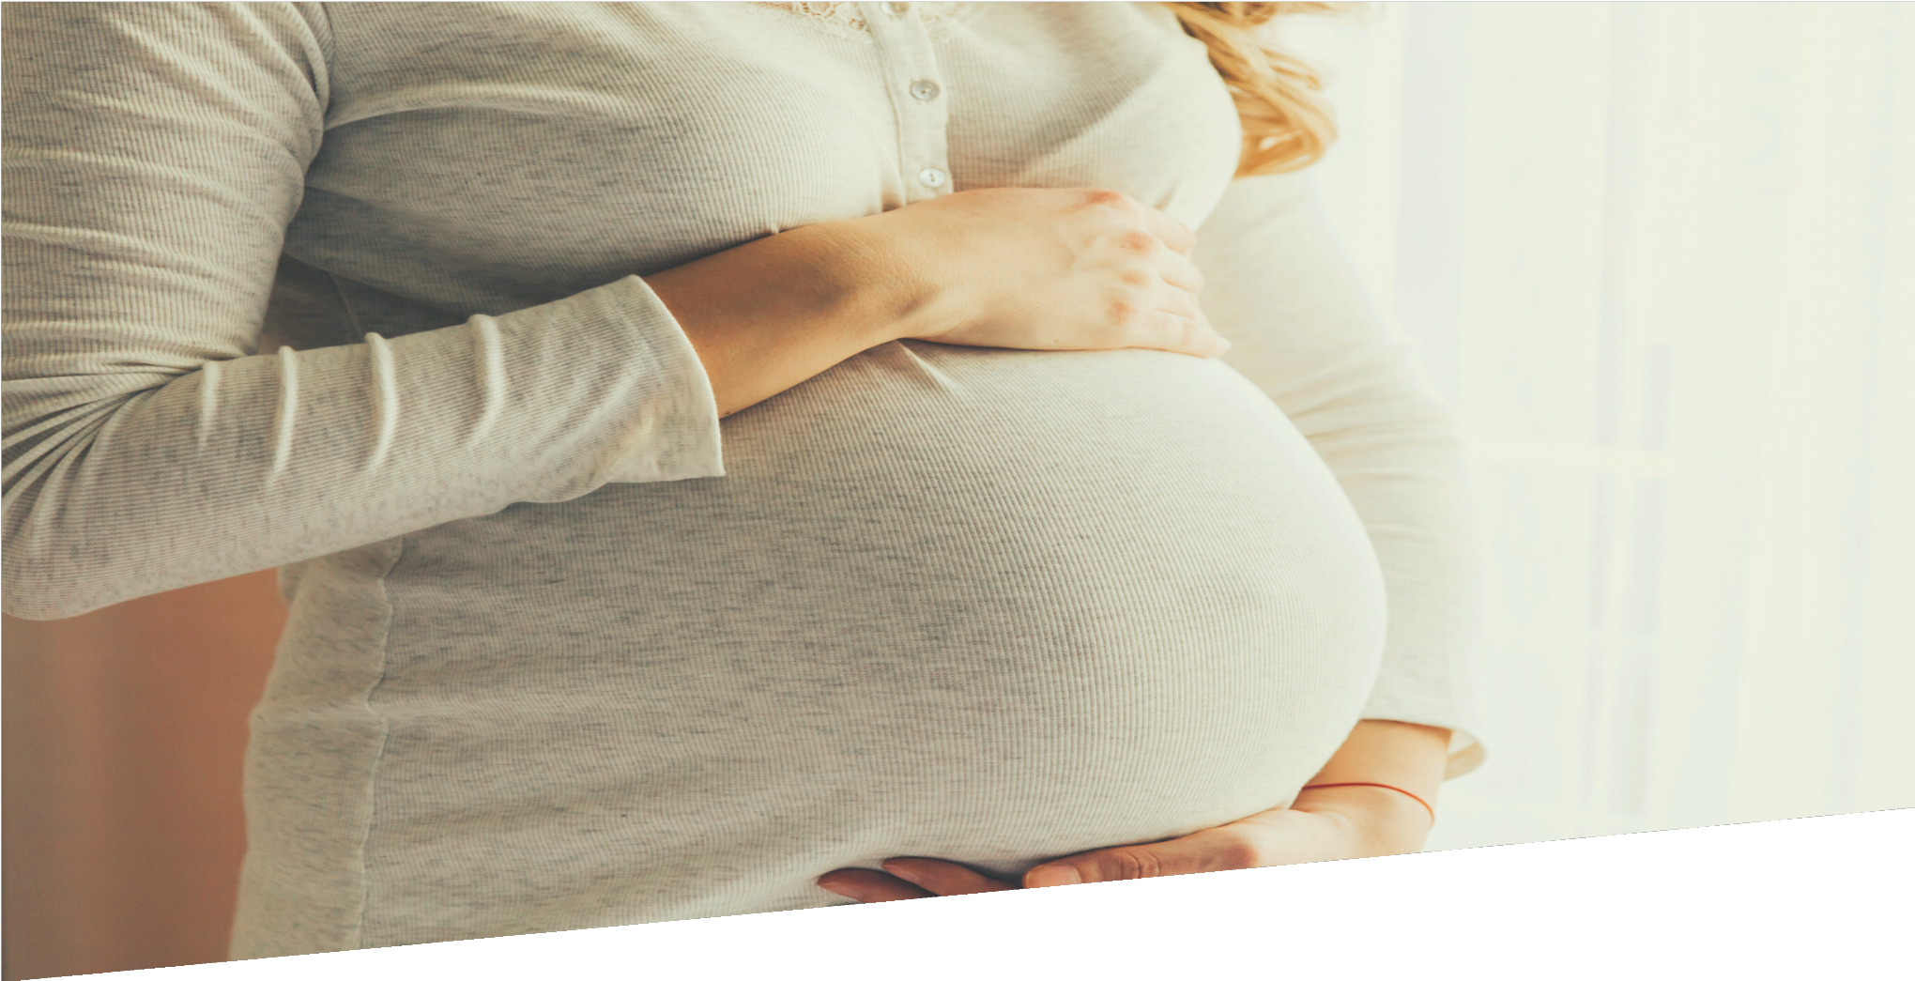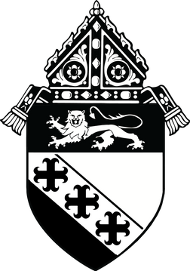

SOCIAL MEDIA TOOLKIT

OCTOBER
RESPECT LIFE MONTH

PREPARED BY THE OFFICE OF MUTLIMEDIA

OVERVIEW

In an effort to better serve the parishes and ministries of South Carolina, the Diocese of Charleston has decided to release a social media toolkit each month for the coming year with social media assets to promote a monthly theme. This coming month, October, will center around issues of life, for Respect Life Month.

All parishes are encouraged to share and amplify this message of #BeRespectfulofAllLife
across their own social platforms with the help of the toolkit below.

OBJECTIVES

The objectives for this month’s campaign are to:
Inform our audiences about the Church’s stance on life-related topics. Equip the faithful of South Carolina to be passionate pro-life advocates.
Spread a consistent message across the state of South Carolina, so that all Catholics will feel empowered with the knowledge and tools necessary to stand for life.

STEPS

- DOWNLOAD the photo by right clicking an image below to save it onto your desktop. You can also simply drag it onto your desktop.
- LOG ON to your favorite social media site, such as Facebook, Twitter or Instagram.
- COPY & PASTE one of the sample captions below into your status update — or create your own message that includes the #BeRespectfulofAllLife hashtag.
- UPLOAD the #BeRespectfulofAllLife image saved to your desktop to accompany your status update.
- POST your status update and encourage others to join the initiative through liking, sharing, reposting, and tagging others!

SOCIAL MEDIA POSTS

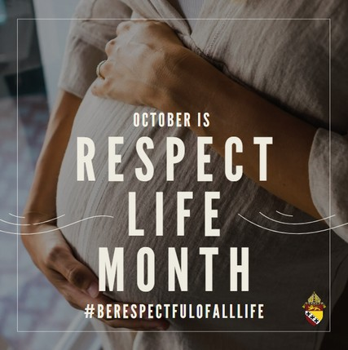
Every year, the Church dedicates October as Respect Life Month. This month, we are each called to spread awareness of the dignity of every human person, and God’s call to cherish and protect life from conception to natural death. Let us be mindful of the great gift of life that we have been given and use it to serve God and neighbor. #berespectfulofalllife

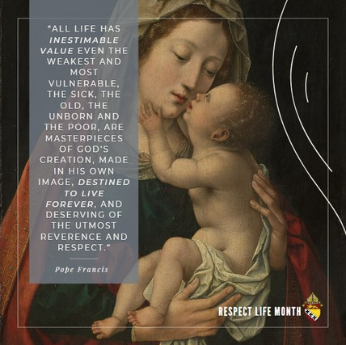
Pope Francis points out that every life is precious, every person is deserving of love, and that our lives on earth are a foretaste of what is to come. Let us continue to pray that every person, regardless of their status in life, is treated with respect and love. Let us also do our part to lend a helping hand to the most vulnerable in our communities. #berespectfulofalllife

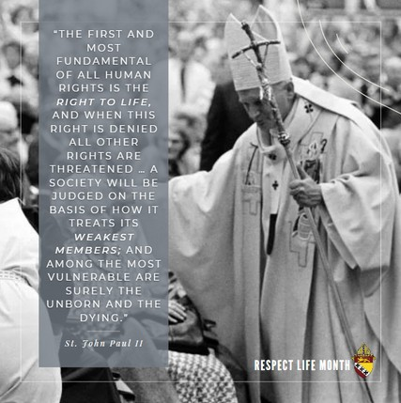
Pope St. John Paul II points out the dangers of a society that determines the value of its citizens based on any criteria other than what God has said. Let us pray that governments around the world serve those under their authority with the respect that is due to every human person. #berespectfulofalllife

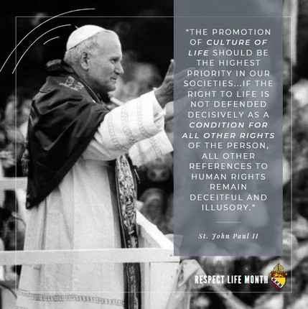
We are each called to foster a culture of life in our families, our communities, and in our country. Pope St. John Paul II elaborates on the consequences of a culture that claims to respect human rights, but does not protect the most vulnerable or in need. Let us do our part in the conversion of all hearts. #berespectfulofalllife

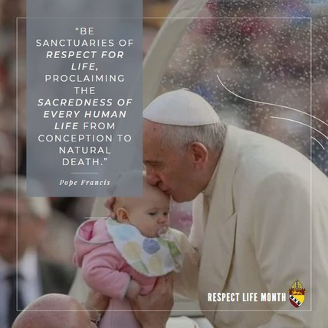
God is the giver and the source of life. As stewards of his revealed truth, let us be mindful of our commission to respect the lives of our brothers and sisters from conception to natural death. Pope Francis tells us that we should act as sanctuaries of respect for life. This means that when we see someone in need of our help, protection, or care, we must act. #berespectfulofalllife

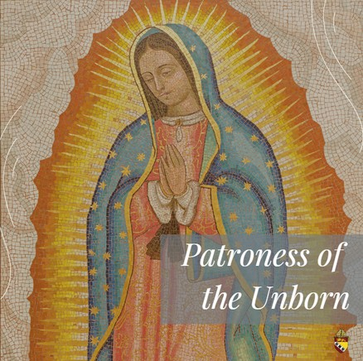
Our Lady of Guadalupe is the patroness of the Americas and of the unborn. In 1531, a Native American man named Juan Diego had a miraculous encounter with Our Lady on Tepeyac hill. She asked that a chapel be built there, and when the bishop of Mexico asked for a sign, Juan Diego brought him beautiful roses that were out of season. When Juan Diego unfurled his tilma to show the roses to the bishop, an image of Mary was imprinted on his garment exactly as she had appeared to him. In the image, she is depicted wearing a black sash, denoting that she is carrying a child. Our Lady of Guadalupe, pray for us! #ourlady #berespectfulofalllife

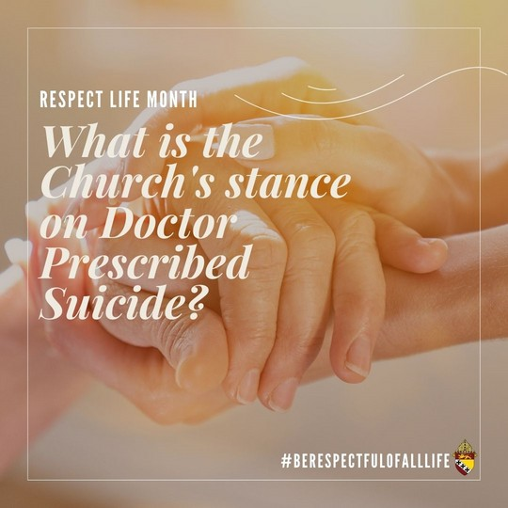
The Church teaches that Doctor Prescribed Suicide is immoral. CCC 2277 states: "Whatever its motives and means … [it] consists in putting an end to the lives of handicapped, sick, or dying persons. It is morally unacceptable."

The Congregation for the Doctrine of the Faith also states: "It is necessary to state firmly once more that nothing and no one can in any way permit the killing of an innocent human being, whether a fetus or an embryo, an infant or an adult, an old person ... For it is a question of the violation of the divine law, an offense against the dignity of the human person, a crime against life, and an attack on humanity." #berespectfulofalllife

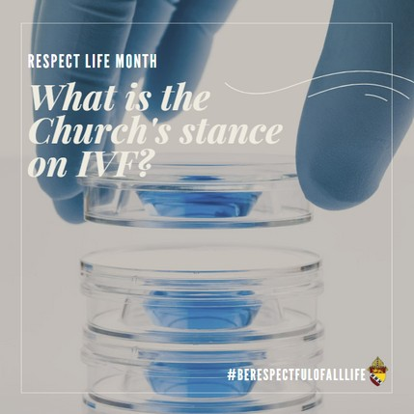
In vitro fertilization is the artificial means by which conception can take place in a laboratory. The Church teaches that actions do not justify means, and though procuring life is a part of our call as humans, artificial insemination is always considered immoral. CCC 2377 states: “Techniques involving only the married couple (homologous artificial insemination and fertilization) … remain morally unacceptable.
They dissociate the sexual act from the procreative act. The act which brings the child into existence is no longer an act by which two persons give themselves to one another, but one that “entrusts the life and identity of the embryo into the power of doctors and biologists and establishes the domination of technology over the origin and destiny of the human person." #berespectfulofalllife

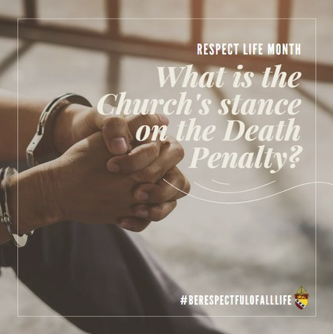
Created in the image and likeness of God, every person is owed respect and dignity. The United States Conference of Catholic Bishops (USCCB) states: “No matter how heinous the crime, if society can protect itself without ending a human life, it should do so.”

God is the creator of life, and to cultivate a society that respects life, we must make a conscious effort and decision to protect even those who take the lives of others. #berespectfulofalllife

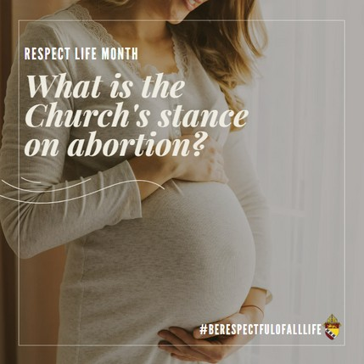
The Church has always stated that abortion is murder, is a grave sin, and is always morally illicit. CCC 2270-2271 reads: “Human life must be respected and protected absolutely from the moment of conception. From the first moment of his existence, a human being must be recognized as having the rights of a person – among which is the inviolable right of every innocent being to life … Since the first century the Church has affirmed the moral evil of every procured abortion. This teaching has not changed and remains unchangeable. Direct abortion, that is to say, abortion willed either as an ends or a means, is gravely contrary to the moral law.” Additionally, those that support or cooperate in the act of abortion incur mortal sin on their souls.

In summary, the Church has always held that abortion is a perversion of nature, murder, and is gravely contrary to God’s law. #berespectfulofalllife

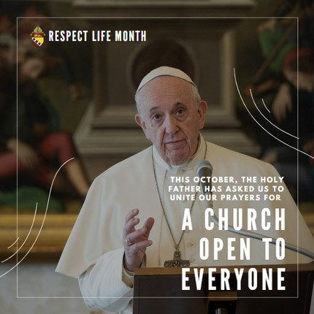
This October, Pope Francis has called us to come together in prayer, that all people created in the image and likeness of God are united in the Universal Church as one family. Let us pray that divisions are healed, and that we and our brothers and sisters are brought to the fullness of God’s Kingdom. #berespectfulofalllife

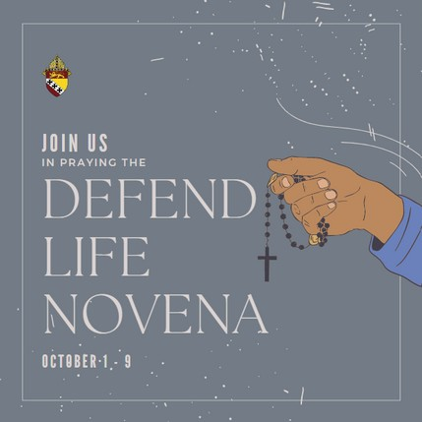
The Catholic Mobilizing Network (CMN) invites all to join in a novena for the abolition of the death penalty from October 1-9, the day before World Day Against the Death Penalty, October
10. Let us pray that all those whom our world governments have deemed unworthy to live will experience a conversion of heart, and that even the lives of those who mean us harm are protected at all costs. #berespectfulofalllife

