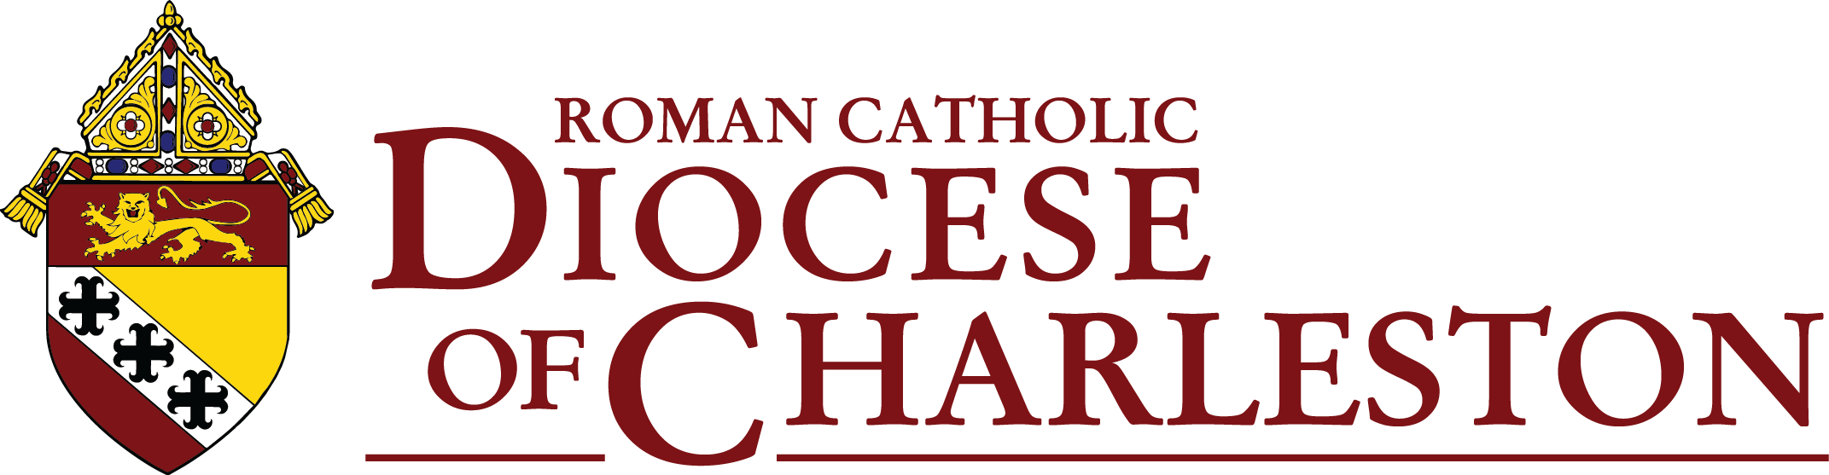

Synod Listening Session

Prayer

Introduction by Facilitator

Everyone here today has come because you are heavily invested in your Catholic faith. Our Church has asked us to take a long, hard look at how we can maximize the participation in our parish and diocesan projects and plans, our religious activities and our outreach to the world around us. We are on a mission to build stronger and stronger communities as we proclaim and live the Gospel.

Our discussion topics touch on many of the concerns raised by the Vatican as it prepares for what is called the Synod on Synodality. As we can see from our Bishop’s introduction, we are invited to look at the areas of Communion (being sacramental people and functioning as one Body), Participation, and Mission.

We will be sharing our insights and ideas on six general topics. Small group facilitators will be summarizing your contributions. We will send these to our Bishop, and diocesan officials will then compile our major insights and send them to the U.S. Conference of Catholic Bishops, who then compile a report for the Vatican. Meanwhile, we are also surveying Catholics across the state on related topics. All of our insights and inspirations count. What we are doing in these listening sessions is for the benefit of the whole People of God and for the whole general public—our brothers and sisters throughout the world.

Come, Holy Spirit!

Questions for Discussion

- In our parish, how are we effectively reaching out and including our parishioners? Are there some additional ways that we need to adopt to communicate with more people and invite their active participation?
Main ideas
A.
B.
C.

- How can we intentionally gain insights and ideas from people in our parish or local community who at times may seem to be on the fringes? What demographic groups should we reach out more to?

Main ideas
A

B.

C.

- Liturgical ministries, outreach to the homebound, religious education, and services to the poor always seem to need additional volunteers. How can we challenge people to get involved in these and other vital parish ministries? What training might be needed?
Main ideas
A.
B.
C.

- How does our parish evangelize? How can we evangelize better? How can we reach those that are not members of our parish and make Jesus real and personal? What fruits of our efforts do we see?
Main ideas:
A.
B.
C.

- Every diocese is being asked by Pope Francis to establish a “Laudato Si’ Action Platform.” Do we have people in our parish or local community who can contribute skills when we are considering renovations, building projects or in the care for our parish property? How knowledgeable are we of environmental issues in the areas around us? What deliberate actions can we take so that we “Care for Our Common Home"?

Main ideas:

A.

B.

C.

- “Synodality” asks us to be energetic and involved ambassadors of our faith by active listening and sharing of insights to advance Jesus’ mission in the world. How can our parishioners become more aware of how much their faith and insights count—and need to be heard?
Main ideas:
A.

B.

C.

Approved by Most Rev. Robert E. Guglielmone — October 12, 2021

