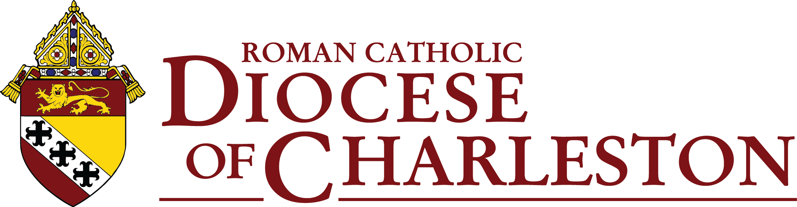

Synod Listening Session

Prayer

Introduction by Facilitator

Everyone here today has come because you are heavily invested in your Catholic faith. Our Church has asked us to take a long, hard look at how we can maximize the participation in our parish and diocesan projects and plans, our religious activities and our outreach to the world around us. We are on a mission to build stronger and stronger communities as we proclaim and live the Gospel.

Our discussion topics touch on many of the concerns raised by the Vatican as it prepares for what is called the Synod on Synodality. As we can see from our Bishop’s introduction, we are invited to look at the areas of Communion (being sacramental people and functioning as one Body), Participation, and Mission.

We will be sharing our insights and ideas on six general topics. Small group facilitators will be summarizing your contributions. We will send these to our Bishop, and diocesan officials will then compile our major insights and send them to the U.S. Conference of Catholic Bishops, who then compile a report for the Vatican. Meanwhile, we are also surveying Catholics across the state on related topics. All of our insights and inspirations count. What we are doing in these listening sessions is for the benefit of the whole People of God and for the whole general public—our brothers and sisters throughout the world.

Come, Holy Spirit!

Questions for Discussion

- In our parish, do we have effective means of reaching our parishioners and including them? Are there some additional ways we might need to adopt to communicate with more people and invite their active participation?
Main ideas
A.
B.
C.
- Do we consciously plan ways to get insights and ideas from people in our parish or local community who at times may seem to be on the fringes? (These might include members of minority groups, young adults, widowed or divorced, singles, elderly, persons with physical or learning disabilities, members of religious communities or various devotional groups, native speakers of a language other than English, those who might be considering becoming Catholic, civic officials, or those of other faiths.) Whose wisdom might we be missing?

Main ideas
A

B.

C.

- Liturgical ministries, outreach to the homebound, religious education, and services to the poor always seem to need additional volunteers. Are we challenging people to take on some vital parish ministries and training them for these?
Main ideas
A.
B.
C.

- Are we an evangelizing parish? Do we reach out to one another and to people who are not members of our Church in ways that makes Jesus real for them and personalizes faith? Are we seeing the fruits of our efforts?
Main ideas:
A.
B.
C.
- Every diocese is being asked by Pope Francis to establish a “Laudato Si’ Action Platform.” Do we have people in our parish or local community who can contribute skills when we are considering renovation or building projects and care for our parish properties? Are we aware of environmental issues in areas around us? Are we deliberate about being conscientious about “Care for Our Common Home"?

Main ideas:

A.

B.

C.

- “Synodality” asks us to be energetic and involved ambassadors of our faith by conscientious listening and sharing of insights to advance Jesus’ mission in the world. How do we see our parishioners becoming more aware of how much their faith and insights count—and need to be heard?
Main ideas:
A.

B.

C.

Approved by Most Rev. Robert E. Guglielmone October 12, 2021

