E-BILLING ENHANCEMENTS
Diocese of charleston| 901 Orange Grove Road, Charleston SC
ADDITIONAL PAYMENTS INSTRUCTIONS
Second collections & savings deposits
2020
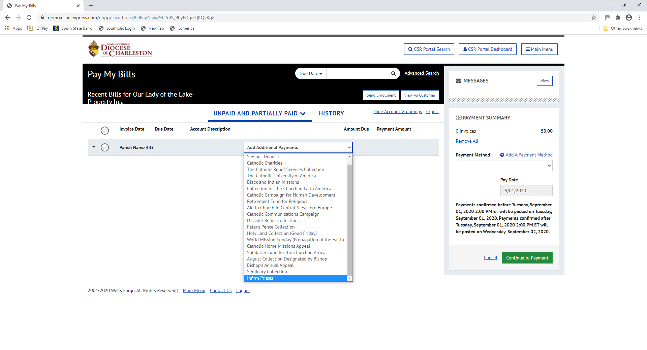
All invoices that are due for payment to the Diocese will show up on this screen. In this example, the screen is blank because example Parish 445 does not owe any invoices.
Select from the Add Additional Payments drop-down list if you wish to remit funds to the Diocese.
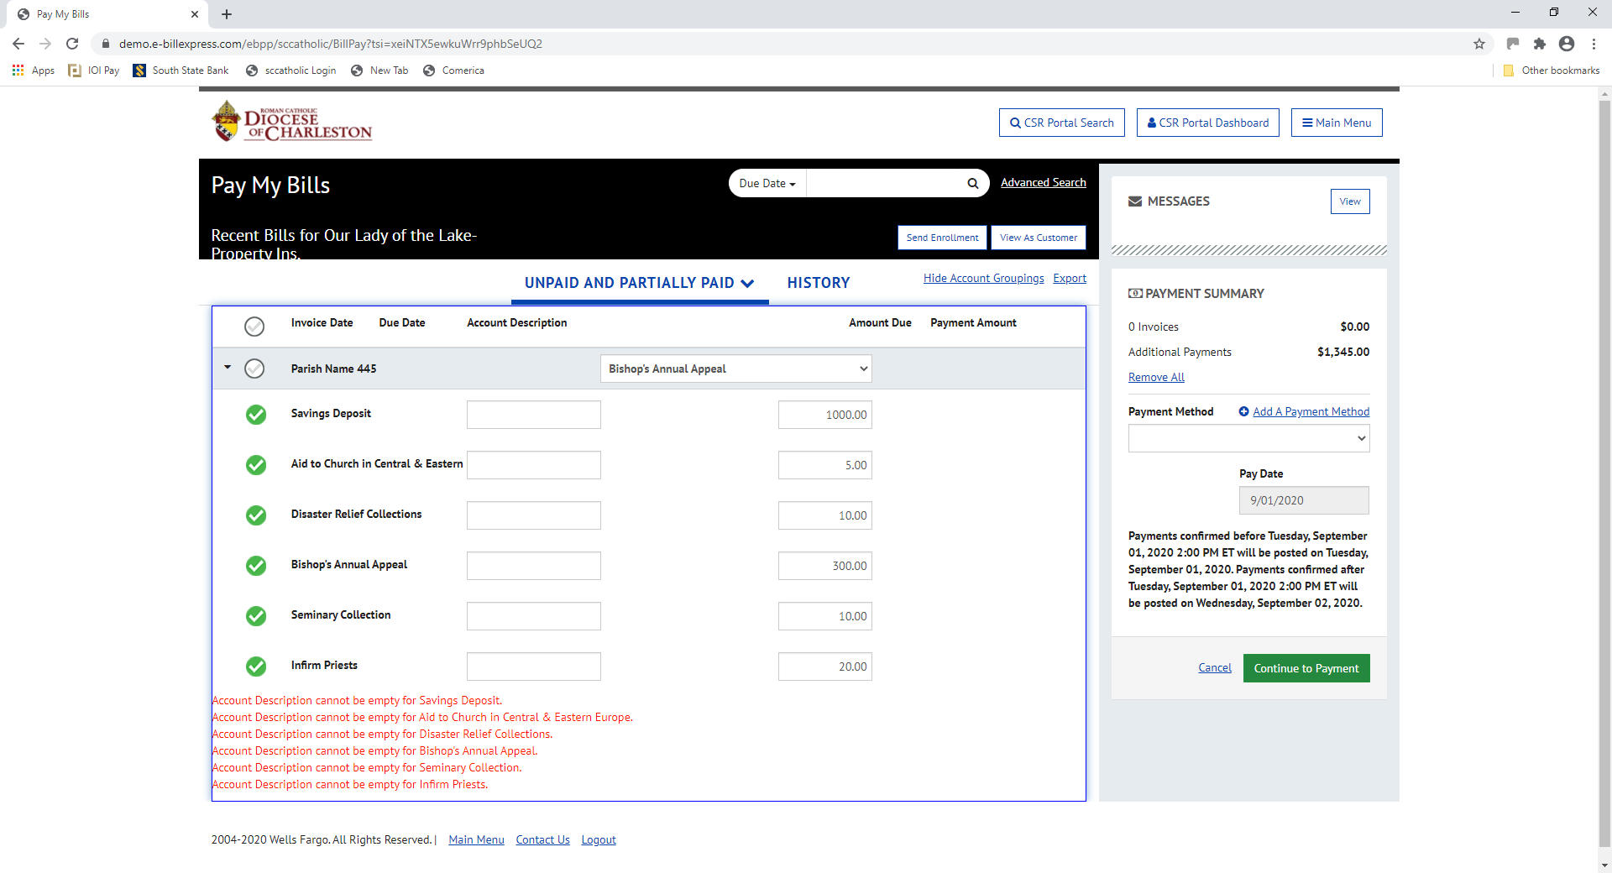

After selecting your specific Additional Payments, you must consult the “Account Description Criteria (Required Labels)” page of these instructions. Additional payments require an Account Description label.
Failure to correctly enter the label in the Account Description may result in the wrong parish or school receiving your deposits or credit.
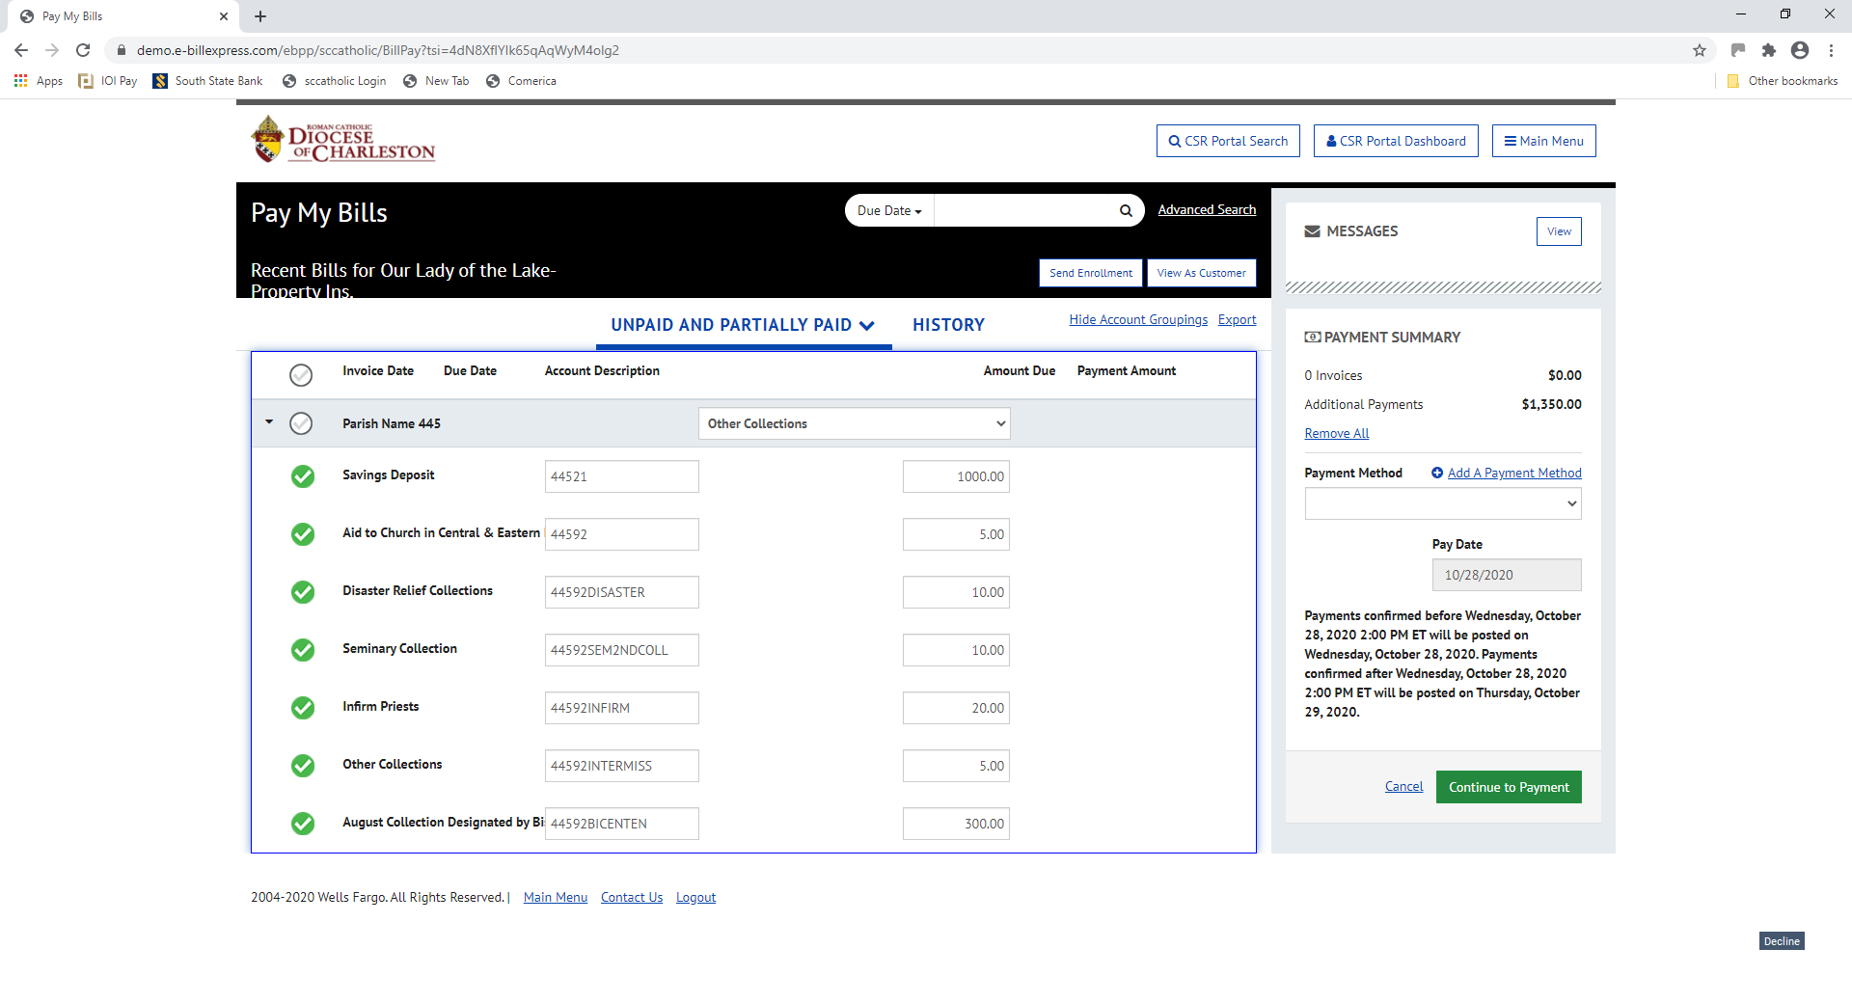

The Account Description is completed with labels for example Parish 445’s Additional Payments. The labels required for this example are on the next page.

ACCOUNT DESCRIPTION CRITERIA (REQUIRED LABELS)

All selections on the “Add Additional Payments” dropdown list require Account Description labelling with your parish number and “92”. This should result in 5 numbers only in the Account Description field/box for most. Extended descriptions where applicable are listed below.
An exception to this rule is made for deposits to diocesan Savings Accounts. Please label the Account Description with your particular Deposit & Loan 5 digit account number. Again, this should result in 5 numbers only in the Account Description field/box.
Unless extended coding is required, deviating from the required 5 numeric characters as stated above may result in the wrong parish or school receiving your deposit or credit. No spaces or letters are allowed. No descriptive words are allowed.
Extended Account Description Coding
Most Second Collections will only be labeled with your parish number and “92”.
However, for the following Second Collections only, please label as stated:
- Disaster Relief Collections – Enter your parish 3-digit number, a 92, and the word DISASTER – i.e. ###92DISASTER
- Bishop’s Designated August Collection – Enter your parish 3-digit number, a 92, and the name assigned by the Diocese to the current year collection. For the August 2020 collection, it would read as: ###92BICENTEN
- Seminary 2nd Collection – Enter your parish 3-digit number, a 92, and SEM2NDCOLL – i.e. ###92SEM2NDCOLL
- Infirm Priest 2nd Collection – Enter your parish 3-digit number, a 92, and INFIRM - i.e. ###92INFIRM
- Other Collections – For calendar year 2020, Guatemalan Mission is a new collection. Enter your parish 3-digit number, a 92, and INTERMISS - i.e. ###92INTERMISS

Once you have selected an Additional Payment by name, you cannot select it again. This includes Savings Accounts.
If you have any questions, please contact the Office of Finance for assistance:
Gabriela Miner, Accounting Supervisor 843-261-0474
Terri Brisson, Director of Financial Services 843-261-0471

