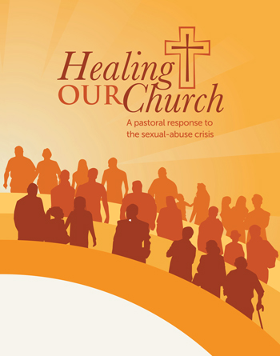
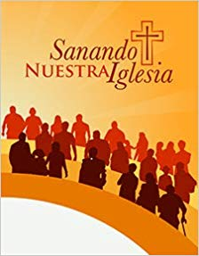

HEALING OUR CHURCH DISCUSSION GROUPS COMING IN LENT

Catholics throughout the Diocese of Charleston are invited to attend small-group discussions, moderated by fellow parishioners, and designed to encourage reflection and conversation about the clergy abuse crisis. Healing Our Church is a program from RENEW International, a Catholic nonprofit organization. Our Bishop sees the parish-based small-group discussions as an opportunity for all of us to prayerfully reflect on scripture, on the abuse crisis, and on our path forward as a Roman Catholic Family of Faith. Discussions will take place during the six weeks beginning in Lent. Please contact the parish office to sign up to participate in this program.

