South Carolina Catholic

Youth Rally for Life

**January 11, 2020**

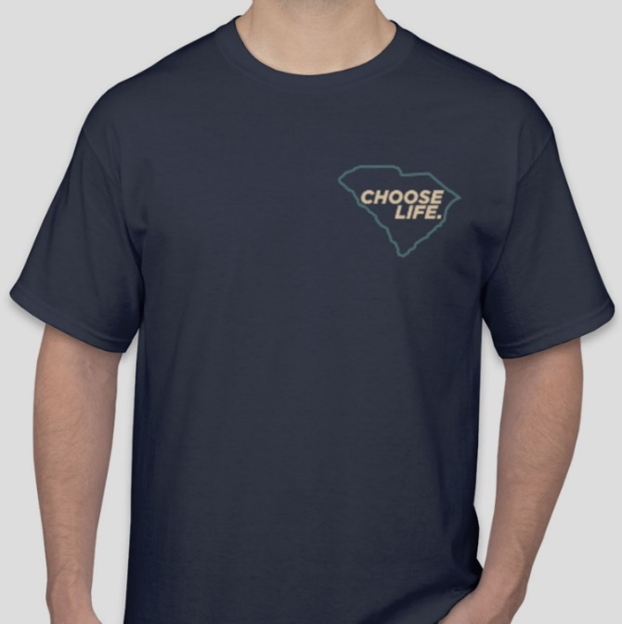 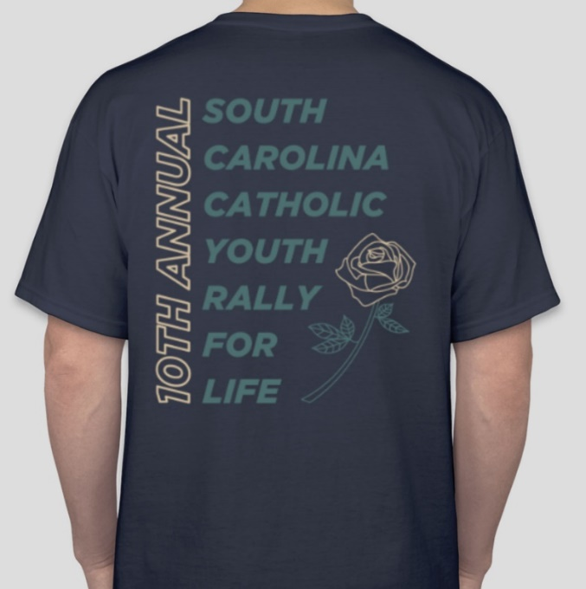

*(Back will say 11th Annual for 2020)*

**T-Shirt Order Form**

Name: ________________________________________________________ Parish Name: _______________________________

Mailing Address: ____________________________________________________________________________________________

Phone Number: ________________________ E-Mail Address: _________________________________________________

|  |  |  |  |
| --- | --- | --- | --- |
| **Size** | **Quantity** | **Cost** | **Total** |
| Short Sleeve Adult Small |  | X $ 10.00 | $ |
| Short Sleeve Adult Medium |  | X $ 10.00 | $ |
| Short Sleeve Adult Large |  | X $ 10.00 | $ |
| Short Sleeve Adult X-Large |  | X $ 10.00 | $ |
| Short Sleeve Adult 2X |  | X $ 11.00 | $ |
| Short Sleeve Adult 3X |  | X $ 11.00 | $ |

|  |  |  |  |
| --- | --- | --- | --- |
| **Size** | **Quantity** | **Cost** | **Total** |
| Long Sleeve Adult Small |  | X $12.00 | $ |
| Long Sleeve Adult Medium |  | X $12.00 | $ |
| Long Sleeve Adult Large |  | X $12.00 | $ |
| Long Sleeve Adult X-Large |  | X $12.00 | $ |
| Long Sleeve Adult 2X |  | X $13.00 | $ |
| Long Sleeve Adult 3X |  | X $13.00 | $ |

Grand Total: $____________

**Deadline for orders (NO EXCEPTIONS) is December 2, 2019. Make checks payable to:**

**Diocese of Charleston, Office of Youth Ministry, 901 Orange Grove Road, Charleston, SC 29407**